FOR IMMEDIATE RELEASE
OCTOBER 18, 2019

ISSA RAE’S RAEDIO AND ATLANTIC RECORDS UNVEIL LANDMARK NEW PARTNERSHIP

EMMY® AWARD-NOMINATED ACTRESS, PRODUCER, AND WRITER
TEAMS WITH LEGENDARY LABEL FOR INNOVATIVE JOINT VENTURE

“KINDA LOVE” BY RAEDIO FLAGSHIP ARTIST TEAMARRR PREMIERES TODAY

OFFICIAL COMPANION VIDEO STREAMING HERE

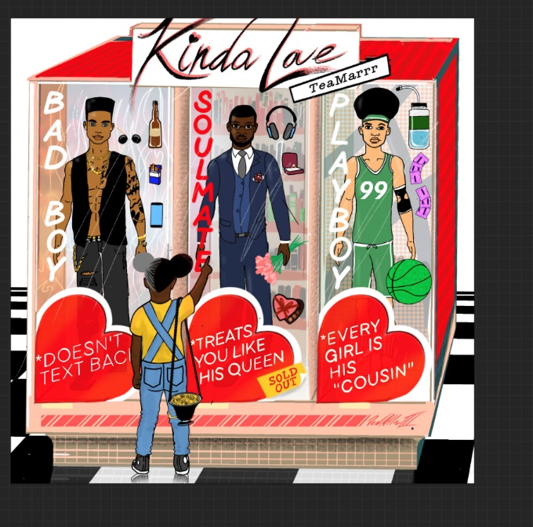
DOWNLOAD HIGH-RES COVER ART HERE

Raedio, the new label co-founded by EMMY® Award-nominated and two-time Golden Globe® Award-nominated actress, producer, and writer Issa Rae, and Atlantic Records have announced a milestone new partnership. The joint venture kicks off with today’s release of the new single, “Kinda Love,” by Raedio flagship artist TeaMarrr via Variety. The track is available now at all DSPs and streaming services HERE. The companion visual, directed by child (Ari Lennox, Lucky Daye), features cameos from label boss Issa Rae and comedian Jessie Woo. Watch Teamarrr assemble her own kind of man in the “Kinda Love” companion visual; streaming now HERE.

Formed earlier this year, Raedio serves artists and creators at the highest level as an “audio everywhere company,” operating as the home to a dynamic roster of talent. Most importantly, Raedio extends a platform across media to align acts with film and television projects, commercials, podcasts, and beyond.

Throughout her career, Issa Rae has maintained a close connection to the music world. Her Peabody Award-winning HBO series, Insecure, has long made a concerted effort to feature female, independent or Los Angeles-based artists, amplifying the work of Jazmine Sullivan, SZA, City Girls, Saweetie, Radiant Children, and more. Indeed, Rae’s emphasis on the importance of soundtracks dates back to her early web series, including her breakthrough The Misadventures of Awkward Black Girl.

"Music has always been an essential part of every project I do and working with emerging talent is a personal passion. Raedio allows me to continue that work within the music industry and audio entertainment space. The Atlantic Records team are innovators in terms of shifting and shaping culture. I'm excited to join forces with them to discover new artists,” states Rae.

“Issa Rae is a next-level, future-thinking creative force who’s been breaking down cultural barriers and conquering one field after another,” said Atlantic Chairman & COO Julie Greenwald. “She’s made music a central character in her artistic evolution, and now she’s brought all that amazing passion, inspiration, and taste to the formation of Raedio. We’re thrilled to be partnering with Issa and her team on this exciting new venture, and TeaMarrr is the perfect artist to launch with.”

Furthermore, Raedio also provides music supervision services for HBO’s critically acclaimed “A Black Lady Sketch Show.” The Raedio team, led by Rae’s longtime business development executive and now President, Benoni Tagoe, champions the next generation of artists and presents a progressive paradigm for the music industry.

DOWNLOAD HIGH-RES HERE
PHOTO CREDIT: TYREN REDD
ABOUT TEAMARRR
Shaking up pop, hip-hop, R&B, and more with a sharp sense of humor – and even sharper mic skills – TeaMarrr emerged in 2016 and quickly earned more than 4 million worldwide streams and high profile media attention spanning Flaunt and NPR to Ones To Watch and Consequence of Sound, to name but a few. The Boston-born and Los Angeles-based Haitian-American songstress truly broke through in 2018 with the hit single, “One Job,” scoring over 1.2 million streams and the attention of Raedio founder Issa Rae, who soon signed her as the new label’s flagship artist. The track is joined by an official companion video, directed by James Bland (creator of Issa Rae Presents’ Daytime EMMY® Award-nominated GIANTS) and co-starring Insecure’s Jean Elie, streaming HERE.

“Kinda Love” marks the first fruit of that alliance, with TeaMarrr bobbing and weaving between sexy soul swagger, island mystique, and subversive appeal. The track – like TeaMarrr’s forthcoming full-length debut album, due next year – suggests the arrival of a remarkable new artist with an admittedly greater purpose.

“I want people to heal themselves with my sound,” TeaMarrr says. “I hope they walk away thinking, ‘TeaMarrr is my new musical pharmacist.’ My catalog will heal whatever mood you’re in; if you’re in a lovey-dovey vibe put on ‘Kinda Love.’ If you’re angry at your ex and don’t understand why he couldn’t have done the one thing you asked him to, I definitely have a song for that too. Think of me as the sonic doctor prescribing music as medicine to help you heal.”

ABOUT RAEDIO
Raedio is “an audio everywhere company” co-founded by EMMY® Award-nominated and two-time Golden Globe® Award-nominated actress, writer and producer Issa Rae in 2019. It houses a roster of artists and creatives and is comprised of alliances with Atlantic Records for distribution, Kobalt for publishing, LiveNation Urban for events/productions, and streaming platforms for weekly playlists, original audio and video content. Its platform extends across media to align acts with film and television, projects commercials, podcasts, and beyond.

ABOUT ATLANTIC RECORDS
Atlantic Records celebrated its 70th anniversary in 2018. Founded in New York City, the label literally grew from a one-room operation into one of the world’s preeminent music companies. Atlantic has released a string of recordings that have had a profound impact on the course of modern music, its rich history including such musical icons as Ray Charles, Aretha Franklin, John Coltrane, and Led Zeppelin. The Atlantic Records Group roster today includes many of the world’s most popular recording artists, among them Kelly Clarkson, Bruno Mars, Ed Sheeran, Cardi B, Sia, Coldplay, Charlie Puth, Janelle Monáe, Wiz Khalifa, Death Cab for Cutie, Matchbox Twenty, Lil Uzi Vert, Kevin Gates, Melanie Martinez, Rob Thomas, Skrillex, Trey Songz, and many more.

CONNECT WITH RAEDIO
OFFICIAL | TWITTER | INSTGRAM | FACEBOOK | YOUTUBE

CONNECT WITH TEAMARRR
INSTAGRAM |TWITTER | FACEBOOK | YOUTUBE

For additional press assets, please visit press.atlanticrecords.com/teamarrr

PRESS CONTACT
Fairley McCaskill | Fairley.McCaskill@atlanticrecords.com

Vanessa Anderson | vanessa@amprgroup.com (Raedio/Issa Rae)
