**TAYLA PARX HOSTS *THE TAYLA MADE POP-UP EXPERIENCE* IN LOS ANGELES AND SURPRISES GUESTS WITH NEW TRACK/VIDEO “SLOW DANCING”**

**VISUAL EXCLUSIVELY PREMIERED TODAY ON *FLAUNT***

**TRACK STREAMING ON ALL DSPS NOW**

**STREAM TRACK** [**HERE**](https://taylaparx.lnk.to/SlowDancingPR)

**WATCH VIDEO** [**HERE**](https://taylaparx.lnk.to/SlowDancingPR/youtube)

**EMBED CODE** [**HERE**](iframe%20width=%22560%22%20height=%22315%22%20src=%22https:/www.youtube.com/embed/OVfEoyKJnRk%22%20frameborder=%220%22%20allow=%22autoplay;%20encrypted-media%22%20allowfullscreen%3e%3c/iframe)

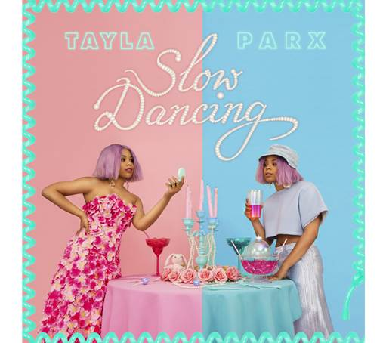

Last night during the ***Tayla Parx Pop Up Experience*** at The Microsoft Lounge in LA, **TAYLA PARX** dropped visuals for her new track **“Slow Dancing”** off her forthcoming project **“We Need To Talk.”** The ***TAYLA MADE POP-UP EXPERIENCE*** hosted by Tayla herself, was not only a cool moment for fans to dive into all things Tayla, but she also surprised attendees by performing tracks off the upcoming project on top of an illuminated box in the center of the experience including an exclusive listening/viewing of her new track/video “Slow Dancing.” The companion visual premiered exclusively today on Flaunt and is out now on all DSPS.

“Slow Dancing” is Tayla’s ultimate carefree revelation, in music form. Although her younger “tomboy” self-had thoughts of never falling in love and indulging in things that normal girls would fall for, she realizes she is in fact a typical girl and enjoys “diamonds and pearls...slow dancin’, romancin’…”

Fans were able to feel the vibe of an extra playful contrast of Tayla’s feminine tomboy aesthetic in her interactive trailer park art experience, while enjoying the “Life Is A Garden, Don't Be A Prick” succulent garden, quirky TaylaMade cocktails and gourmet versions of ‘guilty pleasure American classics.’ The pop-up was a nod to her “Trailer Parx” merchandise line.

3x GRAMMY® Award-nominated recording artist **Tayla Parx** recently released her single/companion visual [**“Me Vs. Us”**](https://www.youtube.com/watch?v=Fuind6upxyc&feature=youtu.be) following an exclusive premiere via [**Complex**](https://www.complex.com/music/2018/09/tayla-parx-me-vs-us-video). Co-produced by Parx, Haze, and xSDTRK, “Me Vs. Us” showcases Parx’s ability to harmonize effortlessly while describing what it feels like to choose between loving someone more than you love yourself. The multi-platinum certified singer-songwriter-producer’s upcoming project, entitled **WE NEED TO TALK** will be her major label release following the debut of her solo mixtape [**TAYLA MADE**](https://taylaparx.lnk.to/TaylaMadePR).

**CONNECT WITH TAYLA PARX**

[**OFFICIAL**](http://www.taylaparx.com/)

[**INSTAGRAM**](http://instagram.com/taylaparx)

[**YOUTUBE**](https://www.youtube.com/channel/UCXR82zHJ6FuWccQQqxtNHyw)

[**TWITTER**](https://twitter.com/TAYLAPARX)

[**FACEBOOK**](https://www.facebook.com/taylaparx/)