FOR IMMEDIATE RELEASE
OCTOBER 22, 2021

DON TOLIVER’S LIFE A DON DEBUTS AT #2 ON BILLBOARD’S TOP R&B/HIP-HOP ALBUMS
& REACHED #1 ON ITUNES UPON RELEASE

YESTERDAY TEXAS SOUTHERN UNIVERSITY CELEBRATED THEIR HOMETOWN HERO
DON TOLIVER DONATES TO TSU BAND
DOWNLOAD EVENT IMAGES, PHOTO CRED: MICHAEL ANTHONY

A BATHING APE®️ X CACTUS JACK X DON TOLIVER MERCH LINE NOW LIVE
SHOP.LIFEOFADON.COM

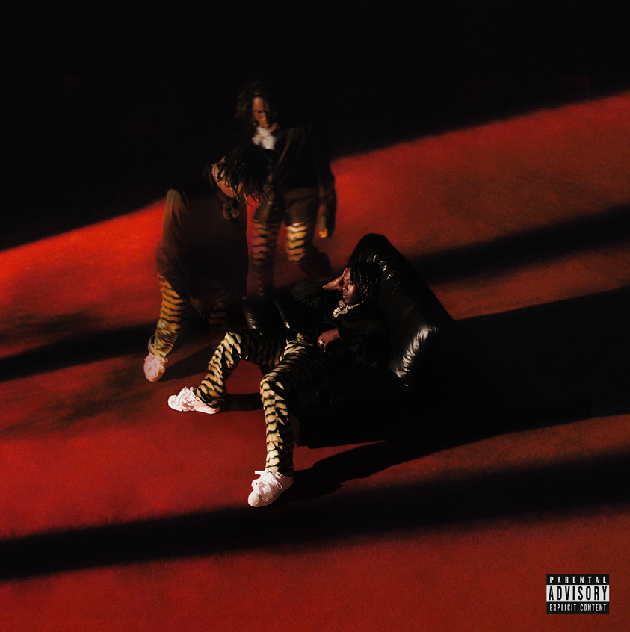 | 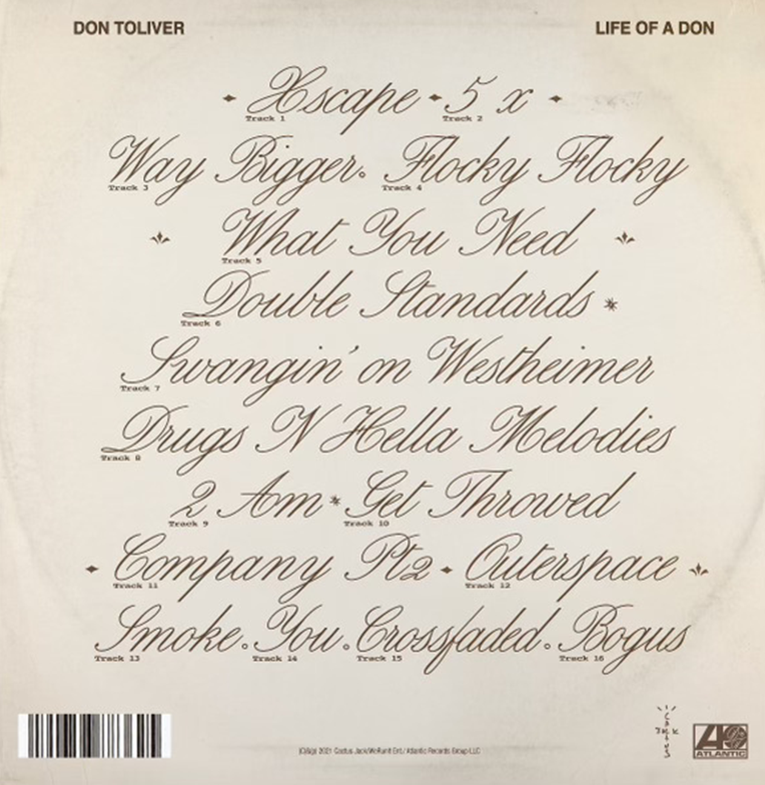

DOWNLOAD LIFE OF A DON COVER ART
DOWNLOAD PRESS PHOTOS, CRED: BETHANY VARGAS
DOWNLOAD IMAGES FROM TSU, CRED: MICHAEL ANTHONY

On Wednesday and Thursday of this week, Don Toliver performed at Houston’s Bayou Music Center on his Life of a DON tour. Culture Fusion Agency, the college marketing agency for Atlantic’s Black Music division, tapped Texas Southern University’s band to welcome Don Toliver home by having the band play covers of Don’s “What You Need” and “No Photos” alongside a group of slab cars. On behalf of Don Toliver and his team, a donation was made to Texas Southern University’s band and treated the staff, local HBCU students and mayor’s office to Life of a DON tour tickets. Download images to the event’s photo recap HERE.

A Bathing Ape®️ x Cactus Jack x Don Toliver teams up to provide an exclusive merch line guided by BAPE’s authority in streetwear and Cactus Jack legacy of craftsmanship. This collaboration was announced alongside the album and is now live on shop.lifeofadon.com. Toliver recently tapped Travis Scott for “Flocky Flocky” (director Tyler Ross), the latest visual from his eagerly anticipated sophomore album Life of a DON. The album was released alongside the official visual for “Way Bigger.” With his Life of a DON headline tour sold out in most cities, purchase tickets to remaining dates HERE. Recently, Kanye West recruited Don Toliver for “Moon” off his DONDA album.

“It’s through his treble-heavy, yet smooth singing voice that he exhibits his agility to glide between R&B, rap, pop and trap elements. His sound can be described as soulful and idiosyncratic — and with it, he delivers catchy melodies, emotive lyrics, and thought-provoking ad-libs.”
HYPEBEAST

“If the velocity of his rise was breathtaking, then Life Of A DON moves to solidify his reputation. It’s a broad, diverse statement – punchy throughout, and soulful when it needs to be – eschewing the vagaries of feature culture to finesse down his art, using a carefully curated array of guests to broaden his own vision.”
CLASH

REMAINING LIFE OF A DON TOUR DATES:
PURCHASE TICKETS TO NEARLY SOLD-OUT LIFE OF A DON TOUR
Fri Oct 22 – Dallas, TX – The Bomb Factory
Sun Oct 24 – Denver, CO – Fillmore Auditorium
Mon Oct 25 – Salt Lake City, UT – The Complex
Sat Oct 30 – Los Angeles, CA – Palladium
Sun Oct 31 – Los Angeles, CA – Palladium
Fri Nov 5 – Houston, TX – Astroworld
Sun Nov 14 – Las Vegas, NV – Day N Vegas
Sun Dec 12 – Los Angeles, CA – Rolling Loud

ABOUT DON TOLIVER:
If Don Toliver pulled up in a spaceship, nobody would question it. His music might as well be its own solar system with otherworldly hip-hop, smoked-out R&B, ambitious pop, and a little rock in a planetary orbit around the multiplatinum singer, songwriter, and artist. It might seem like he hails from some far away galaxy, but he calls Houston, TX home. Forged in the fires of his hometown, he grinded out a visionary style in underground shows, elevating the post-genre grime and grit of his city into mainstream focus. After the 2018 mixtape Donny Womack, he assembled his full-length debut, Heaven Or Hell. It claimed spots on mid-year and year-end lists by Complex and XXL, while Rolling Stone championed him among the 10 Biggest Breakthrough Artists of 2020. Eminem, Nas, and Rico Nasty recruited him for collaborations. Plus, he joined forces with Internet Money, NAV, and Gunna for the triple-platinum banger “Lemonade,” which they also performed on The Tonight Show Starring Jimmy Fallon. Within three years, he has gathered billions of streams, scored platinum plaques, and received praise courtesy of everybody from High Snobiety to Interview Magazine. However, it’s all a part of his life—as chronicled on his 2021 second full-length album, Life of a DON [Cactus Jack/Atlantic Records].

CULTURE FUSION AGENCY:
Culture Fusion Agency is a boutique multicultural marketing agency that works alongside record labels to develop and execute campaigns, rollouts, and events for artists/brands. Our primary focus is to create unique experiences for the HBCU community by providing a hands-on learning experience and networking platform for the next generation of music executives and making meaningful connections for our clients and that target market.

PRESS CONTACT:
Brittany Bell, Brittany.Bell@atlanticrecords.com

