**SHORELINE MAFIA DROPS “WINGS” VISUAL**

**WATCH “WINGS”** [**HERE**](https://shoreline.lnk.to/WingsVideo)

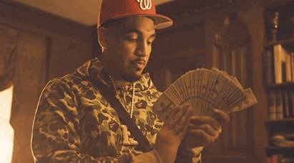

Tearing up functions with their heavy-hitting hedonism, L.A.'s favorite rap collective **Shoreline Mafia**deliver banger after banger. Giving the visual treatment to the opening track from their recent ***Party Pack Vol. 2*EP**, Shoreline Mafia shares the video for **"**[**Wings**](https://shoreline.lnk.to/WingsVideo).**"**Produced by **D.A. Doman**(Tyga's "Taste," Kodak Black's "ZEZE"), "Wings" is an addictive, speaker-knocking slapper, carried by Doman's signature manipulated vox and **OhGeesy**and **Fenix Flexin**'s DGAF witticisms: "This your b*tch? She the homie b*tch/On Instagram we flex your homie sh*t," rhymes Fenix Flexin. In the video, premiered by **Complex**, Fenix and OhGeesy hole up in a tropical mansion like Pablo Escobar, counting cash in the presence of a cadre of female bodyguards. Last night, Shoreline hosted an event for their most-devoted superfans, offering them a first look at the "Wings" music video and a chance to meet their idols.  
  
The video for "Wings" arrives as OhGeesy and Fenix Flexin prepare to embark on the **"**[**Paid In Full Tour**](https://audibletreats.us10.list-manage.com/track/click?u=02fe00e39ae585db7df9cce5e&id=71a0df7c06&e=f1d7519ce1),**"**which kicks off tonight in Edmonton. Immediately following the collective's international **"Euro Wave Tour"**, the headlining "Paid In Full Tour" will take the two Shoreline Mafia rappers coast-to-coast, topping the bill at clubs and theaters across the country. With a stop at New York's **Webster Hall**on **November 11th**, tickets for Shoreline Mafia's "Paid In Full Tour"are currently on sale.  
  
Shoreline Mafia is documenting the "Paid In Full" tour with a fan-sourced "Paid In Full Photobook." Fans attending the "Paid In Full Tour" are encouraged to take their own photos and upload them to [**https://www.hellawave.com/TourDiary/**](https://www.hellawave.com/TourDiary/), a special page on the Shoreline Mafia website for a gallery of "Paid In Full Tour" photos. The best fan photos will then be included (with full credit) in a hardcover coffee table book, eventually becoming available for sale at Shoreline concerts or at the collective's website. The upcoming Tour Diary coffee table book is a tribute to the unique bond between the band and its fans, and proves just how integral their passion is to the Shoreline operation.  
  
A tight nine-pack of radio-ready West Coast snap, *Party Pack Vol. 2*showcases the lived-in chemistry between the collective's four emcees (**Fenix Flexin, OhGeesy, Rob Vicious, Master Kato**), as they explore several unique sonic avenues within the collective's dark and minimalist sound world. With production from frequent Shoreline collaborators like **Ron-Ron**and **Ace The Face**, along with **D.A. Doman,** the project peaked at #4 on Apple Music, landing six songs on the service's Top 200 charts. The new EP peaked at #61 on the **Billboard 200**and helped propel the collective to the top 50 on **Rolling Stone**'s new **Artist 500**chart. Shoreline Mafia currently sits at #120 on that chart, with more than 13.6 million streams on their catalog in the past week.  
  
Watch "Wings": [**https://Shoreline.lnk.to/WingsVideo**](https://shoreline.lnk.to/WingsVideo)

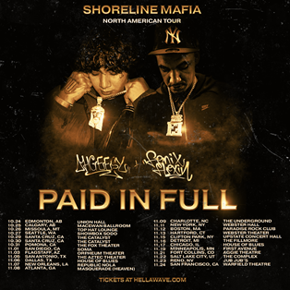

**Shoreline Mafia "Paid In Full Tour" Dates:**  
10/24 Thu - Edmonton, AB - Union Hall  
10/25 Fri - Calgary, AB - Macewan Ballroom  
10/26 Sat - Missoula, MT - Top Hat Lounge  
10/27 Sun - Seattle, WA - Showbox SoDo  
10/29 Tue - Santa Cruz, CA - The Catalyst  
10/30 Wed - Santa Cruz, CA - The Catalyst  
10/31 Thu - Pomona, CA - The Fox Theater  
11/01 Fri - San Diego, CA - SOMA  
11/03 Sun - Flagstaff, AZ - Orpheum Theater  
11/05 Tue - San Antonio, TX - The Aztec Theater  
11/06 Wed - Dallas, TX - House of Blues - Dallas  
11/07 Thu - New Orleans, LA - Republic NOLA  
11/08 Fri - Atlanta, GA - Masquerade (Heaven)  
11/09 Sat - Charlotte, NC - The Underground  
11/11 Mon - New York, NY - Webster Hall  
11/12 Tue - Boston, MA - Paradise Rock Club  
11/13 Wed - Hartford, CT - Webster Theater  
11/15 Fri - Clifton Park, NY - Upstate Concert Hall  
11/16 Sat - Detroit, MI - The Fillmore - Detroit  
11/17 Sun - Chicago, IL - House of Blues - Chicago  
11/19 Tue - Minneapolis, MN - First Avenue  
11/21 Thu - Fort Collins, CO - Aggie Theatre  
11/22 Fri - Salt Lake City, UT - The Complex  
11/23 Sat - Reno, NV - Jub Jub's  
11/24 Sun - San Francisco, CA - Warfield Theatre

**PRESS CONTACT**

[BRITTANY.BELL@ATLANTICRECORDS](mailto:BRITTANY.BELL@ATLANTICRECORDS)