FOR IMMEDIATE RELEASE
OCTOBER 27, 2020

GO “DAY TRIPPIN’ WITH PJ”

R&B SONGSTRESS KICKS OFF 3 EPISODE SERIES WITH VICE AND 76
WATCH FIRST EPISODE IN THE STUDIO HERE

VOCAL POWERHOUSE PERFORMED WITH COMMON AT VIRTUAL PLANET AFROPUNK
WATCH VIA PLANET AFROPUNK HERE

PERFORMED “DON’T FORGET” ON THE KELLY CLARKSON SHOW WITH COMMON FROM
THE NETFLIX SHOW BOOKMARKS

PJ’S EP WAITING FOR PARIS AVAILABLE NOW

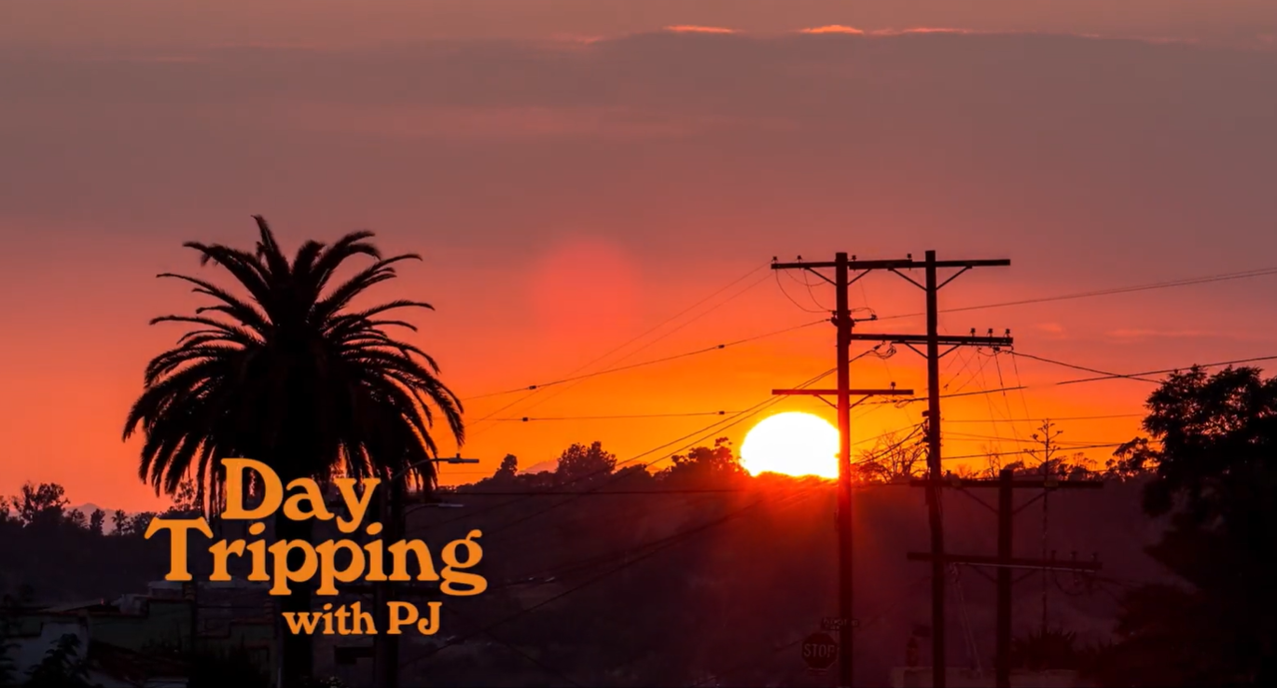
DOWNLOAD PJ’S HIGH-RES PRESS ASSETS HERE

“The award-winning singer-songwriter is making her return to remind everyone of her singing prowess and doing it with pure confidence.” – UPROXX

“With a confident, energetic, and daring vibe, “Waiting For Paris” takes dips into pop, soul, and country, all while remaining true to a classic R&B finish.” – LADYGUNN

Waiting for Paris . . . feels deeply homespun and wonderfully warm . . . The year is 2020 and PJ is no longer an underdog—she deserves household name status. – AUDIOMACK

R&B songstress PJ teamed up with VICE and 76 gas station to drop “Day Trippin’ with PJ,” a powerful three-part series giving intimate insight and details into PJ’s life as a songwriter, artist and woman in the industry. In the series, PJ will drive her own car around Los Angeles to visit places that have inspired, influenced, and impacted her since she's been in the city of angels. Drive down Sunset Boulevard with the top down and drop by the studio in the first installment In The Studio, available now via VICE HERE.

Last Saturday, Common invited PJ to perform with him at Planet AFROPUNK, the virtual festival that paid homage to the reality that the upheavals we’ve gone through over the course of the year are far from novel – they’re central to the Black experience across space and time. Watch the Black cultural explosion HERE. She also teamed up with Common to perform “Don’t Forget” on The Kelly Clarkson Show. The track is featured on the Netflix’s newest series Bookmarks – where black celebrities and artists read children's books by Black authors to spark meaningful conversations about empathy, equality, justice, self-love, and anti-racism. Some guests include Common, Jill Scott, Tiffany Haddish and more. Watch PJ and Common’s incredible performance on Kelly Clarkson HERE.

PJ also recently dropped by South LA’s Alta Adams to give her single “Element” an LA backdrop for an incredible live performance on the patio; watch HERE. “Element” was featured on season 4 for INSECURE and on the INSECURE: Music From the HBO Original Series, Season 4 soundtrack. The record was used as the music bed for Issa Rae’s EMMY nomination category for Best Lead Actress in a Comedy Series.

CONNECT WITH PJ
OFFICIAL | FACEBOOK | TWITTER | INSTAGRAM | YOUTUBE

FOR ADDITIONAL PRESS ASSETS, VISIT HER PRESS SITE HERE

PRESS CONTACT
Brittany Bell | Brittany.Bell@atlanticrecords.com

