FOR IMMEDIATE RELEASE
NOVEMBER 4, 2020

PJ AND LUTE ARE FORREAL

R&B SONGSTRESS TEAMS UP WITH LUTE FOR “I’M FORREAL” VISUAL FROM WAITING FOR PARIS EP
WATCH THE PJ & ALI ROBERTO-DIRECTED VISUAL HERE

CATCH PJ AND COMMON ON THE TONIGHT SHOW WITH JIMMY FALLON TONIGHT
LOCAL LISTINGS HERE

PJ TEAMED UP WITH VICE AND 76 FOR 3 EPISODE SERIES DAY TRIPPIN’ WITH PJ
ALL THREE EPISODES AVAILABLE NOW | WATCH HERE

PERFORMED “DON’T FORGET” ON THE KELLY CLARKSON SHOW WITH COMMON FROM
THE NETFLIX SHOW BOOKMARKS

PJ’S EP WAITING FOR PARIS AVAILABLE NOW

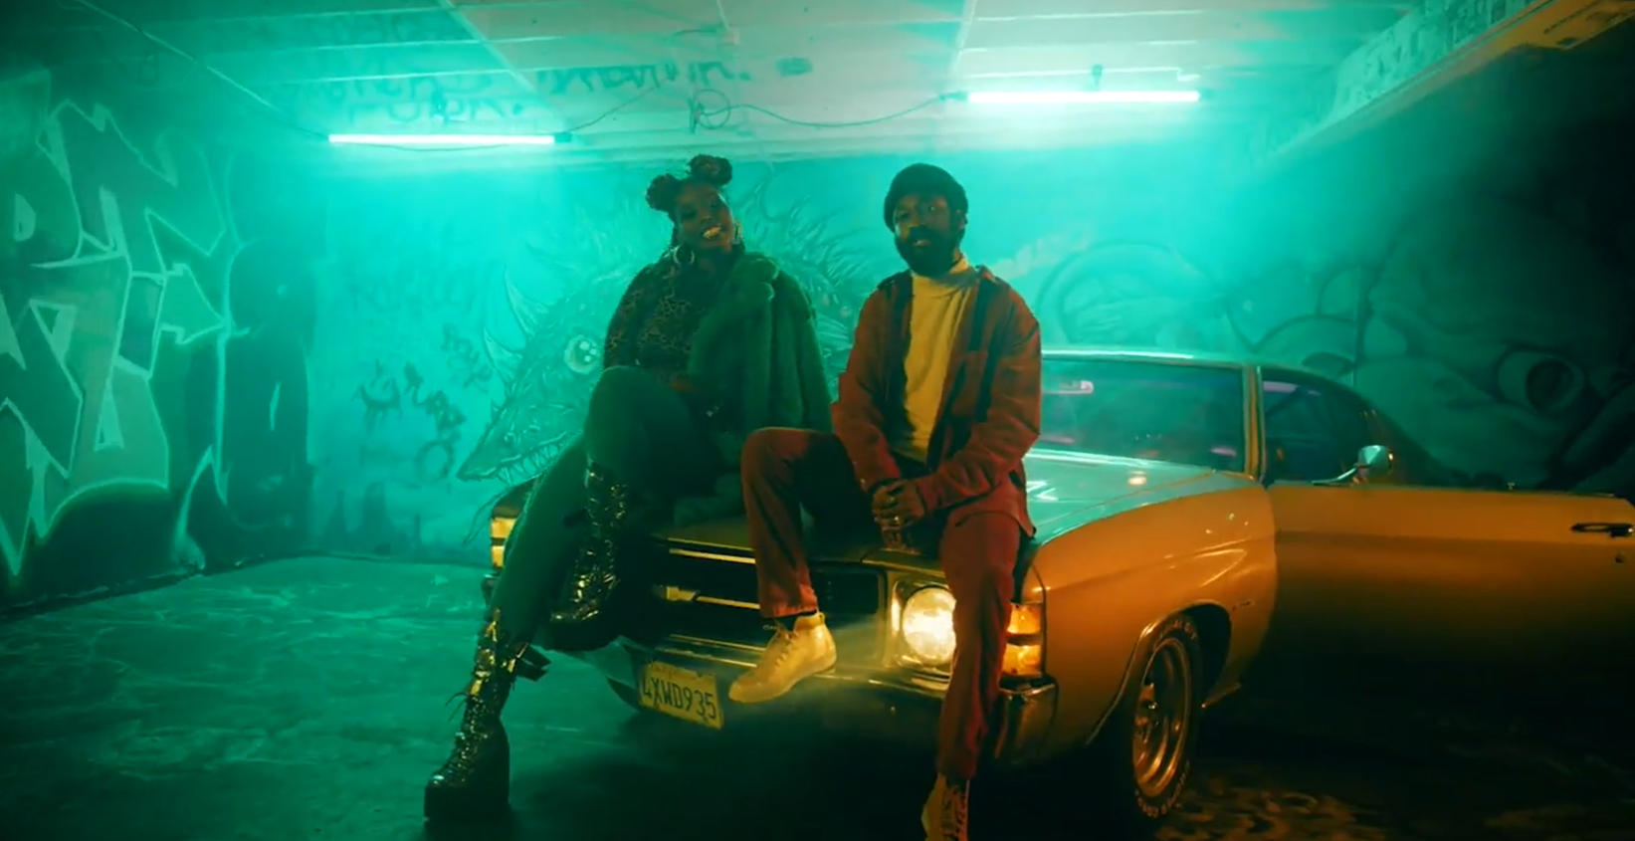
DOWNLOAD PJ’S HIGH-RES PRESS ASSETS HERE

Atlantic Records presents PJ and Lute (Dreamville/Interscope) slow it down and show you they’re for real in the latest visual from PJ’s debut EP Waiting For Paris, “I’m Forreal.” Ghetto Film School and Graff Lab teamed up with co-directors Ali Roberto and PJ to lead production in the visual, which features the two North Carolina natives holding it down Los Angeles. Watch “I’m Forreal” ft. Lute HERE. Waiting For Paris available to stream HERE.

Tune in to The Tonight Show with Jimmy Fallon tonight to catch PJ’s guest performance with Common and Black Thought. They’ll be performing “Say Peace” on Common’s recently released album A Beautiful Revolution Part 1, which features PJ on four tracks and songwriting credits on two. Listen to Common’s album HERE. Click HERE for local listings to catch PJ, Common and Black Thought on The Tonight Show with Jimmy Fallon.

Most recently, the R&B songstress teamed up with VICE and 76 gas station to drop “Day Trippin’ with PJ,” a powerful three-part series giving intimate insight and details into PJ’s life as a songwriter, artist and woman in the industry. In the series, PJ will drive her own car around Los Angeles to visit places that have inspired, influenced, and impacted her since she's been in the city of angels. Drive down Sunset Boulevard with the top down and drop by the studio in the first installment In The Studio, available now via VICE HERE. Take a trip to an LA venue that means a lot to PJ HERE and follow her journey into Joshua Tree for the final episode HERE.

She recently wrapped a 9-city Get Out To Vote Tour with Common from October 22nd to November 2nd, hitting Philadelphia, Orlando, Miami, Charleston, Atlanta, Greensboro, Houston, Charlotte, and Tampa. Further, Common invited PJ to perform with him at Planet AFROPUNK, the virtual festival that paid homage to the reality that the upheavals we’ve gone through over the course of the year are far from novel – they’re central to the Black experience across space and time. Watch the Black cultural explosion HERE. She also teamed up with Common to perform “Don’t Forget” on The Kelly Clarkson Show. The track is featured on the Netflix’s newest series Bookmarks – where black celebrities and artists read children's books by Black authors to spark meaningful conversations about empathy, equality, justice, self-love, and anti-racism. Some guests include Common, Jill Scott, Tiffany Haddish and more. Watch PJ and Common’s incredible performance on Kelly Clarkson HERE.

PJ also recently dropped by South LA’s Alta Adams to give her single “Element” an LA backdrop for an incredible live performance on the patio; watch HERE. “Element” was featured on season 4 for INSECURE and on the INSECURE: Music From the HBO Original Series, Season 4 soundtrack. The record was used as the music bed for Issa Rae’s EMMY nomination category for Best Lead Actress in a Comedy Series.

CONNECT WITH PJ
OFFICIAL | FACEBOOK | TWITTER | INSTAGRAM | YOUTUBE

FOR ADDITIONAL PRESS ASSETS, VISIT HER PRESS SITE HERE

PRESS CONTACT
Brittany Bell | Brittany.Bell@atlanticrecords.com

