FOR IMMEDIATE RELEASE
NOVEMBER 13, 2020

TAYLA PARX IS IN HER ELEMENT IN “FIXERUPPER”

MULTIPLE GRAMMY® AWARD NOMINATED ARTIST PREMIERES LASTEST TRACK + VISUAL
WATCH HERE | LISTEN HERE

PARX GAVE A HALLOWEEN SURPRISE WITH OFFICIAL “RESIDUE” VIDEO
WATCH HERE

EAGERLY-AWAITED NEW ALBUM, COPING MECHANISMS, DUE 11/20

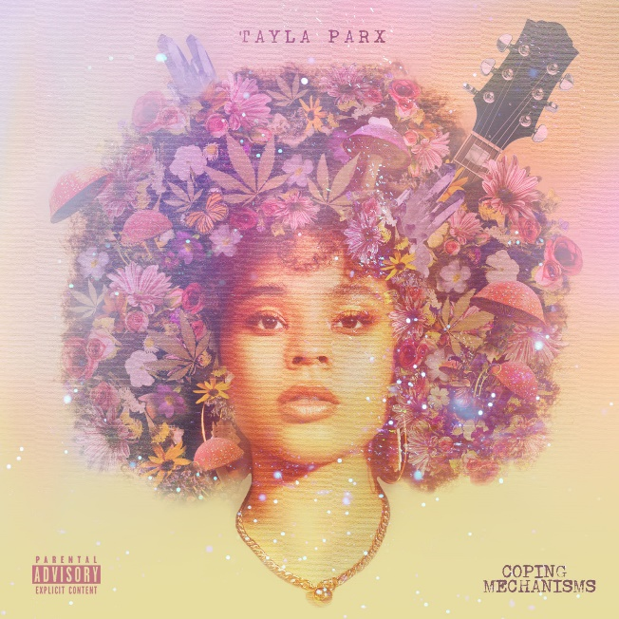
DOWNLOAD COPING MECHANISMS ARTWORK HERE

Multiple GRAMMY® Award-nominated recording artist Tayla Parx drops the third track off her forthcoming album Coping Mechanisms today. “Fixerupper” releases alongside a beautiful companion visual featuring a 70s-inspired Tayla in her classically cactus and pastel element. Watch the “Fixerupper” companion visual HERE; “Fixerupper” is available to stream and download at all streaming services HERE. The single precedes Parx’s eagerly-anticipated album, COPING MECHANISMS, due to arrive at last on November 20th.

“’Fixerupper’ marks a moment of growth,” notes Parx. “It came after I ended up meeting my next love. I recognized the need to get over some situations, be patient, and understand there are some bandages necessary to fix me up.”

Parx wrote on Ariana Grande’s sixth studio album Positions, which topped the Billboard charts within its first week. Most recently, Parx premiered her track “Residue,” which The AV Club called “[a] haunting pop jaunt... Parx’s alluring vocals, gauzy harmonies, and a particularly bewitching guitar make this curiously upbeat bit of mourning a perfect Halloween treat.” In May, Parx released her lead single “Dance Alone” to widespread critical praise as well; Variety raved that “‘Dance Alone’ has perhaps the defining chorus of 2020.” The track has currently garnered over 1.2 million Spotify steams while being featured on Michelle Obama’s #BlackGirlMagic playlist. Watch/share the music videos for “Residue” HERE and “Dance Alone” HERE.

Parx recently released A Blue State, a powerful cover compilation mini project reflecting her mood and political nuance. Parx pays homage to Kirk Franklin’s “I Smile,” Marvin Gaye’s “What’s Going On” and Lauryn Hill’s “Everything is Everything.” A Blue State is available now via Tayla Made/Atlantic at all DSPs and streaming services HERE.

ABOUT TAYLA PARX
By gently caring for herself first, Tayla Parx blossoms as an artist. As a result, the GRAMMY® Award-nominated singer, songwriter, performer, and disruptor empowers, enlightens, and emboldens audiences. Since 2017, she has transcended expectations, conventions, and boundaries, generating tens of millions of streams with each project and earning recognition from critics, peers, and fans all the way up to First Lady Michelle Obama.

Following her breakout TAYLAMADE mixtape and the success of her smash “Runaway (Feat. Khalid) (29 million streams), she made a statement on her 2019 debut album, WE NEED TO TALK. Powered by such anthems as “I Want You” (6.3 million Spotify streams), “Me Vs. Us” (1.3 million Spotify streams), and “Rebound (Feat. Joey Bada$$)” (1.2 million Spotify streams), the collection incited critical applause from Rolling Stone who observed, “The new album, like Parx’s best hits, is playful and conversational, blending pop, R&B and traces of rap.”

As her profile rose, Parx served up an unforgettable live show night after night on tour with the likes of Lizzo and Anderson.Paak. Concurrently, she established herself as a history-making force behind-the-scenes with a discography streamed over 1 billion times and counting. Christened a 2019 “Hitmaker” by Billboard, Tayla made history as the first female songwriter to log three simultaneous Top 10 entries on Billboard’s “Hot 100” since 2014 for penning Ariana Grande’s “7 Rings” and “thank u, next” and Panic! At The Disco’s “High Hopes.” Tayla’s GRAMMY® Award-nominated catalog also comprises Janelle Monáe’s DIRTY COMPUTER, Christina Aguilera’s “Like I Do (Feat. GoldLink],” The Internet’s “Ego Death,” and Hairspray.

Along the way, Parx also worked on Tayla. Rather than let a breakup break her, she took action, parlaying healthy coping mechanisms into bold bops. By doing so, she strengthened herself and her art as evidenced on her long awaited second full-length album, COPING MECHANISMS.

“I’m ever-changing,” Parx says. “I’m unwilling to let my creative side die—ever. I’m a businesswoman, I’m a brand, and I’m a human. I’m working on being a better one all the time too. I’m going to allow myself to continue to evolve. My message is, ‘It’s okay to not be okay sometimes.’ It’s also okay to be better than okay other times. Be nice to yourself. Go through those growing pains, because they enable you to become who you’re meant to be.”

# # #

CONNECT WITH TAYLA PARX
OFFICIAL | INSTAGRAM | YOUTUBE | TWITTER | FACEBOOK

CONTACT
Brittany Bell | brittany.bell@atlanticrecords.com
Chandler Owen (TOUR) | chandler.owen@atlanticrecords.com

