FOR IMMEDIATE RELEASE
NOVEMBER 24, 2020

TAYLA PARX EARNS TWO MORE GRAMMY® NOMINATIONS

ON THE HEELS OF LONG-AWAITED SECOND ALBUM
STREAM COPING MECHANISMS: TAYLAPARX.LNK.TO/COPINGMECHANISMSPR

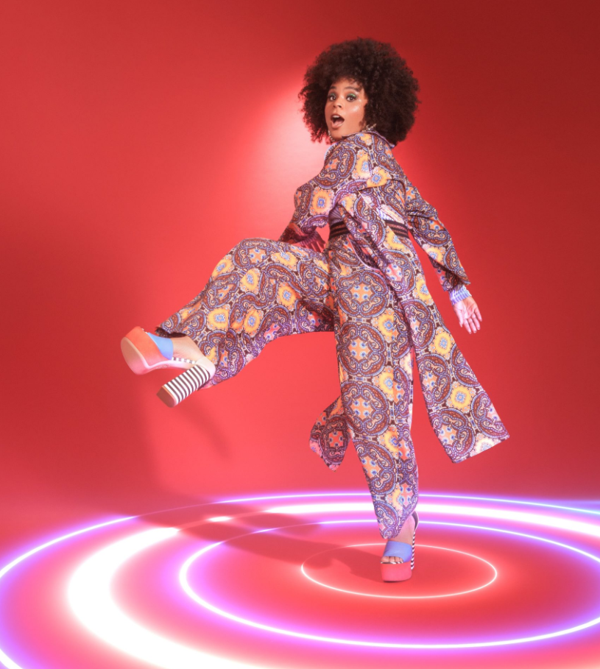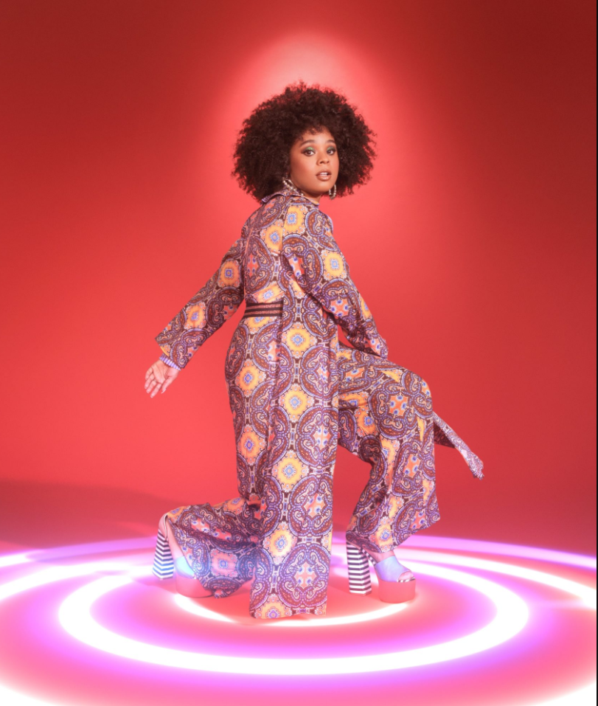
DOWNLOAD PRESS ASSETES HERE

Coping Mechanisms will prove her a force in modern music.
VULTURE

Tayla Parx has quietly shaped modern pop music. Her new album is her biggest statement yet.
INSIDER

In a time of uncertainty and anxiety, Tayla Parx is here to help you cope ... literally. Coping Mechanisms, the singer-songwriter's hotly anticipated new album, offers a wide range of pop-R&B antidotes to whatever is ailing you.
BILLBOARD

Multiple GRAMMY® Award-nominated recording artist Tayla Parx adds two additional GRAMMY® nominations to her repertoire today. She earns one with HAIM for Album of the Year and with John Legend for Best R&B Album. The exciting news drops mere days after her sophomore full-length album COPING MECHANISMS, with critical acclaim from NPR, MTV, Refinery 29 and more.

The album dropped alongside the official video to “System,” an ultra-funky, dance-filled experience directed by Joe DeSantis and produced by Jen Sanchez of WeThemUs. “Fixerupper” heralded the album alongside a dreamy, 70s pastel visual companion, which Billboard considered a “grade-A pop dance beat.” Prior, Parx premiered her track “Residue” and its spooky animated visual, which The AV Club called “a haunting pop jaunt [with] alluring vocals, gauzy harmonies, and a particularly bewitching guitar.” In May, Parx released her lead single “Dance Alone” alongside a groovy and timely companion visual to widespread critical praise as well; Variety raved that it “has perhaps the defining chorus of 2020.” The track has currently garnered over 1.7 million Spotify streams while being featured on Michelle Obama’s #BlackGirlMagic playlist and highlighted in an episode of her podcast.

Parx recently released A Blue State, a powerful cover compilation mini project reflecting her mood and political nuance. Parx pays homage to Kirk Franklin’s “I Smile,” Marvin Gaye’s “What’s Going On” and Lauryn Hill’s “Everything is Everything.” A Blue State is available now via TaylaMade/Atlantic at all DSPs and streaming services HERE.

ABOUT TAYLA PARX
By gently caring for herself first, Tayla Parx blossoms as an artist. As a result, the GRAMMY® Award-nominated singer, songwriter, performer, and disruptor empowers, enlightens, and emboldens audiences. Since 2017, she has transcended expectations, conventions, and boundaries, generating tens of millions of streams with each project and earning recognition from critics, peers, and fans all the way up to First Lady Michelle Obama.

Following her breakout TAYLAMADE mixtape and the success of her smash “Runaway (Feat. Khalid) (29 million streams), she made a statement on her 2019 debut album, WE NEED TO TALK. Powered by such anthems as “I Want You” (6.3 million Spotify streams), “Me Vs. Us” (1.3 million Spotify streams), and “Rebound (Feat. Joey Bada$$)” (1.2 million Spotify streams), the collection incited critical applause from Rolling Stone who observed, “The new album, like Parx’s best hits, is playful and conversational, blending pop, R&B and traces of rap.”

As her profile rose, Parx served up an unforgettable live show night after night on tour with the likes of Lizzo and Anderson.Paak. Concurrently, she established herself as a history-making force behind-the-scenes with a discography streamed over 1 billion times and counting. Christened a 2019 “Hitmaker” by Billboard, Tayla made history as the first female songwriter to log three simultaneous Top 10 entries on Billboard’s “Hot 100” since 2014 for penning Ariana Grande’s “7 Rings” and “thank u, next” and Panic! At The Disco’s “High Hopes.” Tayla’s GRAMMY® Award-nominated catalog also comprises Janelle Monáe’s DIRTY COMPUTER, Christina Aguilera’s “Like I Do (Feat. GoldLink],” The Internet’s “Ego Death,” and Hairspray. Further, Parx wrote on Ariana Grande’s sixth studio album Positions, which topped the Billboard charts within its first week.

Along the way, Parx also worked on Tayla – giving way to her second full-length album, COPING MECHANISMS. “I’m ever-changing,” Parx says. “I’m unwilling to let my creative side die—ever. I’m a businesswoman, I’m a brand, and I’m a human. I’m working on being a better one all the time too. I’m going to allow myself to continue to evolve. My message is, ‘It’s okay to not be okay sometimes.’ It’s also okay to be better than okay other times. Be nice to yourself. Go through those growing pains, because they enable you to become who you’re meant to be.”

COPING MECHANISMS TRACKLISTING:
- Sad
- Dance Alone
- System
- Stare
- Fixerupper
- Bricks
- Residue
- Justified Ft. Tank and The Bangas
- Nonchalant
- Nevermind
- Last Words
- You Don’t Know

# # #

CONNECT WITH TAYLA PARX
OFFICIAL | INSTAGRAM | YOUTUBE | TWITTER | FACEBOOK

CONTACT
Brittany Bell | brittany.bell@atlanticrecords.com
Chandler Owen (TOUR) | chandler.owen@atlanticrecords.com

