Last month, T.R.U. recording artist Worl was featured on his label’s Hitmaka-produced posse cut “Shoot It Out” with Sleepy Rose, 2 Chainz, and Hott LockedN.

Today he revisits his recently released Generally Speaking mixtape with a video for his fan-favorite record “Tell Me” featuring 2 Chainz.
LINK: https://smarturl.it/TellMeWorl
ICYMI: Worl’s “Off The Porch” Interview for Dirty Glove Bastard

Worl has been buzzing in the streets of Southeast Atlanta with tracks like “Insomnia,” “YAMS,” and “By the Coast” from last years Went Broke From Buying Dreams mixtape that saw fans eagerly waiting in line at his project housing to purchase a physical copy. The “street activist” is known for his “No Child Left Behind” initiative in his 4 Seasons neighborhood hosting holiday events for at-risk and abandoned youth.
“If we can get our music across to just one person, they will hopefully feel it in their hearts,” he remarks. “I’m really believing in myself and the people around me. You can hear the pain in my music. It’s real. I’d love it if audiences just want to hear more.”
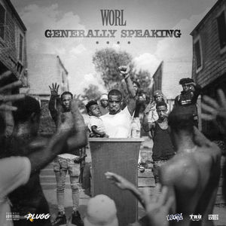
Generally Speaking is available now on all platforms.
LISTEN: https://smarturl.it/GenerallySpeaking
Look out for more music from Worl from the upcoming T.R.U. compilation album with 2 Chainz, Skooly, Sleepy Rose and Hott LockedN via their label partnership with Atlantic Records.

PRESS CONTACT
Fairley McCaskill | Fairley.McCaskill@atlanticrecords.com

