FOR IMMEDIATE RELEASE
DECEMBER 12, 2019

DON TOLIVER RETURNS WITH “CAN’T FEEL MY LEGS”

STREAM/DOWNLOAD “CAN’T FEEL MY LEGS” HERE

WATCH COMPANION VISUAL HERE

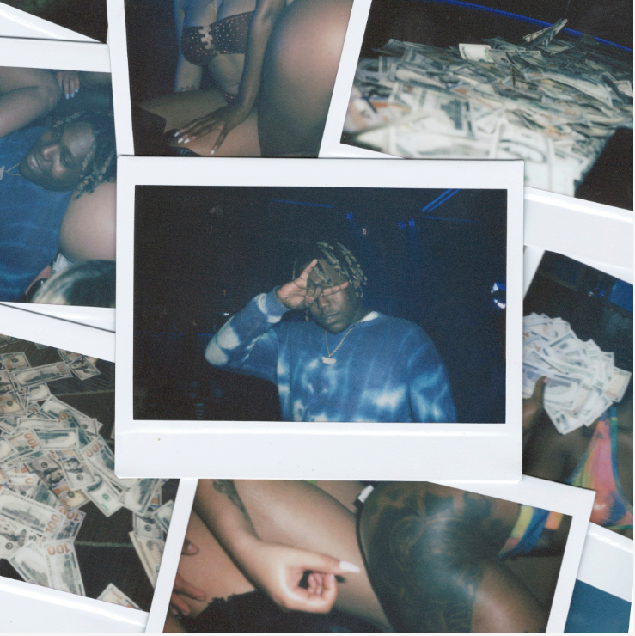
DOWNLOAD HIGH-RES COVER ART HERE

Atlantic Records and Cactus Jack recording artist DON TOLIVER, has returned with the release of his new single “Can’t Feel My Legs” available now at all DSPs and streaming services HERE. “Can’t Feel My Legs” is accompanied by an official companion visual, directed by Kenneth Cappello —watch it HERE.

In May, Toliver released “NO IDEA,” produced by Wondagurl (Travis Scott, Big Sean, Rich the Kid), and has been streamed over 50 million times to date. The single exclusively premiered on HYPEBEAST Toliver also dropped dark visuals to accompany the track, directed by Grant Singer (The Weeknd, Camilla Cabello, Lorde.) Billboard recently featured “No Idea” on its Billboard Hot 100 Songs video series – watch it HERE. The single has also exploded on TikTok, with over 30 million videos created to the sound. December has been a successful month for Toliver – “No Idea” has been streamed 14.1 million times last week (a 125% increase) and it’s accompanying music video is currently sitting at 6 million views. Toliver is also YouTube’s Artist on the Rise this week.

Toliver gained notoriety as the standout feature on TRAVIS SCOTT’S Certified Platinum track, “CAN’T SAY,” off Scott’s Grammy nominated, critically acclaimed 2018 album Astroworld. “Sometimes you don’t even need to put energy on it, ’cause everybody is already energized, so it makes you bring it. It just comes natural,” Toliver tells HYPEBEAST of “Can’t Say” during his exclusive interview last December. Toliver was given the chance to perform at Scott’s first annual ASTROWORLD FESTIVAL in their hometown Houston and was a guest on Scott’s Astroworld tour last year. Toliver will be featured in Travis Scott’s upcoming Netflix documentary.

Last summer brought Toliver’s DONNY WOMACK mixtape, a nod to legendary soul superstar Bobby Womack. The release consisted of , “DIAMONDS,” with an exclusive premiere of the video via THE FADER alongside an interview detailing Toliver’s membership in the remarkable team of collaborators contributing to Travis Scott’s hugely anticipated ASTROWORLD.

Hailed for his distinctive melding of contemporary trap with classic R&B, the arrival of DONNY WOMACK, included such acclaimed hip-hop hits as “RUN UP,” and “BACK END.”

ABOUT DON TOLIVER
Equal parts R&B and Trap (“Trap-n-B”), Don Toliver has Houston, TX in his DNA. Growing up listening to dominant regional figures like Big Mo and Mike Jones, he developed his soundscape – which includes distinct lyrical rhyme schemes combined with futuristic, forward approaches – after broadening his influences to include artists like Pharrell, Sade, Marvin Gaye, and Dom Kennedy. The result is an expressive and quick-witted artist who’s able to embody multiple vibes in one – ride out music, turn-up anthems, chill playlist, wavy jams… While he does play around with effects like auto-tune, Toliver does it more so for style vs. using it as a crutch (you’ll hear reverb and some effects to create a slightly elevated sound in areas).

“I want people to imagine everything in my music,” Toliver mentions. “I want them to take it in so they can mentally and visually feel it. My sound is so different. I’m bringing a new culture into the music game.”

CONNECT WITH DON TOLIVER
INSTAGRAM| TWITTER |FACEBOOK |YOUTUBE I SOUNDCLOUD | SPOTIFY

CONTACT
BRITTANY BELL | BRITTANY.BELL@ATLANTICRECORDS.COM

