FOR IMMEDIATE RELEASE
DECEMBER 15, 2020

YBN ALMIGHTY JAY WANTS TO “BRING OUT THE HOOCHIES”

SECOND SINGLE OFF FORTHCOMING PROJECT BATTLING MY SPIRIT

WATCH OFFICIAL “BRING OUT THE HOOCHIES” VISUAL
YBN.LNK.TO/HOOCHIESVIDEO

STREAM/DOWNLOAD “BRING OUT THE HOOCHIES”
YBN.LNK.TO/HOOCHIES

ON THE HEELS OF “SHOUTOUT TO MY DENTIST”
WATCH VIDEO | STREAM/DOWNLOAD

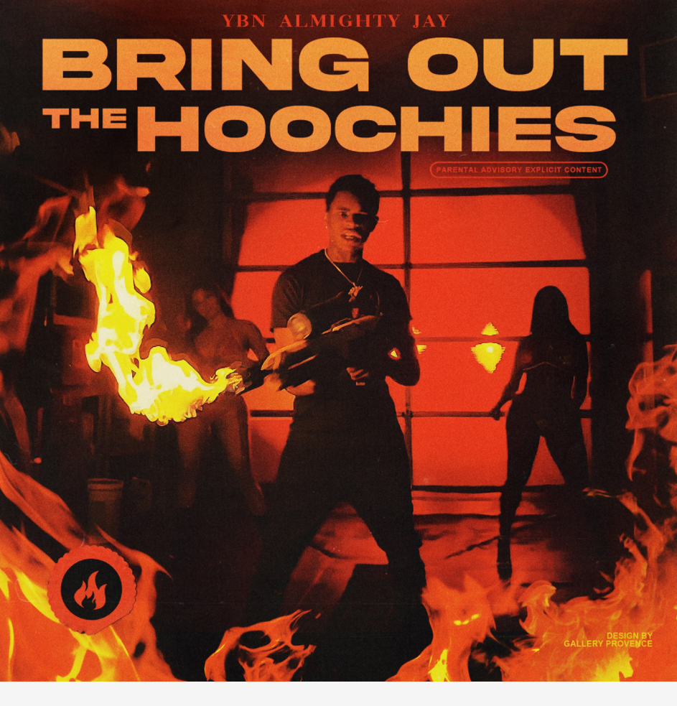
DOWNLOAD HIGH-RES COVER ART HERE

Art@War and Atlantic recording artist YBN Almighty Jay wants to “Bring Out The Hoochies” in his latest single off the forthcoming 2021 project, Battling My Spirit. Watch the Texas rapper bring out the hoochies alongside cars and flame-throwers in the official Rock Davis-directed visual HERE. “Bring Out The Hoochies” is available to stream and download on all major DSPs and streaming services HERE.

The single and visual arrives on the heels of YBN Almighty Jay’s debut single off the project, “Shoutout to My Dentist.” Hype up the dentist and take a trip to the office in the official video HERE, directed by Rock Davis. “Shoutout to My Dentist” is available to stream and download on all major DSPs and streaming services HERE.

YBN Almighty Jay inserts hard-earned wisdom between ice cold flows, clever observations, and hard-hitting hooks. He twists up the drank-induced Houston swagger of his hometown with modern trap-style lyrical fireworks. Growing up in La Marque, TX, he found himself in and out of trouble due to “being associated the wrong crowd and doing stupid shit.” He looked up to his older brother who rapped in a local group, as one of his inspirations for wanting to chase his rap dreams. He also considers Lil Wayne, Soulja Boy, and Chief Keef (whose Almighty So mixtape even inspired his moniker) some of his top musical influences. He competed on Xbox Live, roasting competitors verbally at every turn. He met YBN Nahmir on the platform and formed a unique friendship.

Two weeks before he was set to leave for the U.S. Navy, plans changed when Nahmir called. A whirlwind followed. The then, 18-year-old Jay grew up in front of the world. He made his way to Los Angeles and joined forces with Nahmir and Cordae (formerly YBN Cordae) for the gold-certified YBN: The Mixtape. Jay’s solo single “Chopsticks” clocked 44 million Spotify streams and earned praise from Pitchfork who wrote it “sounds most convincing.” He accelerated his momentum via “2 Tone Drip” and “Spaceship” before dropping 2020’s “Ooouuu” [feat. Blac Youngsta]. Amassing hundreds of millions of streams and receiving acclaim from Pitchfork, Complex, and many more, the gold-selling Los Angeles-based rapper catches listeners off guard once again with his latest, “Shoutout To My Dentist”. Be on the look out for his next project, Battling My Spirit in 2021.

ABOUT ART@WAR
ART@WAR is a record label and management company founded by entertainment executive James McMillan. ART@WAR is committed to artist development and invests in the careers of emerging musical talent of all genres to create opportunities across multiple entertainment platforms. More than a label, ART@WAR functions as an artist rights management company.

The ART@WAR label name was inspired by Sun Tzu’s stratagem and reflects the label’s “Artist First” ethos and takes a collaborative approach in building artists into multi-tiered global brands. The ART@WAR record label roster includes Cordae, YBN Nahmir, YBN Almighty Jay, SK8, Jucee Froot and Prince Taee among other bright emerging stars.

ART@WAR operates as a Limited Liability company with label and management headquarters based in New York with offices in Los Angeles.

CONNECT WITH YBN ALMIGHTY JAY
INSTAGRAM | TWITTER | WEBSITE

PRESS CONTACTS
Fairley McCaskill | Fairley.McCaskill@atlanticrecords.com

