FOR IMMEDIATE RELEASE
DECEMBER 16, 2019

4TH & ORANGE HIT THE ROAD WITH REGGAE STAR COLLIE BUDDZ

LONG BEACH OUTFIT TO SHARE THE STAGE ON FLORIDA TOUR LEG

CONTINUE TO ANNOUNCE FESTIVAL APPEARANCES FOR 2020

LISTEN TO LATEST SINGLE “ONLY YOU” HERE
COMPANION VISUAL STREAMING HERE

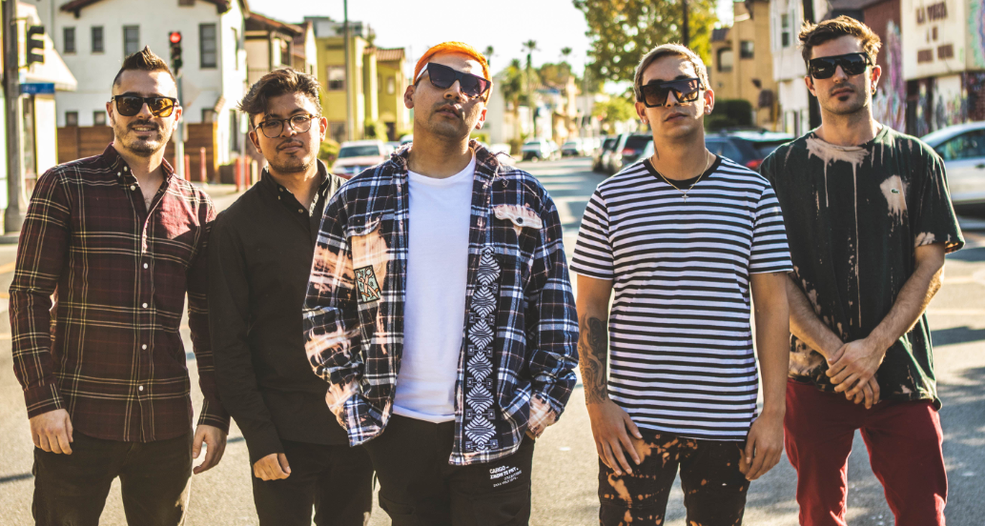
DOWNLOAD HIGH-RES PRESS PHOTOS HERE

Acclaimed reggae-rock outfit 4th & Orange will embark on their first tour run in support of Collie Buddz for dates across Florida. The Long Beach-based group will trek across the Sunshine State, hitting Miami Beach, Ft. Meyers, Ft. Pierce, Orlando, and will perform at St. Petersburg’s Reggae Rise Up Music Festival on March 22nd at Vinoy Park. Tickets will on sale to the public on Thursday, December 18th at 10am local. For complete itinerary and ticket details, see below.

4th & Orange brought some California sunshine to the big apple last month with their eagerly awaited live debut at NYC’s renowned Mercury Lounge. Check out the exclusive behind-the-scenes recap on Noisetrend. In addition, the band will appear at a number of upcoming festivals, including Long Beach, CA’s One Love Cali Reggae Fest (February 7-9); Chandler, AZ’s Arizona Roots Music & Arts Festival (February 22-23); St. Petersburg, FL’s Reggae Rise Up Music Festival (March 20-22); and Las Vegas, NV’s Reggae Rise Up Music Festival (April 18-19). Additional festival dates will soon be announced.

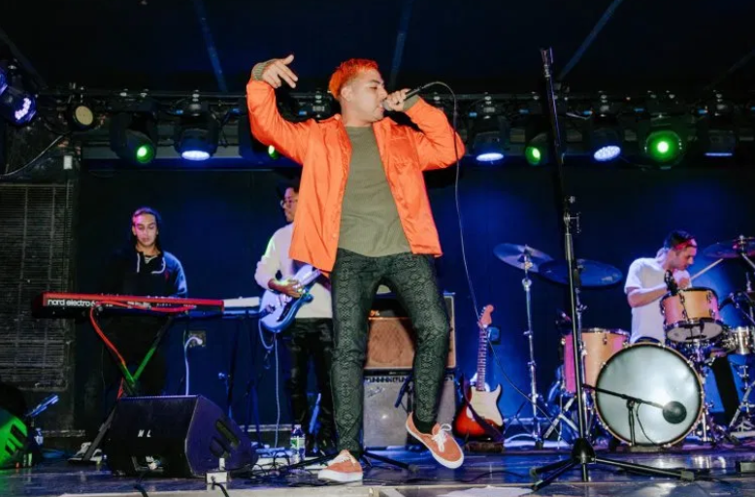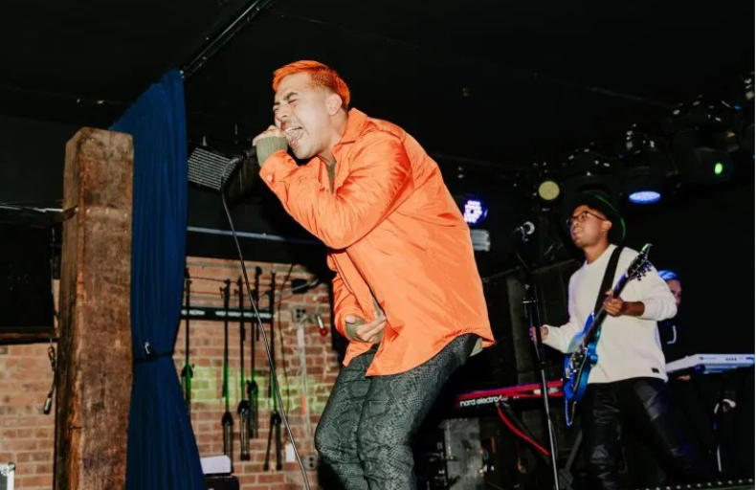
4TH & ORANGE LIVE IN NYC | NOISETREND, PHOTO CREDIT: GRACE PRACHTHAUSER

The tour announcement comes on the heels of 4th & Orange’s awaited new single “Only You,” which sees the group putting their quintessential SoCal pop-reggae touch on an undisputed classic song. The track dropped alongside an electric companion visual directed by Jose Omar. They kickstarted the summer of 2019 with their sizzling debut single, “Girl Next Door,” with an official video directed by Michael Garcia that’s now boasting more than 2.5 million individual views. The single was swiftly followed by two additional summer smashes in “No More Favors” and “Junky.”

Their debut single “Girl Next Door” arrived amidst a tidal wave of positive press attention, beginning with its exclusive premiere via Alternative Press, which wrote, “Merging pop elements with reggae in the likes of Sublime, ‘Girl Next Door’ introduces (4th & Orange’s) summery, poolside vibe along with their storytelling style that draws on relatable circumstances from real-life experiences.” “It is clear that 4th & Orange are on an exciting track for some relaxing and fun music,” wrote Poptized. “’Girl Next Door’ is an exciting first single for the band, with easy and fun music that’s perfect for your next summer backyard party or casual radio listening.” “4th & Orange is taking this summer by storm,” raved Earmilk. “For the rest of 2019, we can look forward to the group engaging with fans and providing us with even more music, hopefully sooner than we think.”

4TH & ORANGE 2020 LIVE ITINERARY
* * in support of Collie Buddz

FEBRUARY
7 Long Beach, CA One Love Cali Festival TICKETS
23 Chandler, AZ Arizona Roots Festival TICKETS

MARCH
18 Miami Beach, FL North Beach Bandshell TICKETS**
19 Fort Meyers, FL The Ranch TICKETS**
20 Fort Pierce, FL Rhumcay Resort TICKETS**
21 St. Petersburg, FL Reggae Rise Up Festival TICKETS
22 Orlando, FL Ace Café TICKETS**
APRIL
19 Las Vegas, NV Reggae Rise Up Festival TICKETS

BAND MEMBERS
Garret Douglas - Lead Vocals
Chris “DJ Irey” Garcia - Keyboards / Producer
Ricardo Santiago – Guitar
Alex Bursztyn – Bass
Sam Ward – Drums

CONNECT WITH 4TH & ORANGE
INSTAGRAM | TWITTER | FACEBOOK | YOUTUBE

For additional press assets, please visit their press site HERE.

PRESS CONTACT
Chandler Owen | Chandler.Owen@atlanticrecords.com

