FOR IMMEDIATE RELEASE
FEBRUARY 22, 2022

22Gz CELEBRATES YEAR OF THE BLIXKY WITH
THE BLIXKY TAPE 2 (DELUXE)

GROUNDBREAKING BROOKLYN DRILL RAPPER UNVEILS EXPANDED EDITION
OF BLOCKBUSTER MIXTAPE

NEW VIDEO FOR “POSSESSED,” PREMIERES TODAY

THE BLIXKY TAPE 2 (DELUXE) AVAILABLE NOW VIA SNIPER GANG/ATLANTIC

LISTEN TO “THE BLIXKY TAPE 2 (DELUXE)” | WATCH OFFICIAL “POSSESSED” MUSIC VIDEO

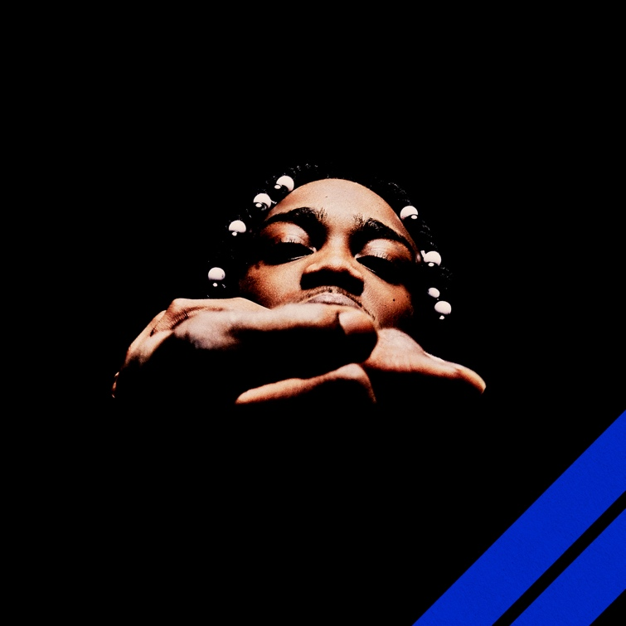

RIAA gold certified Brooklyn Drill pioneer 22Gz is celebrating his self-proclaimed “Year of the Blixky” with today’s arrival of THE BLIXKY TAPE 2 (DELUXE), a newly expanded release of his blockbuster 2021 mixtape available now via Atlantic/Sniper Gang at all DSPs and streaming services.

THE BLIXKY TAPE 2 (DELUXE) includes the brand new single, “Possessed,” available now for streaming and download alongside an official music video premiering today via YouTube.

22Gz first heralded THE BLIXKY TAPE 2 (DELUXE) earlier this month with another new single, “Said It’s Lit,” available now at all DSPs and streaming services. An official music video is streaming now at YouTube.

Released March 2021 to wide ranging national applause, THE BLIXKY TAPE 2 is highlighted by the hugely popular, RIAA gold certified single, “Twirlanta,”. The track has earned millions of worldwide streams to date and is joined by an equally potent official video, now with more than 9M views via YouTube HERE.

In addition, THE BLIXKY TAPE 2 – which features beats created by a cadre of top domestic and international producers including Reazy Renegade, Ghosty, Young Dza, Zacky Beatz, and more – also includes such hits as “Blixky Gang Freestyle Pt. 2,” “Movie (Feat. CoachDaGhost),” “Casa,” “Never Be The Same (Feat. Jackboy),” and “Fallen Blixkys,” all joined by official music videos streaming now at YouTube. Furthermore, 22Gz kept the fire going with a pair of additional 2021 smashes, “Retaliation” and “Steppers,” both of which are joined by official visuals at YouTube.

With hundreds of millions of worldwide streams and more than 106M YouTube views thus far, 22Gz stands tall at the forefront of New York Drill, consistently rewriting the rulebook with every release, leading the pack while bringing “Blixky” to the worldwide lexicon. Beyond the metallic ironclad beats, viral dances, hundreds of millions of streams, and acclaim from such high-profile outlets as Vulture, The Source, Pitchfork, and Noisey, 22Gz has cast a long shadow over the genre with a one-of-a-kind combination of menacing melodies and razor-sharp rhymes. Toughened up by the trauma of his father’s murder, the tribulations of being raised by his older sisters, and his own trouble with the law, 22Gz first lit the match for the Brooklyn Drill movement in 2017 with “Suburban,” christened by Pitchfork as “the first Brooklyn Drill song worth a damn.” A deal with Sniper Gang in partnership with Atlantic Records kicked off with 2019’s original THE BLIXKY TAPE, followed a year later by GROWTH & DEVELOPMENT, highlighted by the RIAA gold certified breakthrough, “Suburban Pt. 2,” now boasting over 31M YouTube views. In its aftermath, Complex cited 22Gz as “a trailblazer of Brooklyn drill music,” while HYPEBEAST simply stated, “22Gz is one of the main reasons Brooklyn’s drill scene made its way to the masses.”

CONNECT WITH 22Gz
22GZOFFICIAL.COM | INSTAGRAM | YOUTUBE | TWITTER | FACEBOOK
# # #

FOR PRESS INQUIRIES PLEASE CONTACT
ARIANA.WHITE@ATLANTICRECORDS.COM

