**BURNA BOY’S “PULL UP” FEATURED ON ZANE LOWE’S WORLD RECORD**

**FEATURES SINGLE**[**“JA ARA E”**](https://open.spotify.com/track/6pdip6qgVJOI5JxqgbAlu6?si=FqUc8FKkQZin9cHaOR8sxw)**ON BEYONCE’S *THE GIFT***

**BURNA BOY RECENTLY FEATURED ON MAHALIA’S “**[**SIMMER**](https://protect-us.mimecast.com/s/3z9wCDkJ8zc7YQ4qS5HSnI)**”**

**LISTEN TO “PULL UP” VIA ZANE LOWE’S WORLD RECORD** [**HERE**](https://protect-us.mimecast.com/s/io-4CyPJX0cG58JRhyB7BV)

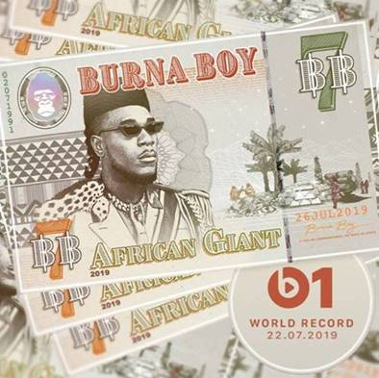

Following the release of acclaimed single **“**[**ANYBODY**](https://burna.lnk.to/AnybodyPR)**,”** **BURNA BOY** returns with another single, **“**[**PULL UP**](https://open.spotify.com/album/02YJA5p7vZv9itjHcRrV6K?si=gGhnz4cvQ1egQr-EJ6coLw)**.”** The track, which will be featured on **BURNA’S** new album **“AFRICAN GIANT”** slated to release this Friday July 26,  premiered today as**ZANE LOWE’S WORLD RECORD** on Apple Music’s **BEATS 1**.

Burna Boy recently revealed his contribution to the **BEYONCÉ**-produced **LION KING** album *The Gift* with his smooth flowing single **"**[**JA ARA E."**](https://open.spotify.com/track/6pdip6qgVJOI5JxqgbAlu6?si=FqUc8FKkQZin9cHaOR8sxw)Following on the heels of the release of the Lion King album, Burna was featured in [**BILLBOARD**](https://www.billboard.com/articles/columns/hip-hop/8520544/burna-boy-african-giant-interview)highlighting his success story!

Further, breakout UK star **MAHALIA** featured Burna Boy in her recent single and video [**“SIMMER.”**](https://atlanti.cr/Simmer-video) Directed by **KC Locke**, the visual was shot in London and showcases Mahalia glowing with confidence - all while Burna Boy attempts to defend the male's perspective. Produced by **Felix Joseph** and **Jonah Christian**, the track also contains portions of the smash **‘Playground Riddim’** which was performed by Jeffrey Harding and later sampled in Beanie Man’s iconic 1997 hit, ‘**Who Am I (Sim Simma**)’.

Burna Boy is among contemporary African music’s brightest new stars and creator of an enigmatic new genre he simply dubs “Afrofusion.” Born Damini Ogulu in Port Harcourt City, Nigeria, the gifted singer-songwriter has released a long series of EPs, singles, mixtapes, and albums including 2018’s extraordinary OUTSIDE. The award-winning collection proved Burna Boy’s U.S. breakthrough, debuting at #3 on Billboard’s “Reggae Albums” chart, fueled in part by the blockbuster single/video, “Ye,” joined by an official video streaming [**HERE**](https://www.youtube.com/watch?v=lPe09eE6Xio)**.**

Hailed by [**The FADER**](https://www.thefader.com/2018/08/06/burna-boy-ye-video-premiere) for “(mixing) pop, dancehall, and Afrobeats into its own unique thing,” Burna Boy was recently featured in YouTube’s “Artist Spotlight Series,” streaming[**HERE**](https://www.youtube.com/watch?v=GlOwFDh85TU). The Nigerian superstar also united with DJDS for the collaborative EP,[**STEEL & COPPER**](https://burna.lnk.to/SteelAndCopperID)**,** available via On A Spaceship/Our Bad Habit/Atlantic Records/Loma Vista Recordings [**HERE**](https://burna.lnk.to/SteelAndCopperID)**.** Indeed, Burna Boy has collaborated with a variety of his fellow worldwide stars, including Fall Out Boy, Lily Allen, Major Lazer, and Dave, to name but a few.

**CONNECT WITH BURNA BOY**

[TWITTER](https://twitter.com/burnaboy)

[FACEBOOK](https://facebook.com/Officialburnaboy)

[INSTAGRAM](https://instagram.com/burnaboygram)

[YOUTUBE](https://www.youtube.com/channel/UCEzDdNqNkT-7rSfSGSr1hWg/featured)

**PRESS CONTACT**

BRITTANY BELL – [BRITTANY.BELL@ATLANTICRECORDS.COM](mailto:BRITTANY.BELL@ATLANTICRECORDS.COM)