FOR IMMEDIATE RELEASE

FRIDAY, JULY 26, 2019

**4TH & ORANGE RETURNS WITH “NO MORE FAVORS”**

***POP-ROCK REGGAE OUTFIT DROPS SOPHOMORE SINGLE + VINTAGE VISUAL***

***WATCH/STREAM “NO MORE FAVORS” AVAILABLE*** [***HERE***](https://atlantic.lnk.to/NoMoreFavorsPR)

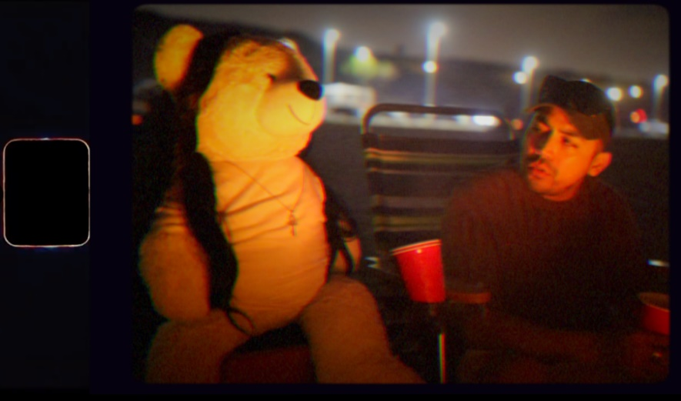

*DOWNLOAD HIGH-RES VIDEO STILL* [*HERE*](https://warnermusicgroup.box.com/s/rd28hxdyoy4w73zrqhyyixv53tvp4ihu)

*DOWNLOAD SINGLE ARTWORK* [*HERE*](https://drive.google.com/drive/folders/1fRyp83ggbjmsc0FpdqO7PWg_m_5Imidt)

Long Beach, CA-based pop-rock reggae group 4th & Orange unveiled their sophomore single of the summer “[**No More Favors**](https://atlantic.lnk.to/NoMoreFavorsPR)” via Latium Entertainment and Atlantic Records. The track is accompanied by a nostalgia-inspired official visual on the beach, exuding old-school home video vibes. “**No More Favors**” is available now via all digital music retailers and streaming services.

“No More Favors” arrives on the heels of the group’s debut single “[Girl Next Door](https://atlantic.lnk.to/GirlNextDoorIA),” whose accompanying [official music video](https://www.youtube.com/watch?v=6S9cpWTOYcw) recently surpassed two-million views via YouTube. Co-produced by GRAMMY® Award-nominee DJ Flict (Sublime w/Rome, Wiz Khalifa, Lauryn Hill, Fifth Harmony) and DJ Irey, “No More Favors” showcases 4th & Orange’s expert gift for fusing quintessential summertime pop-rock reggae with urban, ska, and hip-hop characteristics – fashioning an out-of-the-box sound that’s uniquely their own.

4th & Orange was co-founded by longtime friends Garrett Douglas and Chris “DJ Irey” Garcia with a goal of merging inspiration from hometown heroes, Sublime, with their own individual style to craft a fresh sound. Douglas and DJ Irey’s friendship began while playing high school football, their shared passion for music providing solace from their troubled home lives. Each soon went on to forge their own path in the music industry – Douglas took on the moniker ‘Beach Boy’ and became a successful songwriter, DJ Irey a successful producer. The two reunited in early 2019, determined to take their decade of industry experience and put their creative energy into a project all their own.

“The goal of our music is to bring light to others in dark situations,” says Douglas. “Both Irey and I came from a rough past, but that’s how we connected and created 4th & Orange. Our music reminds others that in the dark you can be the light.”

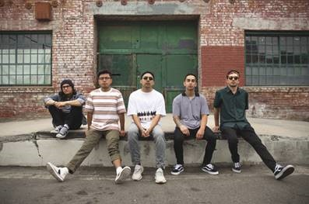

High-res press photo download [here](https://warnermusicgroup.app.box.com/s/12xpyv7cqtori1j1s0ger21mwloglgy1)

Photo credit: Monique Chavez

**4TH & ORANGE IS**

Garrett Douglas – Lead

Chris “DJ Irey” Garcia – Keyboards / Producer

Ricardo Ramirez – Guitar

Jacob Lucero – Bass

Sam Ward – Drums

**CONNECT WITH 4TH & ORANGE**

[Instagram](https://protect-us.mimecast.com/s/P4tBClYM7zcwnPnYiq8viJ) | [Twitter](https://protect-us.mimecast.com/s/LXCaCmZMyAsoJPJQHQcYhC) | [Website](https://protect-us.mimecast.com/s/drmYCn5NOBtZO3ORHEaCw7) | [Press Site](http://press.atlanticrecords.com/4th-orange/)

**PRESS CONTACT**

Chandler Owen | [chandler.owen@atlanticrecords.com](mailto:chandler.owen@atlanticrecords.com)