FOR IMMEDIATE RELEASE

AUGUST 2, 2018

**DON TOLIVER UNVEILS *DONNY WOMACK***

***HOUSTON, TX-BASED TRAP-N-B ARTIST RELEASES EAGERLY AWAITED DEBUT MIXTAPE***

***NEW TRACK, “DIAMONDS,” PREMIERES TODAY***

***RISING STAR NAMED TO SWISHER SWEETS ARTIST PROJECT’S HOUSTON PACK,***

***WITH VOTING NOW UNDERWAY*** [***HERE***](https://ap.swishersweets.com/houston/)

**DONNY WOMACK *AVAILABLE NOW AT ALL DSPS AND STREAMING SERVICES***

***DOWNLOAD*** [***HERE***](https://dontoliver.lnk.to/DonnyWomack)

***[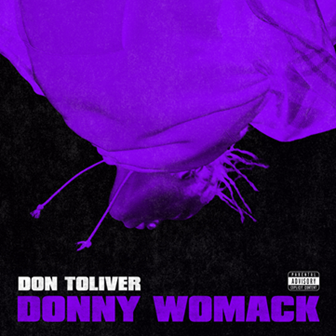](https://warnermusicgroup.box.com/s/6nx169zrtuj4kl2ue06yokybbsbg58yd)***

Houston, TX-based Trap-n-B artist Don Toliver has announced the release of his eagerly awaited debut mixtape. [DONNY WOMACK](https://dontoliver.lnk.to/DonnyWomack) is available now via We Run It Entertainment at all DSPs and streaming services.

DONNY WOMACK – a nod to legendary soul superstar Bobby Womack – includes the new track release, “Diamonds.” The track and video premiered exclusively via [THE FADER](http://www.thefader.com/2018/08/02/don-toliver-travis-scott-diamonds-video-premiere?utm_source=tftw) alongside a new interview detailing Toliver’s membership in the remarkable team of collaborators contributing to Travis Scott’s hugely anticipated ASTROWORLD.

A number of tracks heralded the arrival of DONNY WOMACK, including such acclaimed hip-hop hits as “[Run Up](https://dontoliver.lnk.to/RunUp),” “[Back End](https://dontoliver.lnk.to/BackEnd),” and “[Holdin’ Steel (Feat. Dice Soho)](https://dontoliver.lnk.to/HoldinSteel),” all available now for individual download or streaming. The latter track is joined by a new companion visual, directed by 713 Media and streaming now on Don Toliver’s official YouTube channel [HERE](https://www.youtube.com/watch?v=9M6Y7KR9H_U), after premiering on[HotNewHipHop](https://www.hotnewhiphop.com/don-toliver-and-dice-soho-are-holdin-steel-in-new-visuals-new-video.44077.html).

Hailed for his distinctive melding of contemporary trap with classic R&B, Toliver has just been named among Swisher Sweets Artist Project’s selection of Houston’s top artists, with voting now underway to determine the city’s hottest new hip-hop talent en route to a national concert competition in December (VOTE [HERE](https://ap.swishersweets.com/houston/)). Toliver will be among the stars performing at Artist Project’s Houston Pack Night, headlined by Machine Gun Kelly and featuring fellow Space City nominees J Soulja and Rizzoo Rizzoo, set for October 20th at Houston’s Numbers – tickets and additional information can be found [HERE](https://www.eventbrite.com/e/swisher-sweets-artist-project-houston-pack-night-tickets-45326165782).

As if that weren’t enough, Toliver is currently the cover artist on Deezer’s influential “[Fresh RNB](https://www.deezer.com/en/playlist/2021225582)” playlist [HERE](https://www.deezer.com/en/playlist/2021225582), with “Run Up” as its intro track ahead of such artists as Childish Gambino, The Internet, and Blood Orange.

CONNECT WITH DON TOLIVER

[INSTAGRAM](https://www.instagram.com/thedontoliver/)| [TWITTER](https://twitter.com/TheDonToliver) |[FACEBOOK](https://www.facebook.com/DonToliverMusic/) |[YOUTUBE](https://www.youtube.com/channel/UCgT01FILdWB9BsXBXKjpQ7A/featured) I [SOUNDCLOUD](https://soundcloud.com/don-toliver-the-1st-1) | [SPOTIFY](https://open.spotify.com/artist/4Gso3d4CscCijv0lmajZWs?si=Z2rQyIX3RrSqge8C-MJ11g)

**DON TOLIVER**

***DONNY WOMACK***

**(We Run It Entertainment)**

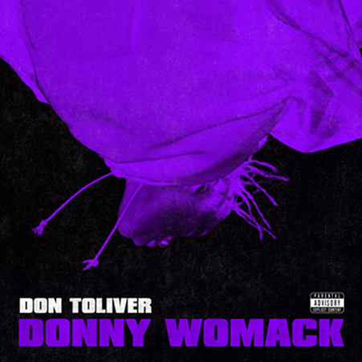

TRACKLISTING

1. Diamonds
2. Diva
3. Issues
4. Back End
5. Mama Mia
6. Holdin’ Steel (Feat. Dice Soho)
7. Bang Bang
8. Lil Shorty
9. VideoGirl
10. Around
11. AMG
12. Run Up
13. Talk No More

# # #