**A Boogie Wit Da Hoodie Releases Visual For Latest Single “Mood Swings”**

***Donates $50,000 to UNICEF USA for Hurricane Dorian Efforts, Lil Uzi Vert Promises to Match Every Additional Dollar Raised up to $50K***

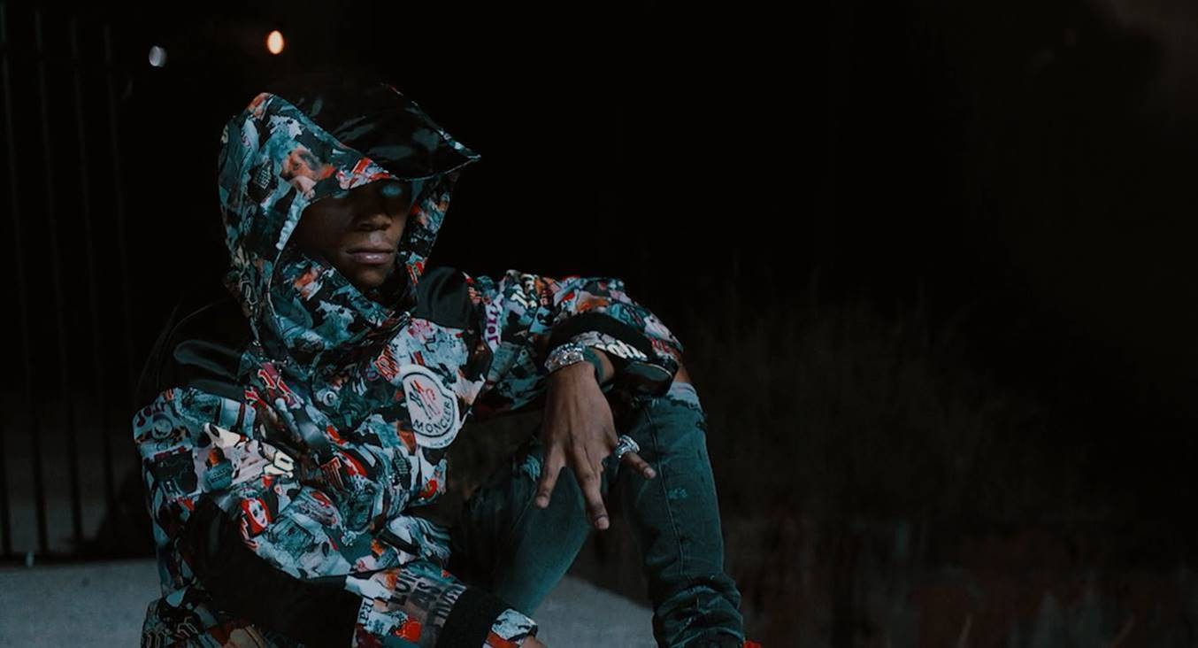

[**Click Here to Watch the Video**](https://youtu.be/8-xqc0M8C6s)

[**Click Here to Buy/Stream/Download “Mood Swings”**](https://aboogie.lnk.to/MoodSwings)

[**Click Here to Download Single Artwork**](https://www.dropbox.com/sh/e123rug9ogflj8d/AACCsbjJwJt7L099cY3HuO4Qa?dl=0)

[**Click Here to Download Hi Res Photos of A Boogie Wit Da Hoodie**](https://www.dropbox.com/sh/72l2kcdx86octzn/AABdbnT3lDSH8Ui7mqzKjS0Ka?dl=0)

**New York, New York - September 17, 2019** - Today, multi-platinum hip-hop artist and entrepreneur [**A Boogie Wit Da Hoodie**](https://www.instagram.com/artisthbtl/) **debuts his eclectic visual for the** [**just released single “Mood Swings”**](https://www.rollingstone.com/music/music-news/a-boogie-wit-da-hoodie-mood-swings-884068/)off his forthcoming album *Artist 2.0.* He also announces that he’s **donating $50,000 to UNICEF USA to aide in their Hurricane Dorian efforts on the ground in the Bahamas**.

In the video, we see A Boogie coming into his own and recognizing his strength, while not allowing women to distract him on his journey. The opening frame has him sitting down in front of a building with graffiti showcasing his signature hoodie look and recreation of the *Hoodie SZN* album cover, with neon beams in his eyes before a thunderstorm erupts. He then enters a door that changes him into a camouflage outfit surrounded by his crew with army tanks and guns as he raps, “you don’t want no problems”. This version of A Boogie walks up to an alter-ego of himself dressed in black, who is shown being played on a piano like a puppet with strings attached, by a woman that’s attracted his attention in recreation of his previous *Artist* mixtape cover. The tough camo-dressed version of A Boogie sees his alter-ego is mesmerized by her,  so he cuts off the puppet strings that she’s controlling. Right after, another side of A Boogie is snapped by the paparazzi while he goes about his rockstar lifestyle. In the final clip, he confidently enjoys the latest version of who he is, surrounded by his boys and girls since he’s got himself.

Coupled with the new video release, announced today, **A Boogie has launched a CrowdRise fundraiser to support UNICEF USA and the organization’s Hurricane Dorian relief efforts.  A Boogie has donated $50,000 and fellow rapper and friend, Lil Uzi Vert, has promised to match every additional dollar raised up to $50,000**. With the potential to bring $150,000 to these children and their families, the funds will provide relief for the Bahamian people who survived the catastrophic Category 5 hurricane, have lost their livelihoods and have been left with little to no water and food.

“The Bahamas need our help, man. You got kids and families left with nothing out there,” said A Boogie. We got to show love and support in any way we can to help rebuild that beautiful place. Every little thing helps."

To learn more about A Boogie’s CrowdRise fundraiser with UNICEF USA click [here](http://bit.ly/2kNXEIU).

**About A Boogie Wit Da Hoodie:**

The Bronx-bred rapper Artist Dubose, better known as A Boogie Wit Da Hoodie, first hit the rap scene with the breakout hit “Still Think About You” which was featured on his 2016 debut mixtape, ARTIST. The mixtape also introduced fans to “My Shit” which went on to become RIAA certified double-platinum and was also listed as one of “The Best Songs of 2016” on Apple Music. A Boogie quickly proved himself to be one of the game’s newest heavyweights after XXL dubbed him as “one of the hottest and newest up-and-comers in hip-hop” and included him in the 2017 Freshman Class. The young star also went on to release the 3x platinum “Drowning feat. Kodak Black” along with the platinum certified singles “Jungle” and “Timeless.” During the fall of 2017, A Boogie went on to release his highly anticipated, now gold certified, debut album, THE BIGGER ARTIST, which quickly sprung into the Top 5 on Billboard’s Top 200. He also became the top emerging acting in the U.S. as he simultaneously sprung to #1 on Billboard’s Emerging Artists chart. It is easy to see why The New York Times named A Boogie “the most promising young rapper the city has produced in some time.” A Boogie earned a BET Award Nomination for “Best New Artist” at the end of 2018 in addition to releasing his platinum-certified sophomore album, HOODIE SZN, which made its debut at #2 before spending three nonconsecutive weeks at #1 and maintaining a stunning 17 week streak within the top 10 on the Billboard Top 200 chart. The album also soared on streaming, garnering over 83 million streams the week it went #1. Following his latest album as well as his “A Boogie Vs. Artist” tour which wrapped with 26 of its 30 dates sold out, there’s no doubt A Boogie will continue to make waves and redefine the sound of New York rap.

**NEW PRESS PHOTO:**

*[Photo Credit: Jimmy Fontaine]*

[DOWNLOAD HIGH-RES IMAGE HERE](http://press.atlanticrecords.com/wp-content/uploads/2019/09/Main-Press-Photo-PC-Jimmy-Fontaine.jpeg)

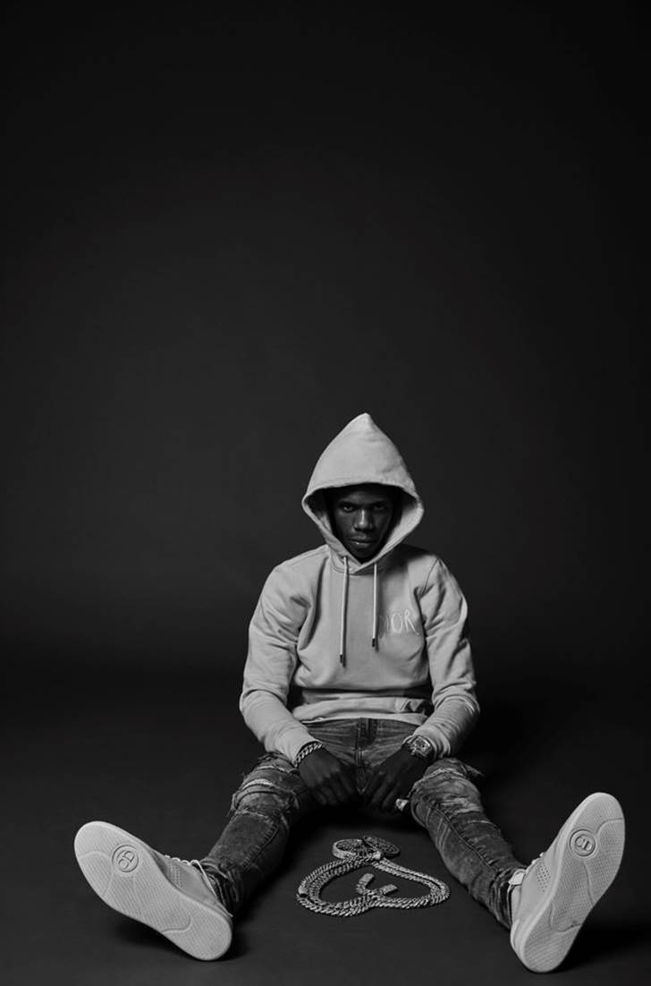

[Click here to view Twitter](https://twitter.com/ArtistHBTL)

[Click here to view Instagram](https://www.instagram.com/artisthbtl/)

[Click here to view Facebook](https://www.facebook.com/ArtistHBTL/)