**A BOOGIE WIT DA HOODIE TO RELEASE THIRD STUDIO ALBUM**

***ARTIST 2.0* OUT FEBRUARY 14TH**

**LATEST SINGLE** [**“KING OF MY CITY”**](https://www.youtube.com/watch?v=gnBBEv5a-F8) **OUT NOW ALONGSIDE STUNNING MUSIC VIDEO**

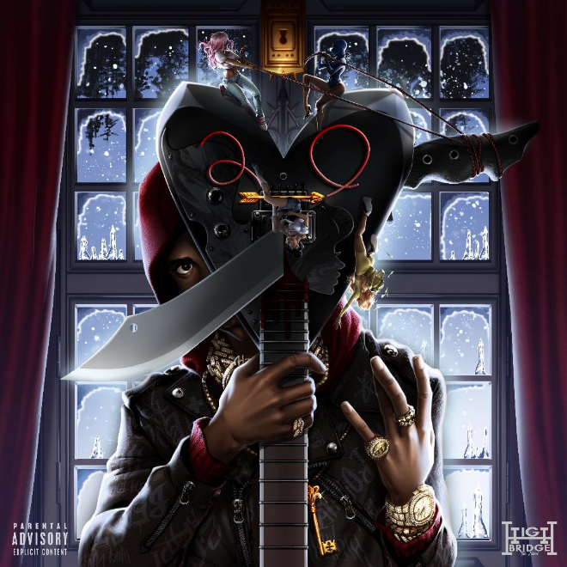

[**DOWNLOAD ARTWORK HERE**](https://press.atlanticrecords.com/wp-content/uploads/2020/02/artist-2.0-cover.jpg)

**New York, NY – Monday, February 10th –** Multi-platinum recording artist **A Boogie Wit Da Hoodie** has announced the release date of his third studio album, ***Artist 2.0***, which is scheduled to drop this Friday, February 14th.

The Valentine’s Day release will follow a string of successful singles from the Bronx-born superstar. Just over a week ago, A Boogie offered a glimpse at ***Artist 2.0*** with his new single and companion visual for **“King of My City,”** an ode to his Highbridge, NY upbringing – [**WATCH HERE**](https://www.youtube.com/watch?v=gnBBEv5a-F8).

**“King of My City”** succeeds two one-off singles released late last year by the streaming phenomenon including **“Reply (Feat. Lil Uzi Vert)”** and **“Mood Swings,”** the latter of which spawned an eclectic music video to match.

***Artist 2.0*** is the highly anticipated follow-up to A Boogie’s groundbreaking, RIAA platinum-certified sophomore LP, ***Hoodie SZN*,** which spawned the 2X RIAA certified-platinum “Look Back At It,” RIAA certified-platinum “Startender,” 3x RIAA certified-platinum “Swervin,” RIAA certified-gold “Demons & Angels,” and RIAA certified-gold “Love And Drugs.”

***About A Boogie Wit Da Hoodie:***

The Bronx-bred artist Artist Dubose, better known as A Boogie Wit Da Hoodie, first hit the rap scene with the breakout hit “Still Think About You” which was featured on his 2016 debut mixtape, ARTIST. The mixtape also introduced fans to “My Shit” which went on to become RIAA certified platinum and was also listed as one of “The Best Songs of 2016” on Apple Music. A Boogie quickly proved himself to be one of the game’s newest heavyweights after XXL dubbed him as “one of the hottest and newest up-and-comers in hip-hop” and included him in the 2017 Freshman Class. The young star also went on to release the 3x platinum “Drowning feat. Kodak Black” along with the platinum certified singles “Jungle” and “Timeless.” During the fall of 2017, A Boogie went on to release his highly anticipated, now gold certified, debut album, THE BIGGER ARTIST, which quickly sprung into the Top 5 on Billboard’s Top 200. He also became the top emerging acting in the U.S. as he simultaneously sprung to #1 on Billboard’s Emerging Artists chart. It is easy to see why The New York Times named A Boogie “the most promising young rapper the city has produced in some time.” A Boogie earned a BET Award Nomination for “Best New Artist” at the end of 2018 in addition to releasing his gold-certified sophomore album, HOODIE SZN, which made its debut at #2 before spending three nonconsecutive weeks at #1 and maintaining a stunning 17-week streak within the top 10 on the Billboard Top 200 chart. The album also soared on streaming, garnering over 83 million streams the week it went #1. Following his latest album as well as his sold out “A Boogie Vs. Artist” tour, there’s no doubt A Boogie will continue to make waves and redefine the sound of New York rap.

**NEW PRESS PHOTO:**

***[Photo Credit: Xavier Codie]***

[**DOWNLOAD HERE**](https://app.box.com/s/5s9f6c99z675bdagbn5y6gri0zte2n8t)

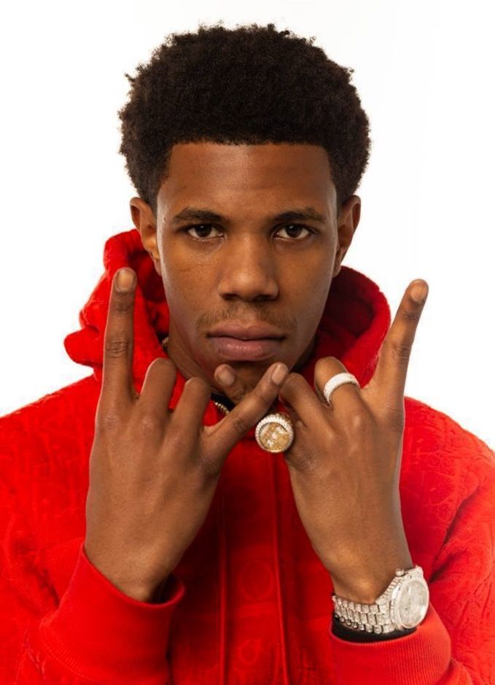

**CONNECT WITH A BOOGIE WIT DA HOODIE:**

[INSTAGRAM](https://www.instagram.com/artisthbtl/?hl=en) | [TWITTER](https://twitter.com/ArtistHBTL?ref_src=twsrc%5Egoogle%7Ctwcamp%5Eserp%7Ctwgr%5Eauthor) | [FACEBOOK](https://www.facebook.com/ArtistHBTL/) | [YOUTUBE](https://www.youtube.com/channel/UCfgsFOdVScKetBXYrFNr5LQ) | [PRESS SITE](http://press.atlanticrecords.com/a-boogie-wit-da-hoodie/)

**PRESS CONTACT:**

JASON DAVIS | [JASON.DAVIS@ATLANTICRECORDS.COM](mailto:JASON.DAVIS@ATLANTICRECORDS.COM)