FOR IMMEDIATE RELEASE
OCTOBER 11, 2019

A R I Z O N A RETURNS WITH ASYLUM
& UNVEILS NEW VIDEO FOR “PROBLEMS”

ACCLAIMED ALT/ELECTRONIC TRIO UNVEIL EAGERLY AWAITED NEW ALBUM

WATCH ELECTRIFYING NEW VIDEO FOR THE EMOTIONALLY CHARGED SINGLE, “PROBLEMS”

NORTH AMERICAN LIVE DATES TO BE ANNOUNCED SOON

ASYLUM AVAILABLE NOW HERE

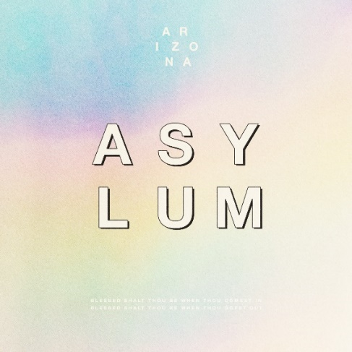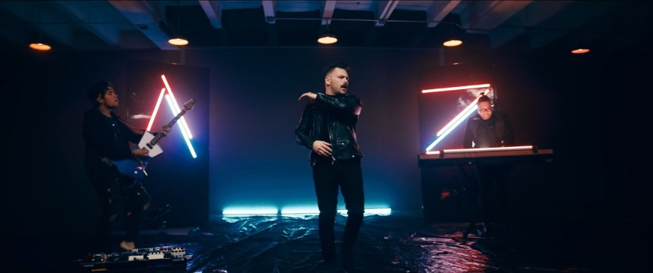

Atlantic recording group A R I Z O N A are back today with their highly-anticipated sophomore album – ASYLUM - available now at all DSPs and streaming services HERE.

ASYLUM – which follows the NJ-based trio’s hugely successful 2017 debut album, GALLERY – features the emotionally charged bop “Problems” as well as previously released tracks, “Find Someone,” “Nostalgic,” and “Freaking Out.” “Problems” is joined by an electrifying, retro-inspired companion video streaming now at the official A R I Z O N A YouTube channel HERE.

“’Problems’ is one of my favorite songs on the album” Zachary shares. “We are all constantly experiencing growth, so we are never exactly where we want to be in our lives and that is okay. Even though there is a dark side to this song, making it energetic and bright like we did was a way to celebrate the changes in our lives. We hope that the listeners know they are not alone if they are feeling imperfect, because we all feel that way. We all have problems.”

Fusing groundbreaking pop technique with creative visual design and uncommon textural depth, ASYLUM sees A R I Z O N A driving their signature approach to remarkable new heights. Multi-faceted tracks such as “Problems” and “Still Alive” reveal a profound and powerful sense of community, fueled in part by the band’s exploration of their own interpersonal relationship.

“We chose the word ‘asylum’ as our album title, as we found ourselves in a place where we felt the pressure of album two,” says A R I Z O N A’s David Labuguen. “The pressure of following up, of creating something great, of making sure we don't alienate our fanbase while creating something new and fresh – the classic sophomore album dilemma. For us, we had to re-think our friendship. We had to reevaluate the way we work. We had to check in with ourselves, and center back on why we do this in the first place. We had to take our bond as A R I Z O N A and invoke asylum for ourselves as people. It was a physical, mental, and spiritual journey to reconcile the situation, both within ourselves as individuals, and with the world as a band.”

A R I Z O N A celebrated ASYLUM with a pair of exclusive album release events, the first last night in New York City, and an additional event tonight in Los Angeles. In addition, the band is slated for a pair of upcoming festivals, including Monterrey, Mexico’s Tecaté Live Out 2019 (October 19th) and Tucson, AZ’s Dusk Music Festival (November 9th-10th). Additional live dates will be announced soon. For updates, please visit https://thisisarizonamusic.com/#tour.

With over a billion worldwide streams and counting, A R I Z O N A has proven a true planetary phenomenon, creating worldwide waves with their ingenious brand of contemporary electronic dance pop. The trio first came together at Boston’s prestigious Berklee College of Music, their shared interests in production and songwriting uniting them as much as their mutual New Jersey heritage. Songs like “Where I Wanna Be“ soon drew millions of multi-platform streams as well as a fervent online following from London to Los Angeles, Stockholm to Singapore. Signed to Atlantic/APG in 2015, GALLERY proved among 2017’s biggest global releases, now boasting over 750 million worldwide streams. The album showcases a stunning collection of hit singles, among them “Electric Touch,” “I Was Wrong,” and the RIAA gold certified “Oceans Away,” all of which are joined by creative companion videos streaming now at A R I Z O N A’s hugely popular YouTube channel HERE.

2018 saw A R I Z O N A return with a string of new singles and remixes, including “What She Wants,” and the double-A sided “Summer Days“ and “Freaking Out,” all available now for streaming and download.

In addition, A R I Z O N A can be heard on Avicii’s recently released “Hold The Line (Feat. A R I Z O N A),” found on the late artist’s posthumous album, TIM. The track – which was immediately added to Spotify’s Today’s Top Hits playlist – was met by widespread critical acclaim, with Rolling Stone praising the song as “a powerful confrontation of loss and grief.” A R I Z O N A marked the track’s summer release with a powerful acoustic performance video of the song, dedicated to Avicii, streaming HERE following its exclusive premiere via SPIN.

A R I Z O N A have spent much of past few years on the road, including a sold out series of increasingly larger headline tours – the first of which completely sold-out three months in advance, with some shows selling out within minutes of going on sale – as well as a North American arena tour supporting Panic! At The Disco, and spectacularly well-received festival sets at such gatherings as Lollapalooza, Music Midtown, ACL, Bunbury, Bonnaroo, Hangout Music Fest, BottleRock Napa Valley, Firefly, Budweiser Made In America Festival, and Governors Ball, to name but a few. Perhaps FORBES said it best: “If you haven’t seen A R I Z O N A, you’re missing out.”

A R I Z O N A is: Nathan Esquite, David Labuguen, and Zachary Charles.

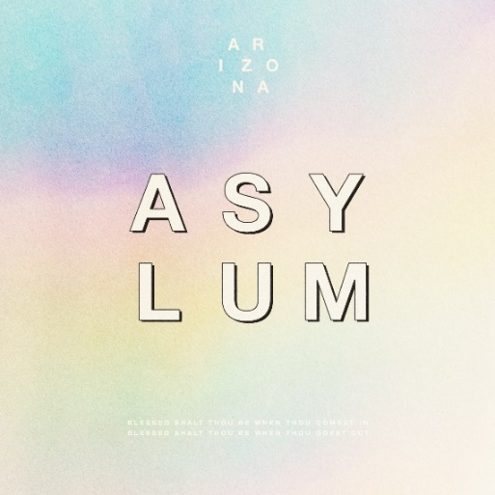

ASYLUM TRACKLIST

1. Let Me Know
2. Nostalgic
3. Where You Are
4. Don’t Leave
5. Find Someone
6. Trouble
7. Problems
8. Freaking Out
9. Still Alive

CONNECT WITH A R I Z O N A
THISISARIZONAMUSIC.COM
TWITTER
FACEBOOK
YOUTUBE
INSTAGRAM

