A R I Z O N A UNVEILS “NOSTALGIC” VIDEO FOR LATEST SINGLE
WATCH HERE: https://lnk.to/NostalgicPR

ALT/ELECTRONIC TRIO’S SINGLE GETS NEW VISUAL STIRRING UP ALL THE FEELS

“NOSTALGIC” FOLLOWS A R I Z O N A’S ACCLAIMED COLLABORATION WITH AVICII “HOLD THE LINE”

LIVE SCHEDULE INCLUDES BUMBERSHOOT, LIFE IS BEAUTIFUL & TECATE LIVE OUT

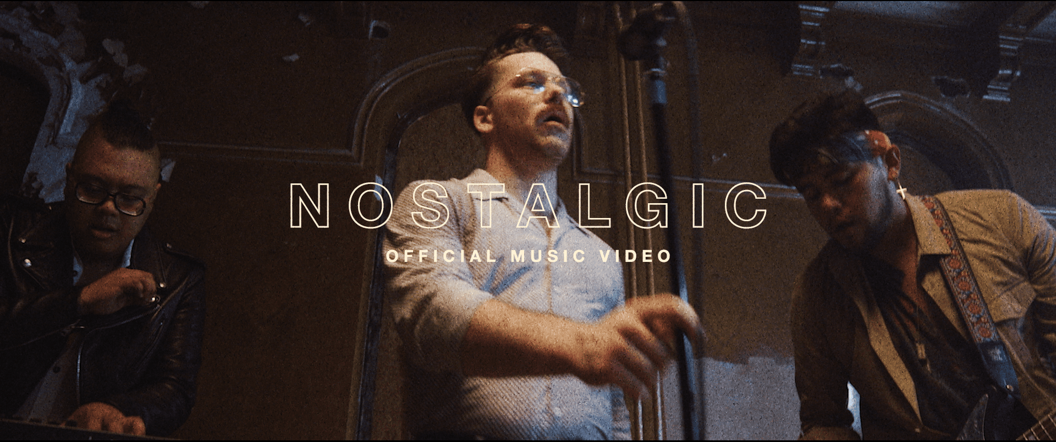

Today, alt/electronic trio A R I Z O N A released the visual for their latest single “Nostalgic.” The incredibly catchy, sentimental bop with over 11 million streams is accompanied by a new emotion-stirring video; watch HERE. “Nostalgic” is also available at all DSPs and streaming services HERE.

“Nostalgic” arrived this summer on the heels of A R I Z O N A’s emotional and powerful collaboration with Avicii, “Hold The Line,” which was released on the artist’s posthumous album TIM. “Hold The Line” was added to Spotify’s Today’s Top Hits playlist last week after immediately being met with wide critical acclaim. Rolling Stone praised the song as “a powerful confrontation of loss and grief,” while NY TIMES added, “the track has the rising, twinkling, intrinsically hopeful keyboard tones that Avicii brought to so many of his productions.” Upon the song’s release A R I Z O N A posted a beautiful acoustic performance video of the song, dedicated to Tim, that premiered on SPIN.

Earlier this summer, the critically-acclaimed band took their undeniably energetic live show across North America, selling out every night of their massive nationwide headline Find Someone Tour. A R I Z O N A’s upcoming live schedule includes major festival appearances at Bumbershoot in Seattle, WA, Life Is Beautiful in Las Vegas, NV and Tecaté Live Out in Monterrey, Mexico. Full schedule below.

A R I Z O N A ON TOUR 2019
*denotes festival appearance
DATE | MARKET | VENUE
8/17/2019 | Montauk, NY | Surf Lodge
8/30/2019-9/1/2019 | Seattle, WA | Bumbershoot 2019*
9/6/2019 | New Albany, OH | A&F Challenge*
9/20/2019 | Las Vegas, NV | Life Is Beautiful*
9/21/2019 | Santa Ana, CA | The Observatory
10/19/2019 | Monterrey, Mexico | Tecate Live Out*
11/9/2019-11/10/2019 | Tucson, AZ | Dusk Music Festival*

ABOUT A R I Z O N A

With over a billion worldwide streams and counting, A R I Z O N A has proven a true planetary phenomenon, creating worldwide waves with their ingenious brand of contemporary electronic dance pop. The trio first came together in college in 2015, their shared interests in production and songwriting uniting them as much as their mutual New Jersey heritage. Their early songs like “Where I Wanna Be“ soon drew millions of multi-platform streams as well as a fervent online following from London to Los Angeles, Stockholm to Singapore. Their debut album “GALLERY“ showcases a stunning collection of hit singles, among them “Electric Touch,” “I Was Wrong,” and the RIAA gold certified “Oceans Away,” all of which are joined by compelling companion videos streaming now at A R I Z O N A’s hugely popular YouTube channel HERE.

2018 saw A R I Z O N A return with a string of new singles and remixes, including “What She Wants,” and the double-A sided “Summer Days“ and “Freaking Out,” all available now for streaming and download. The band kicked off 2019 with their catchy single “Find Someone,” which debuted alongside their most adorable video to-date, watch here.

A R I Z O N A has spent much of past few years on the road on a sold-out series of increasingly larger headline tours – the first of which completely sold-out three months in advance, with some shows selling out within minutes of going on sale – a North American arena tour supporting Panic! At The Disco, which will continue in Europe this month, and a multitude of insanely massive festival sets at Lollapalooza, Austin City Limits, Bonnaroo, Corona Capital and many more. Perhaps FORBES said it best: “If you haven’t seen A R I Z O N A, you’re missing out.”

A R I Z O N A is: Nate Esquite, David Labuguen, and Zachary Charles.

CONNECT WITH A R I Z O N A
THISISARIZONAMUSIC.COM
TWITTER
FACEBOOK
YOUTUBE
INSTAGRAM

