FOR IMMEDIATE RELEASE
NOVEMBER 20, 2019
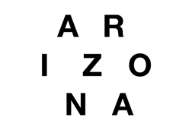

A R I Z O N A RELEASE MUSIC VIDEO FOR NEW TRACK “STILL ALIVE”

NEW ALBUM ASYLUM AVAILABLE NOW HERE

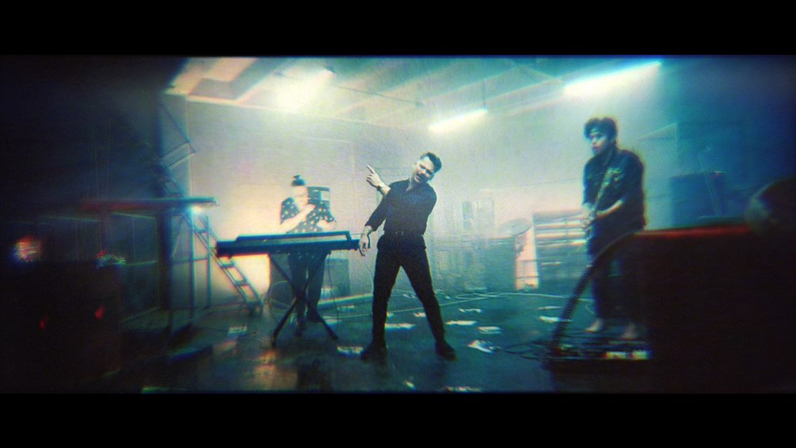

WATCH THE “STILL ALIVE” MUSIC VIDEO HERE
LISTEN TO THE ASYLUM ALBUM HERE

Today, Atlantic/APG recording band A R I Z O N A unveil the music video for their emotionally charged track “Still Alive”. The video, which premieres on VMAN, is their latest visual off their critically acclaimed sophomore album, ASYLUM.

The powerful track touches on overcoming hardships and the chorus backs it up by declaring, “I just won't die...baby, I'm still alive.” The video’s entrancing colors, hypnotizing lights, and old-school static coincides with every beat to emphasize the message A R I Z O N A is sharing in “Still Alive”.

“’Still Alive’ punctuates the idea that you’re going to go through these crazy moments in life and these weird times - bad things and good things. The message in that song is even though you go through those things, you don’t have to lose your fight,” says Zachary Charles about the track.

Following the arrival of their sophomore album ASYLUM, which generated over 100 million streams and counting, A R I Z O N A dropped a series of performance videos for their single “Problems,” which exceeded 8 million streams globally in addition to nearly 1 million video views and “Where You Are”, which racked up close to 200,000 video views. Additionally, the band continues to garner widespread acclaim. Billboard praised “Problems” as “a perfect introduction...the song perfectly encompasses the overall feel of the album.” Idolator raved, “The follow-up to 2017’s breakout release GALLERY features a wealth of thoughtful electro/alt-pop anthems.”

About A R I Z O N A:
With over a billion worldwide streams and counting, the New Jersey trio A R I Z O N A – Nathan Esquite, David Labuguen, and Zachary Charles – has proven a true planetary phenomenon, creating worldwide waves with their ingenious brand of contemporary electronic dance pop. Signed to Atlantic/APG in 2015, their debut GALLERY emerged among 2017’s biggest global releases, boasting over 750 million worldwide streams. The album showcases a stunning collection of hit singles, among them “Electric Touch,” “I Was Wrong,” and the RIAA gold-certified “Oceans Away.” In addition, A R I Z O N A can be heard on Avicii’s recently released “Hold The Line (Feat. A R I Z O N A),” from the late artist’s posthumous album, TIM. 2019’s ASYLUM sees them brilliantly and boldly build on this foundation with “Freaking Out,” “Nostalgic,” “Problems,” “Where You Are,” and more.

A R I Z O N A have spent much of the past few years on the road, including a sold out series of headline tours, a North American arena tour supporting Panic! At The Disco, and spectacularly well-received festival sets including Lollapalooza, ACL, Coachella, Hangout Music Fest, Firefly, and Governors Ball.

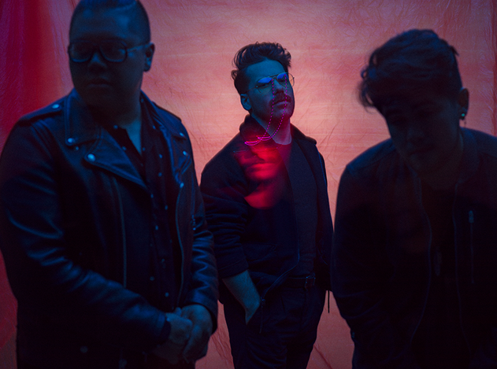
Photo credit: Tom Oldham

CONNECT WITH A R I Z O N A
THISISARIZONAMUSIC.COM
TWITTER
FACEBOOK
YOUTUBE
INSTAGRAM

