FOR IMMEDIATE RELEASE
OCTOBER 16, 2019

A R I Z O N A RELEASE MUSIC VIDEO FOR NEW TRACK “WHERE YOU ARE”

ACCLAIMED ALT/ELECTRONIC TRIO GENERATE OVER 3 MILLION FIRST-WEEK ALBUM STREAMS

NORTH AMERICAN LIVE DATES TO BE ANNOUNCED SOON

NEW ALBUM ASYLUM AVAILABLE NOW HERE

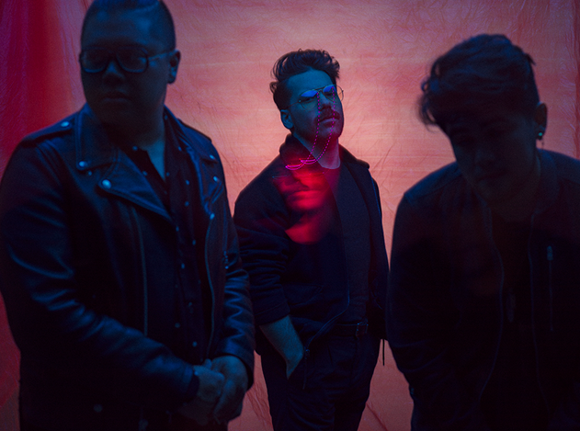
Photo credit: Tom Oldham

WATCH THE “WHERE YOU ARE” VIDEO HERE
LISTEN TO THE ASYLUM ALBUM HERE

Off the heels of their critically acclaimed sophomore album release, ASYLUM, Atlantic recording group A R I Z O N A share the music video for their new track “Where You Are” today.

The New Jersey-based trio performs in a sparse room flanked by white sheets hanging from the ceiling. Between an electronic beat and glistening neon synths, the hook immediately rings out, “Where you are…I just wanna be.” As this retro sonic backdrop shimmers, an interpretative dancer twists and turns through the sheets, paralleling the ebb and flow of the song in live motion. It offers a gorgeous visual companion to the tune.

Following its arrival last week, ASYLUM generated over 3.6 million streams in under seven days. Last Thursday, they dropped the video for new single “Problems,” which exceeded 1 million streams in addition to 154k-plus video views. Additionally, the band continues to garner widespread acclaim. Billboard praised “Problems” as “a perfect introduction” and went on to add, “the song perfectly encompasses the overall feel of the album.” Idolator raved, “The follow-up to 2017’s breakout release GALLERY features a wealth of thoughtful electro/alt-pop anthems.”

About A R I Z O N A:
With over a billion worldwide streams and counting, A R I Z O N A has proven a true planetary phenomenon, creating worldwide waves with their ingenious brand of contemporary electronic dance pop. The trio first came together at Boston’s prestigious Berklee College of Music, their shared interests in production and songwriting uniting them as much as their mutual New Jersey heritage. Songs like “Where I Wanna Be“ soon drew millions of multi-platform streams as well as a fervent online following from London to Los Angeles, Stockholm to Singapore. Signed to Atlantic/APG in 2015, GALLERY proved among 2017’s biggest global releases, now boasting over 750 million worldwide streams. The album showcases a stunning collection of hit singles, among them “Electric Touch,” “I Was Wrong,” and the RIAA gold certified “Oceans Away,” all of which are joined by creative companion videos streaming now at A R I Z O N A’s hugely popular YouTube channel HERE.

2018 saw A R I Z O N A return with a string of new singles and remixes, including “What She Wants,” and the double-A sided “Summer Days“ and “Freaking Out,” all available now for streaming and download.

In addition, A R I Z O N A can be heard on Avicii’s recently released “Hold The Line (Feat. A R I Z O N A),” found on the late artist’s posthumous album, TIM. The track – which was immediately added to Spotify’s Today’s Top Hits playlist – was met by widespread critical acclaim, with Rolling Stone praising the song as “a powerful confrontation of loss and grief.” A R I Z O N A marked the track’s summer release with a powerful acoustic performance video of the song, dedicated to Avicii, streaming HERE following its exclusive premiere via SPIN.

A R I Z O N A have spent much of the past few years on the road, including a sold out series of increasingly larger headline tours – the first of which completely sold-out three months in advance, with some shows selling out within minutes of going on sale – as well as a North American arena tour supporting Panic! At The Disco, and spectacularly well-received festival sets at such gatherings as Lollapalooza, Music Midtown, ACL, Bunbury, Bonnaroo, Hangout Music Fest, BottleRock Napa Valley, Firefly, Budweiser Made In America Festival, and Governors Ball, to name but a few. Perhaps FORBES said it best: “If you haven’t seen A R I Z O N A, you’re missing out.”

A R I Z O N A is: Nathan Esquite, David Labuguen, and Zachary Charles.

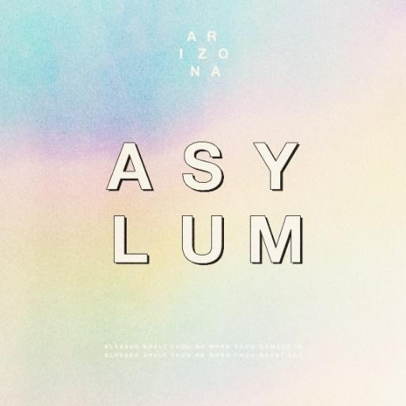

ASYLUM TRACKLIST

1. Let Me Know
2. Nostalgic
3. Where You Are
4. Don’t Leave
5. Find Someone
6. Trouble
7. Problems
8. Freaking Out
9. Still Alive

CONNECT WITH A R I Z O N A
THISISARIZONAMUSIC.COM
TWITTER
FACEBOOK
YOUTUBE
INSTAGRAM

