FOR IMMEDIATE RELEASE

SEPTEMBER 11TH, 2020

**RISING STAR AYANIS TAPS RAPPER JACK HARLOW FOR THE OFFICIAL REMIX TO HER STANDOUT SINGLE**

**“LIL BOI (BIG TALK)”**

**LISTEN NOW** [**HERE**](https://nam04.safelinks.protection.outlook.com/?url=https%3A%2F%2Fayanis.lnk.to%2FLBBTRemix&data=02%7C01%7CAlyssa.Reddish%40atlanticrecords.com%7Cc450a60125f24b87f6fc08d854d0fc3f%7C8367939002ec4ba1ad3d69da3fdd637e%7C0%7C0%7C637352604127063473&sdata=28vTZpjK%2BFcSqA%2BFzB70ZBtNIUoHO1Heww1ydSnEaWo%3D&reserved=0)

**WATCH THE OFFICIAL LYRIC VIDEO** [**HERE**](https://www.youtube.com/watch?v=QbZJdRHN0rA&ab_channel=Ayanis&src=Linkfire&lId=bd9ad17b-0811-43f6-8f64-0ebdabe46f14&cId=d3d58fd7-4c47-11e6-9fd0-066c3e7a8751)

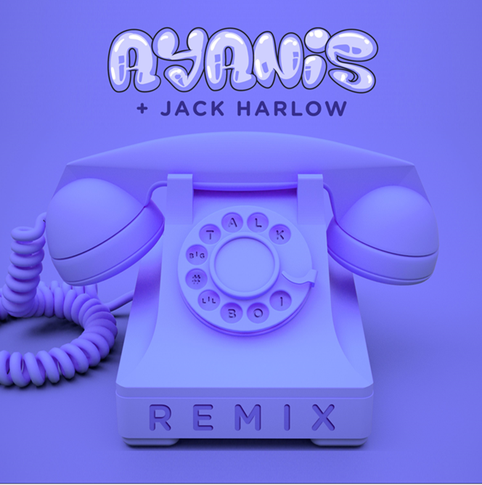

Island Prolific/Atlantic Records recording artist Ayanis is back to announce a fiery remix to her earlier standout “Lil Boi (Big Talk) [Feat. Queen Naija],” this time featuring the rising rap phenomenon and recently-crowned XXL Freshman based out of Louisville, KY, Jack Harlow. Listen to the hot track now via all digital retailers and streaming platforms [HERE](https://nam04.safelinks.protection.outlook.com/?url=https%3A%2F%2Fayanis.lnk.to%2FLBBTRemix&data=02%7C01%7CAlyssa.Reddish%40atlanticrecords.com%7Cc450a60125f24b87f6fc08d854d0fc3f%7C8367939002ec4ba1ad3d69da3fdd637e%7C0%7C0%7C637352604127063473&sdata=28vTZpjK%2BFcSqA%2BFzB70ZBtNIUoHO1Heww1ydSnEaWo%3D&reserved=0). The remix is accompanied by a colorful lyric video; watch [HERE](https://www.youtube.com/watch?v=QbZJdRHN0rA&ab_channel=Ayanis&src=Linkfire&lId=bd9ad17b-0811-43f6-8f64-0ebdabe46f14&cId=d3d58fd7-4c47-11e6-9fd0-066c3e7a8751).

The initial release of “[Lil Boi (Big Talk](https://nam04.safelinks.protection.outlook.com/?url=https%3A%2F%2Fayanis.lnk.to%2FLilBoiBigTalkPR&data=02%7C01%7CAlyssa.Reddish%40atlanticrecords.com%7Ce50fb5470f344da7197b08d854d61e2b%7C8367939002ec4ba1ad3d69da3fdd637e%7C0%7C0%7C637352625887398603&sdata=2gJGJHduZJ0J2C6Fdrvzfflbv0jxRfVSR5nVdhX6Y%2Bc%3D&reserved=0))” was widely embraced by listeners, with over 5.9 million combined streams to date and the official music video surpassing 2.1 million views on YouTube. As if that weren’t enough, the single followed Ayanis’ earlier collaboration with acclaimed rapper and labelmate Wiz Khalifa, “[One Night](https://nam04.safelinks.protection.outlook.com/?url=https%3A%2F%2Fwww.youtube.com%2Fwatch%3Fv%3DLORlGwdD_n0&data=02%7C01%7CAlyssa.Reddish%40atlanticrecords.com%7Ce50fb5470f344da7197b08d854d61e2b%7C8367939002ec4ba1ad3d69da3fdd637e%7C0%7C0%7C637352625887408597&sdata=Lach7dzyQJyIsEZdmiozBBmjxqRTlKOxJrZgW7xMRZI%3D&reserved=0),” which has amassed 2.1 million streams to date with an official music video at over 3.2 million views on YouTube. The enticing companion visual, directed by Brad Wong, showcases the artist’s seductive melodies in a number of colorful settings. “'One Night' represents a mature side of me as well as a sultry, intimate, personal side."

In 2018, Ayanis released her debut EP, *DIRECTION*, which included acclaimed tracks “[Awh Yeh](https://nam04.safelinks.protection.outlook.com/?url=https%3A%2F%2Fwww.youtube.com%2Fwatch%3Fv%3DFJUiq8GKyc8&data=02%7C01%7CAlyssa.Reddish%40atlanticrecords.com%7Ce50fb5470f344da7197b08d854d61e2b%7C8367939002ec4ba1ad3d69da3fdd637e%7C0%7C0%7C637352625887408597&sdata=DYe9uQGadxiVXCovjas%2B7fWuNRZTjqirW2MSuYyizAk%3D&reserved=0)” and “[F.I.Y.T. (Fuck Is You Thinking)](https://nam04.safelinks.protection.outlook.com/?url=https%3A%2F%2Fwww.youtube.com%2Fwatch%3Fv%3DxhwaZocwy48&data=02%7C01%7CAlyssa.Reddish%40atlanticrecords.com%7Ce50fb5470f344da7197b08d854d61e2b%7C8367939002ec4ba1ad3d69da3fdd637e%7C0%7C0%7C637352625887418587&sdata=U4fq4HmHjzdNQKV815j70af3mrl1QgJWi%2BYdiU96PSQ%3D&reserved=0).” That year, Ayanis made her debut on the “Access Granted: HBCU Tour” presented by Atlantic Records and Live Nation Urban. She joined labelmates Bri Steves, RecoHavoc and K’ron while visiting select Historically Black Colleges and Universities along the east coast. BET helped celebrate the month-long trek and highlighted the rising R&B singer with an exclusive tour diary available for viewing [here](https://nam04.safelinks.protection.outlook.com/?url=https%3A%2F%2Fwww.youtube.com%2Fwatch%3Fv%3D2AKxOIYq2bE%26t%3D2s&data=02%7C01%7CAlyssa.Reddish%40atlanticrecords.com%7Ce50fb5470f344da7197b08d854d61e2b%7C8367939002ec4ba1ad3d69da3fdd637e%7C0%7C0%7C637352625887428578&sdata=GNTdWxvqiDgYWoduwy1ZCfsEaKQgSKeb8b3tvsurIRM%3D&reserved=0).

For more information and updates please visit [http://www.itsayanis.com/](https://nam04.safelinks.protection.outlook.com/?url=http%3A%2F%2Fwww.itsayanis.com%2F&data=02%7C01%7CAlyssa.Reddish%40atlanticrecords.com%7Ce50fb5470f344da7197b08d854d61e2b%7C8367939002ec4ba1ad3d69da3fdd637e%7C0%7C0%7C637352625887428578&sdata=tLDNjuvo3jtdKKovwvsM6R4uK%2FRx9PFq4mtrMZT5ZW4%3D&reserved=0).

# # #

**FOR PRESS INQUIRIES CONTACT:**

SYDNEY MARGETSON

[SYDNEY.MARGETSON@ATLANTICRECORDS.COM](mailto:SYDNEY.MARGETSON@ATLANTICRECORDS.COM)

**CONNECT WITH AYANIS:**

[INSTAGRAM](https://nam04.safelinks.protection.outlook.com/?url=https%3A%2F%2Fwww.youtube.com%2Fredirect%3Fv%3DxhwaZocwy48%26event%3Dvideo_description%26redir_token%3DI-n64L7i9dHDit5S7tQwSPJLnTp8MTU2OTA4MTA5NUAxNTY4OTk0Njk1%26q%3Dhttps%253A%252F%252Fwww.instagram.com%252Fayanis%252F&data=02%7C01%7CAlyssa.Reddish%40atlanticrecords.com%7Ce50fb5470f344da7197b08d854d61e2b%7C8367939002ec4ba1ad3d69da3fdd637e%7C0%7C0%7C637352625887438576&sdata=vUg9QluADMnd7IREWEjWAez9SuT2nDSX8p3oo%2FT6%2B%2BU%3D&reserved=0) | [TWITTER](https://nam04.safelinks.protection.outlook.com/?url=https%3A%2F%2Fwww.youtube.com%2Fredirect%3Fv%3DxhwaZocwy48%26event%3Dvideo_description%26redir_token%3DI-n64L7i9dHDit5S7tQwSPJLnTp8MTU2OTA4MTA5NUAxNTY4OTk0Njk1%26q%3Dhttps%253A%252F%252Ftwitter.com%252Fitsayanis&data=02%7C01%7CAlyssa.Reddish%40atlanticrecords.com%7Ce50fb5470f344da7197b08d854d61e2b%7C8367939002ec4ba1ad3d69da3fdd637e%7C0%7C0%7C637352625887438576&sdata=uvQna%2F1aFHhSMyO84Jubfel4u%2BUGyji1%2F2LMen%2BPlcI%3D&reserved=0) | [FACEBOOK](https://nam04.safelinks.protection.outlook.com/?url=https%3A%2F%2Fwww.youtube.com%2Fredirect%3Fv%3DxhwaZocwy48%26event%3Dvideo_description%26redir_token%3DI-n64L7i9dHDit5S7tQwSPJLnTp8MTU2OTA4MTA5NUAxNTY4OTk0Njk1%26q%3Dhttps%253A%252F%252Fwww.facebook.com%252FItsAyanis%252F&data=02%7C01%7CAlyssa.Reddish%40atlanticrecords.com%7Ce50fb5470f344da7197b08d854d61e2b%7C8367939002ec4ba1ad3d69da3fdd637e%7C0%7C0%7C637352625887448573&sdata=903Mt1r9csBheWOFR9ZbS5PwAJrlnWkSDzRFa%2BDNQZ0%3D&reserved=0) | [SOUNDCLOUD](https://nam04.safelinks.protection.outlook.com/?url=https%3A%2F%2Fwww.youtube.com%2Fredirect%3Fv%3DxhwaZocwy48%26event%3Dvideo_description%26redir_token%3DI-n64L7i9dHDit5S7tQwSPJLnTp8MTU2OTA4MTA5NUAxNTY4OTk0Njk1%26q%3Dhttps%253A%252F%252Fsoundcloud.com%252Fitsayanis%252F&data=02%7C01%7CAlyssa.Reddish%40atlanticrecords.com%7Ce50fb5470f344da7197b08d854d61e2b%7C8367939002ec4ba1ad3d69da3fdd637e%7C0%7C0%7C637352625887448573&sdata=%2BkAsi71RIpan7uMZALTJte8Y7S32SAYKYXKg1jiBUFc%3D&reserved=0)

[WWW.ITSAYANIS.COM](https://nam04.safelinks.protection.outlook.com/?url=http%3A%2F%2FWWW.ITSAYANIS.COM&data=02%7C01%7CAlyssa.Reddish%40atlanticrecords.com%7Ce50fb5470f344da7197b08d854d61e2b%7C8367939002ec4ba1ad3d69da3fdd637e%7C0%7C0%7C637352625887458565&sdata=USrMD2efG9WFCASYKynAmqY1Usa5PqOUGJN6wIGznbw%3D&reserved=0)