FOR IMMEDIATE RELEASE
MARCH 28, 2019

A R I Z O N A RECRUITS FUTURE BASS HEAVY HITTERS DROELOE FOR REMIX OF SMASH SINGLE “FIND SOMEONE”

“FIND SOMEONE” MUSIC VIDEO BECOMES THE TRIO’S MOST POPULAR VIDEO TO DATE,
QUICKLY GARNERING OVER 1 MILLION VIEWS

A R I Z O N A’S NORTH AMERICAN HEADLINE TOUR INSTANTLY SELLS OUT VENUES NATIONWIDE INCLUDING CHICAGO, DENVER WASHINGTON DC, SEATTLE, SAN FRANCISCO,
AND TWO NIGHTS IN NYC AT IRVING PLAZA AND BROOKLYN STEEL

THE ‘FIND SOMEONE TOUR’ KICKS OFF MAY 14TH IN CHARLOTTE, NC,
FOLLOWING THE BAND’S UPCOMING COACHELLA DEBUT

“FIND SOMEONE” (DROELOE REMIX) AVAILABLE EVERYWHERE NOW

WATCH/LISTEN: https://youtu.be/SXhtzMDTxKI
DOWNLOAD/STREAM: https://lnk.to/FINDSOMEONE_DROELOEPR

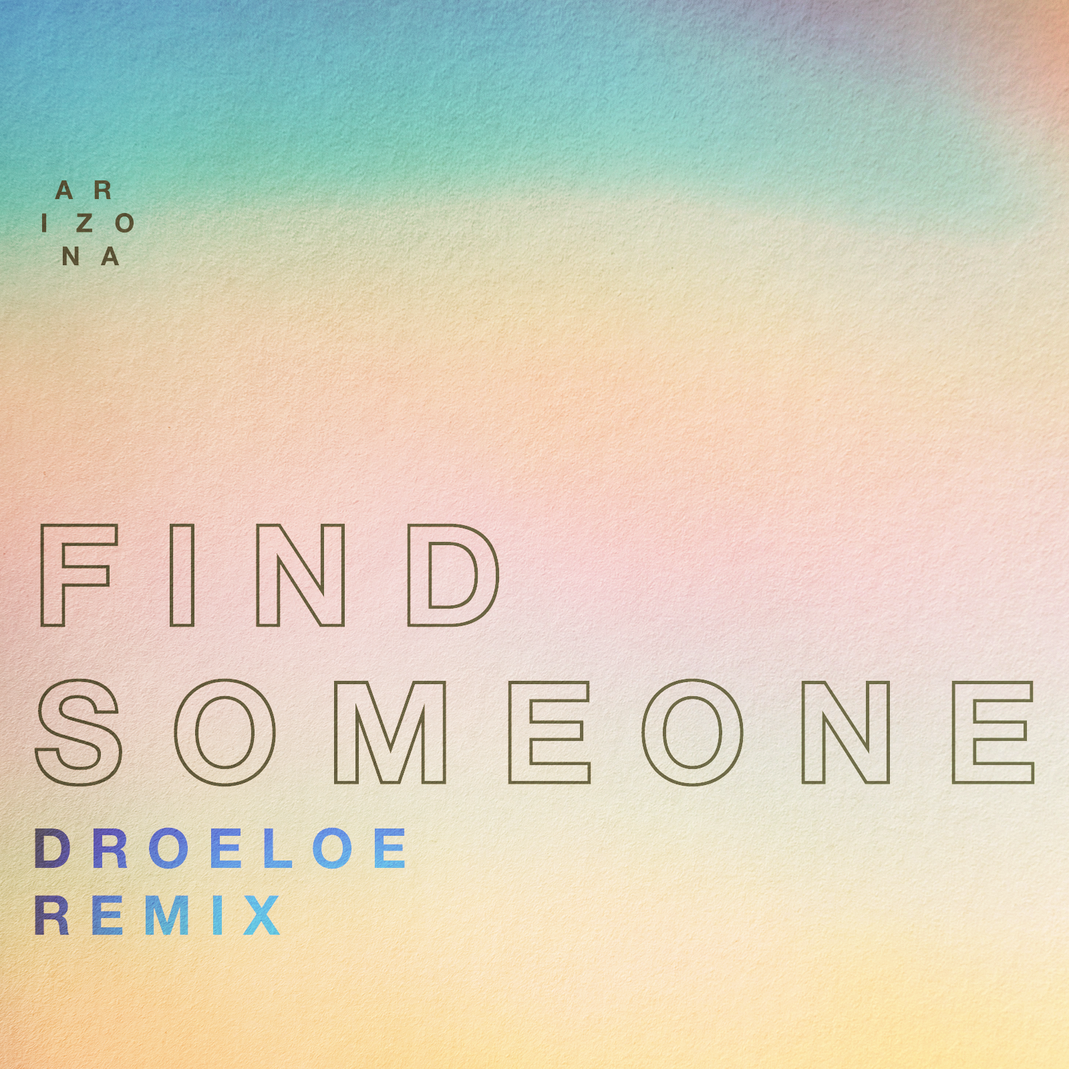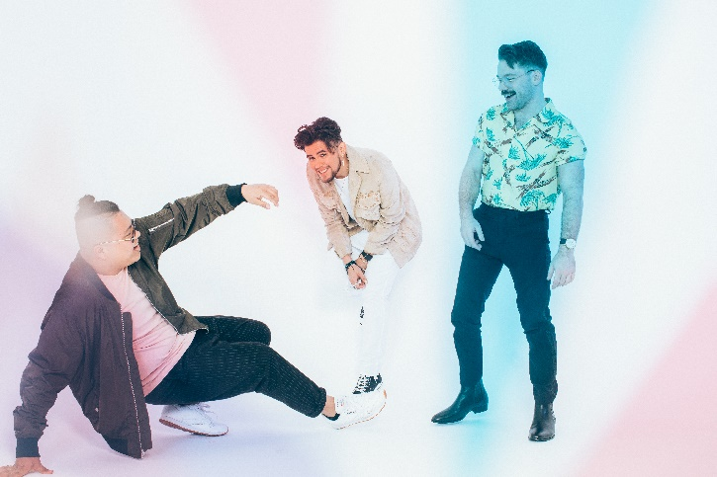

Atlantic recording group A R I Z O N A have teamed up with Dutch future-bass duo, DROELOE, for a Coachella-ready remix of the band’s brand new single, “Find Someone.” The remix is accompanied by a feel-good companion visualizer which features fun, behind-the-scenes footage from the band’s latest photo shoot, watch HERE. “Find Someone” (DROELOE Remix) is available at all DSPs and streaming services HERE.

“Find Someone” is quickly proving to be another smash for the band, with the official companion video - starring baby animals - reaching over 1 million views in just a few weeks (watch HERE). The incredibly catchy 80s-vibe bop marks the first single from A R I Z O N A’s sophomore effort, the follow-up to their hugely successful debut album GALLERY, which proved among 2017’s biggest global releases, now boasting over 750 million worldwide streams and counting.

Recently, A R I Z O N A reprised their opening slot on Panic! At The Disco’s European arena tour, which will be followed by a run of their own European headline shows before returning to the U.S. for their long-awaited Coachella debut. Following Coachella, the band will embark on their nationwide “Find Someone Tour,” which has instantly sold out in several cities including two dates in San Francisco, Boston, Seattle, Chicago, Washington, D.C, and two nights in New York City. The band is donating $1 from every ticket sold to Hope For The Day - a Chicago based non-profit organization aimed at suicide prevention and mental health awareness. For tickets and more information, please visit: https://thisisarizonamusic.com/

ABOUT A R I Z O N A
With over a billion worldwide streams and counting, A R I Z O N A has proven a true planetary phenomenon, creating worldwide waves with their ingenious brand of contemporary electronic dance pop. The trio first came together in college in 2015, their shared interests in production and songwriting uniting them as much as their mutual New Jersey heritage. Their early songs like “Where I Wanna Be“ soon drew millions of multi-platform streams as well as a fervent online following from London to Los Angeles, Stockholm to Singapore. Their debut album “GALLERY“ showcases a stunning collection of hit singles, among them “Electric Touch,” “I Was Wrong,” and the RIAA gold certified “Oceans Away,” all of which are joined by compelling companion videos streaming now at A R I Z O N A’s hugely popular YouTube channel HERE.

2018 saw A R I Z O N A return with a string of new singles and remixes, including “What She Wants,” and the double-A sided “Summer Days“ and “Freaking Out,” all available now for streaming and download.

A R I Z O N A has spent much of past few years on the road on a sold-out series of increasingly larger headline tours – the first of which completely sold-out three months in advance, with some shows selling out within minutes of going on sale – a North American arena tour supporting Panic! At The Disco, which will continue in Europe this month, and a multitude of insanely massive festival sets at Lollapalooza, Austin City Limits, Bonnaroo, Corona Capital and many more. Perhaps FORBES said it best: “If you haven’t seen A R I Z O N A, you’re missing out.”

A R I Z O N A is: Nate Esquite, David Labuguen, and Zachary Charles.

CONNECT WITH A R I Z O N A
THISISARIZONAMUSIC.COM
TWITTER
FACEBOOK
YOUTUBE
INSTAGRAM

PRESS CONTACTS:
Chelsey Northern – National – chelsey.northern@atlanticrecords.com
Jessica Nall – Tour/Online – jessica.nall@atlanticrecords.com

A R I Z O N A
NORTH AMERICA TOUR DATES 2019
*denotes festival appearance

4/13 Indio, CA Coachella Valley Music & Arts Festival*
4/20 Indio, CA Coachella Valley Music & Arts Festival*
5/14 Charlotte, NC Underground
5/16 Atlanta, GA Buckhead Theatre
5/17 Nashville, TN Cannery Ballroom
5/18 Gulf Shores, AL Hangout Music Festival*
5/21 Houston, TX House of Blues
5/22 Austin, TX Emo's
5/23 Dallas, TX House of Blues
5/25 El Paso, TX Neon Desert*
5/28 San Diego, CA House of Blues
5/29 Phoenix, AZ Van Buren
6/1 San Francisco, CA Regency Ballroom *SOLD OUT*
6/2 San Francisco, CA Fillmore *SOLD OUT*
6/4 Seattle, WA The Showbox *SOLD OUT*
6/5 Vancouver, BC Commodore Ballroom
6/6 Portland, OR Wonder Ballroom
6/8 Salt Lake City, UT The Depot
6/9 Denver, CO The Summit *SOLD OUT*
6/11 Minneapolis, MN First Avenue
6/12 Chicago, IL House of Blues *SOLD OUT*
6/13 Detroit, MI St. Andrews Hall
6/15 Toronto, ON Phoenix Concert Theatre
6/16 Montreal, QC Corona Theatre
6/18 New York City, NY Irving Plaza *SOLD OUT*
6/19 Brooklyn, NY Brooklyn Steel *SOLD OUT*
6/20 Washington DC 9:30 Club *SOLD OUT*
6/22 Boston, MA House of Blues
6/23 Philadelphia, PA Fillmore

