FOR IMMEDIATE RELEASE

MARCH 4, 2019

**A R I Z O N A ANNOUNCE MAJOR NORTH AMERICAN HEADLINE TOUR**

**GENERAL ONSALE BEGINS FRIDAY MARCH 8TH AT 10AM**

**THE FIND SOMEONE TOUR  KICKS OFF MAY 14TH IN CHARLOTTE, NC;**

**TREK INCLUDES STOPS IN NASHVILLE, AUSTIN, SAN FRANCISCO, BROOKLYN, AND MORE**

**NEW SINGLE + VIDEO “FIND SOMEONE” AVAILABLE EVERYWHERE NOW**

**WATCH HERE:** [**https://lnk.to/FindSomeonePR/youtube**](https://lnk.to/FindSomeonePR/youtube)

**LISTEN HERE:** [**https://lnk.to/FindSomeonePR**](https://lnk.to/FindSomeonePR)

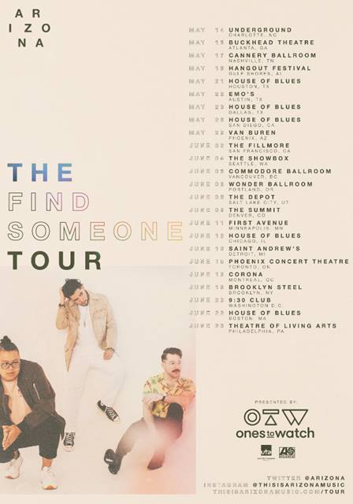

[[DOWNLOAD HI-RES ARTWORK + PRESS PHOTOS](http://press.ahttp/press.atlanticrecords.com/a-r-i-z-o-n-a/tlanticrecords.com/a-r-i-z-o-n-a/) | [DOWNLOAD TOUR ADMAT](https://www.dropbox.com/sh/34m71f47faanxos/AABmXcdt8UjVyBfyCN-P5huea?dl=0)]

Atlantic recording group **A R I Z O N A** have unveiled details for their upcoming North American headline tour- **The Find Someone Tour -**  kicking off May 14th in Charlotte, NC. The nationwide trek stops at legendary venues including Nashville’s Cannery Ballroom (May 17th), The Fillmore in San Francisco (June 2nd) , and Brooklyn’s Brooklyn Steel (June 19th). Fan pre-sales begin Tuesday, March 5th at 10am (local) and Spotify pre-sale begins Wednesday, March 6th at 10am (local); all remaining tickets will be released to the general public on Friday, March 8th at 10am (local). For tickets and more information, please visit: <https://thisisarizonamusic.com/>

Today’s announcement comes on the heels of A R I Z O N A’s highly-anticipated new single, “[Find Someone](https://lnk.to/FindSomeonePR).” The incredibly catchy 80s-vibe bop is available now at all DSPs and streaming services with the unbelievably adorable companion video - *starring baby animals* – streaming now at the band’s official YouTube channel (watch [**HERE**](https://lnk.to/FindSomeonePR/youtube)).  “Find Someone” marks the first single from A R I Z O N A’s sophomore effort, the follow-up to their hugely successful debut album [*GALLERY*](https://atlantic.lnk.to/galleryPR), which proved among 2017’s biggest global releases, now boasting *over 750 million* worldwide streams and counting.

Later this month, A R I Z O N A will travel to Europe to reprise their opening slot on Panic! At The Disco’s arena tour, followed by a slew of their own European headline shows before returning to the U.S. for their long-awaited Coachella debut. For more information, please visit: [thisisarizonamusic.com](http://thisisarizonamusic.com/).

**A R I Z O N A ON TOUR 2019**

*\*denotes festival appearance*

|  |  |  |
| --- | --- | --- |
| **DATE** | **MARKET** | **VENUE** |
| 4/13/2019 | Indio, CA | Coachella Valley Music & Arts Festival* |
| 4/20/2019 | Indio, CA | Coachella Valley Music & Arts Festival* |
| 5/14/2019 | Charlotte, NC | Underground |
| 5/16/2019 | Atlanta, GA | Buckhead Theatre |
| 5/17/2019 | Nashville, TN | Cannery Ballroom |
| 5/18/2019 | Gulf Shores, AL | Hangout Music Festival* |
| 5/21/2019 | Houston, TX | House of Blues |
| 5/22/2019 | Austin, TX | Emo's |
| 5/23/2019 | Dallas, TX | House of Blues |
| 5/25/2019 | El Paso, TX | Neon Desert* |
| 5/28/2019 | San Diego, CA | House of Blues |
| 5/29/2019 | Phoenix, AZ | Van Buren |
| 6/2/2019 | San Francisco, CA | Fillmore |
| 6/4/2019 | Seattle, WA | The Showbox |
| 6/5/2019 | Vancouver, BC | Commodore Ballroom |
| 6/6/2019 | Portland, OR | Wonder Ballroom |
| 6/8/2019 | Salt Lake City, UT | The Depot |
| 6/9/2019 | Denver, CO | The Summit |
| 6/11/2019 | Minneapolis, MN | First Avenue |
| 6/12/2019 | Chicago, IL | House of Blues |
| 6/13/2019 | Detroit, MI | St Andrews |
| 6/15/2019 | Toronto, ON | Phoenix Concert Theatre |
| 6/16/2019 | Montreal, QC | Corona Theatre |
| 6/19/2019 | Brooklyn, NY | Brooklyn Steel |
| 6/20/2019 | Washington DC | 9:30 Club |
| 6/22/2019 | Boston, MA | House of Blues |
| 6/23/2019 | Philadelphia, PA | Theatre of Living Arts |

**ABOUT A R I Z O N A**

With over a *billion* worldwide streams and counting, A R I Z O N A has proven a true planetary phenomenon, creating worldwide waves with their ingenious brand of contemporary electronic dance pop. The trio first came together in college in 2015, their shared interests in production and songwriting uniting them as much as their mutual New Jersey heritage. Their early songs like “[Where I Wanna Be](https://www.youtube.com/watch?v=mRWhwdQK0cs)“ soon drew millions of multi-platform streams as well as a fervent online following from London to Los Angeles, Stockholm to Singapore. Their debut album “[GALLERY](https://atlantic.lnk.to/galleryPR)“ showcases a stunning collection of hit singles, among them “[Electric Touch](https://www.youtube.com/watch?v=i-eX8ri3pr0),” “[I Was Wrong](https://www.youtube.com/watch?v=8eCGkOL6WGw),” and the RIAA gold certified “[Oceans Away](https://www.youtube.com/watch?v=1MoAdVyuEuU),” all of which are joined by compelling companion videos streaming now at A R I Z O N A’s hugely popular YouTube channel [HERE](https://www.youtube.com/channel/UCoQJcz3rOY-CbzM-t4CRioQ/featured).

2018 saw A R I Z O N A return with a string of new singles and remixes, including “[What She Wants](https://lnk.to/WhatSheWantsPR),” and the double-A sided [“Summer Days](https://lnk.to/SummerDaysFreakingOutPR)“ and “[Freaking Out](https://lnk.to/SummerDaysFreakingOutPR),” all available now for streaming and download.

A R I Z O N A has spent much of past few years on the road on a sold-out series of increasingly larger headline tours – the first of which completely sold-out three months in advance, with some shows selling out within minutes of going on sale – a North American arena tour supporting Panic! At The Disco, which will continue in Europe this month, and a multitude of insanely massive festival sets at Lollapalooza, Austin City Limits, Bonnaroo, Corona Capital and many more. Perhaps [FORBES](https://protect-us.mimecast.com/s/7kV0CwpRrOFN0x0VFxj_fj) said it best: “If you haven’t seen A R I Z O N A, you’re missing out.”

A R I Z O N A is: Nate Esquite, David Labuguen, and Zachary Charles.

CONNECT WITH A R I Z O N A

[THISISARIZONAMUSIC.COM](http://thisisarizonamusic.com/)

[TWITTER](http://twitter.com/arizona_music)

[FACEBOOK](http://facebook.com/thisisarizonamusic)

[YOUTUBE](http://youtube.com/thisisarizonamusic)

[INSTAGRAM](http://instagram.com/thisisarizonamusic)