FOR IMMEDIATE RELEASE
MARCH 6, 2020

ABSOFACTO RELEASES NEW SINGLE, “LEMON DROP”

ACCLAIMED SINGER/SONGWRITER/PRODUCER RETURNS WITH DREAMY NEW SINGLE
ALONG WITH B-SIDE TRACK, “PYTHON”

HEADLINE DATES TO KICK OFF MAY 20TH IN SEATTLE FOLLOWED BY PERFORMANCES AT
BOTTLEROCK NAPA AND FIREFLY MUSIC FESTIVAL

LISTEN TO “LEMON DROP” HERE
WATCH THE “LEMON DROP” VIDEO HERE

“Absofacto is truly a game changer…”
– Ones To Watch

“Absofacto is a powerful sound that’s fueled by the subtleties that live in the meaningful lyrics and the catchy choruses that can lift and carry listeners from start to finish…”
– EARMILK

Today, Absofacto has released his eagerly awaited single "Lemon Drop," accompanied by a trippy visual now streaming on Absofacto’s official YouTube channel HERE. “Lemon Drop” arrives along with new B-Side track, “Python.” Listen to “Lemon Drop” and “Python” now via all DSPs and streaming services.

Earlier this week Absofacto announced a slew of headlining shows this summer in addition to his many festival appearances. The headlining run kicks off on May 5th in Seattle, WA and runs through an epic performance at New York’s Mercury Lounge on June 22. Full list of dates below. Tickets are available now HERE.

“Lemon Drop” arrives today following the release of fan favorite “Rewind” and the smash hit “Dissolve.” Absofacto is fresh off claiming the #1 spot at Alternative Radio and the top spot on Billboard’s “Alternative Songs” after an incredible 30 weeks on the airplay chart – the fifth-longest trip to the top in the chart's three-decade history with his viral phenomenon “Dissolve.” “Dissolve” has racked up almost 100 million streams, spent 18 weeks on SiriusXM’s Alt18 Most Requested Countdown -- 4 of which in the #1 position -- and has been featured in 2.8 million videos on TikTok. The song was associated with countless viral videos and trends on the platform, and one of the most popular memes in 2019 known as #mirrorfall. The viral hit was joined by an official music video that was directed by Absofacto and Matt Day and has racked up over 15 million views via Absofacto’s official YouTube channel. From explosions, defying gravity, and hilarious memes, “Dissolve” has inspired endless creativity and is currently averaging 1 million views per day across all platforms.

ABOUT ABSOFACTO
Hailed by Ones To Watch as “an exceptionally forward-thinking project,” Absofacto is the brainchild of Michigan-born, Los Angeles-based musician Jonathan Visger. He began creating his distinctive fusion of dream pop, art rock, and inventive electronica in 2008, earning a wide range of attention, acclaim, and online activity before truly breaking out in 2015 with the initial arrival of “Dissolve.” Though it received virtually no promotional support, the track quickly proved a cult favorite, rising to #1 on Hype Machine thanks to passionate proselytizing from an array of influential music blogs.

DOWNLOAD PRESS PHOTOS HERE

CONNECT WITH ABSOFACTO
OFFICIAL | FACEBOOK | TWITTER | INSTAGRAM | YOUTUBE

PRESS CONTACT
JESSICA.NALL@ATLANTICRECORDS.COM

ABSOFACTO HEADLINE + FESTIVAL DATES
*denotes festival date

5/20 – Seattle, WA @ Crocodile
5/21 – Portland, OR @ Hawthorne Theatre
5/23 - Napa CA @ JaM Cellars Ballroom w/ Milky Chance
5/24 - Napa @ Bottlerock Napa*
5/27- Los Angeles, CA @ Echo
6/6 – Chicago, IL @ Subterranean
6/21 - Dover, DE @ Firefly Music Festival*
6/22 – New York, NY @ Mercury Lounge

MORE DATES TBA

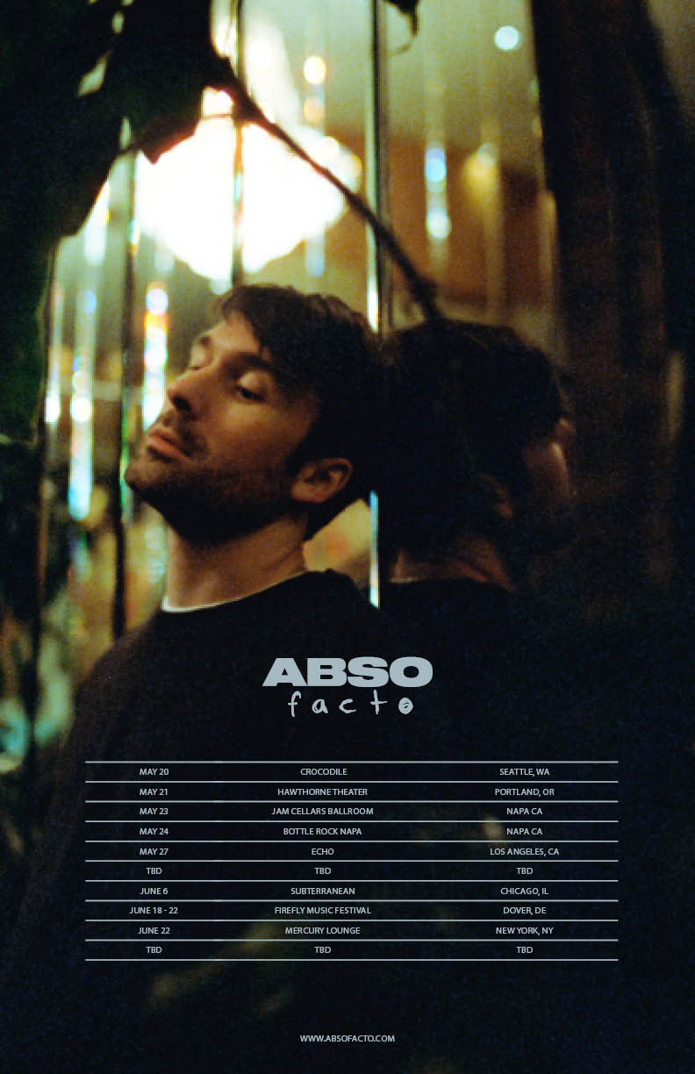
DOWNLOAD ADMAT HERE

