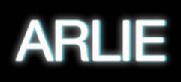

NASHVILLE INDIE-POP BAND ARLIE RELEASE NEW SINGLE ‘crashing down’

ARRIVES ALONGSIDE OFFICIAL TECHNICOLOR MUSIC VIDEO STARRING THE BAND

LISTEN TO “crashing down” HERE | WATCH OFFICIAL MUSIC VIDEO HERE

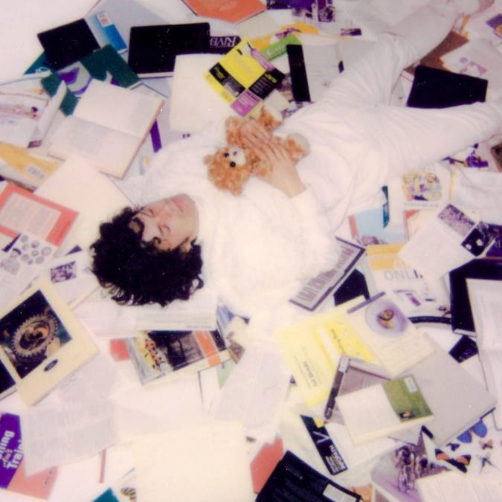

“Fusing a sound both futuristic and vintage…Arlie flirts with an aroma of nostalgic youth, like a mix between a 1984 Testarossa and The Jetsons’ hovercraft.”
– FLAUNT

“A true collage of everything from pop to alternative, pulled together with a squelching kaleidoscopic flare…beaming with lyrical savviness that exudes alternative infatuation.”
– ONES TO WATCH

Visionary indie-pop outfit Arlie has today released their retro-futurist lite-rock new single “crashing down” – out now via Atlantic Records (listen here). The new single highlights the idea that even on your darkest day, life will go on. The song arrives with an official music video starring lead singer/songwriter/producer Nathaniel Banks and the entire band – Adam Lochemes, Carson Lystad, and Ryan Savage (watch here).

To accompany the release of the single, the band embarked on a 6-date DIY tour, playing at unconventional spaces like houses, skateparks, and art galleries. The ‘crashing down’ tour kicked off in Memphis and included sold-out shows in Birmingham, Atlanta, and Athens before culminating with today’s hometown show in Nashville. These live shows follow Arlie’s recent appearances at ACL festival this past September where they performed both weekends.

From Arlie’s leader Nathaniel –
“Right now feels like about the right time to be putting this one out. "crashing down" is about this feeling of "everything I've built my sense of security upon might suddenly crumble" and how that can really make you re-evaluate your priorities. The more I internalize the fact that everything I take for granted is temporary (including life itself), the more I consider radically shifting my life choices. It's about how a dream scared me enough to snap me out of taking a lot of things for granted, and enough to make me realize how much I care about being in the physical presence of the people I love most.”

Today’s release follows previous released singles, “wait a minute”, “poppin”, and “karma” which were met with critical acclaim from the likes of Atwood Magazine, Melodic Magazine, Milky and more. “karma”, the first released of the three marked the first new music from Arlie since their breakthrough Wait EP, released in 2018.

Hailed for its striking synthesis of classic pop melodies with wildly creative modern production, the band’s 2018 Wait EP included such hit singles as “didya think” and “big fat mouth,” both joined by official music videos.

The project immediately drew acclaim for its invigorating songcraft, meticulous production, and playful, summertime energy. Upon release, FLAUNT praised the EP for “fusing a sound both futuristic and vintage…Arlie flirts with an aroma of nostalgic youth, like a mix between a 1984 Testarossa and The Jetsons’ hovercraft.” Ones to Watch similarly declared it: “A true collage of everything from pop to alternative, pulled together with a squelching kaleidoscopic flare…beaming with lyrical savviness that exudes alternative infatuation.”

Arlie followed the Wait EP with nearly non-stop touring, including tours with Rostam, Mt Joy, COIN, and Cold War Kids, show-stealing sets at such festivals as Bonnaroo and Forecastle, and an East Coast headline run (supported by Briston Maroney) that included sold-out shows in both Nashville and Brooklyn.

With over 59M worldwide streams and counting, Arlie have fast risen from a lo-fi solo project to critically acclaimed indie pop sensations. Founded in 2015 as the bedroom pop brainchild of Nashville-based singer-songwriter-producer Nathaniel Banks, Arlie expanded into a full-fledged band and quickly began growing a fervent fan following in Music City and beyond. Genre-blurring tracks like “big fat mouth” and “Too Long” lit up playlists across the country and have only grown in popularity in the years that followed. In fact, Arlie’s overall streaming audience has grown during that time to over 650K monthly listeners.

# # #

CONNECT WITH ARLIE:
OFFICIAL | INSTAGRAM | FACEBOOK | YOUTUBE | TWITTER

FOR ALL PRESS INQUIRIES, PLEASE CONTACT:
Libby Kober | Libby.Kober@AtlanticRecords.com
Trish Mollo | Trish.Mollo@AtlanticRecords.com

