ARLIE RETURN WITH “karma”

VISIONARY INDIE-POP BAND UNVEILS LONG-AWAITED NEW SINGLE

SINGLE ARRIVES WITH OFFICIAL MUSIC VIDEO STARRING LEAD SINGER/SONGWRITER/PRODUCER NATHANIEL BANKS

NORTH AMERICAN TOUR SUPPORTING DAYGLOW
BEGINS SEPTEMBER 9TH IN DALLAS, TX

LISTEN TO “karma” HERE | WATCH OFFICIAL MUSIC VIDEO HERE

“Fusing a sound both futuristic and vintage…Arlie flirts with an aroma of nostalgic youth, like a mix between a 1984 Testarossa and The Jetsons’ hovercraft.”
– FLAUNT

“A true collage of everything from pop to alternative, pulled together with a squelching kaleidoscopic flare…beaming with lyrical savviness that exudes alternative infatuation.”
– ONES TO WATCH

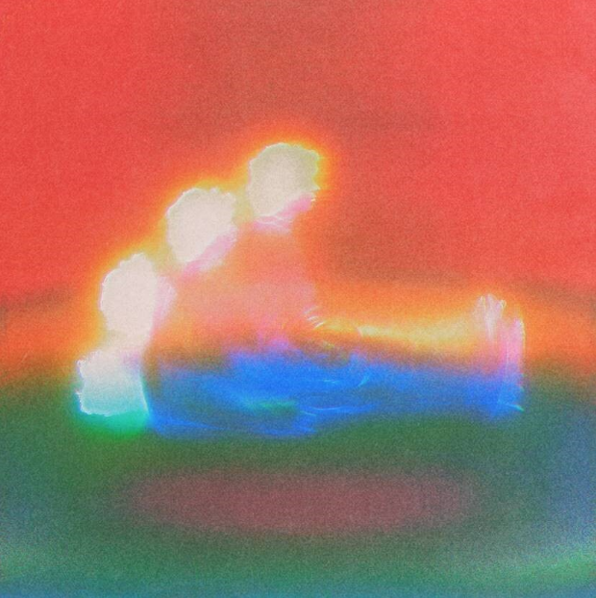
download hi-res artwork

Visionary indie-pop outfit Arlie has announced today’s long-awaited premiere of their transcendent new single “karma” – out now via Atlantic Records (listen here). Their first new release in over three years, the song arrives with an official music video shot in their hometown of Nashville and starring lead singer/songwriter/producer Nathaniel Banks, plus appearances by the whole band – Adam Lochemes, Carson Lystad, and Ryan Savage (watch here).

“karma” is at once many things – an alt-rock banger that slowly crescendos into raucous auto-tune and distortion, while simultaneously a showcase of exceptional songwriting.

Banks expands upon the song: “‘karma’ is both narrative-driven and pure emotional catharsis. It’s easily the most ‘country’ and simultaneously the most Warped-Tour-mosh-pit-ready song on our upcoming album. The song tells the story of a pregnancy scare that brought an already tumultuous relationship to the breaking point.”

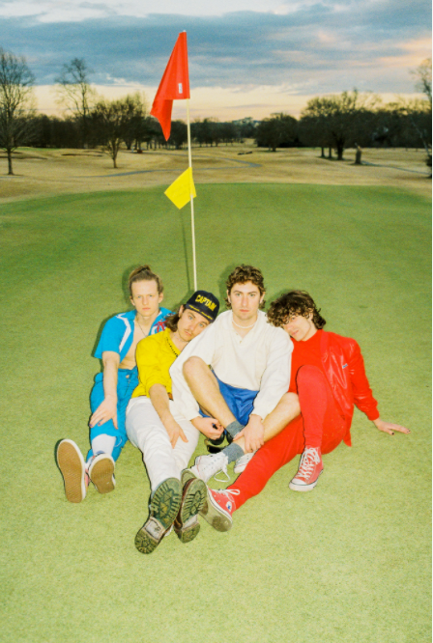
download hi-res press photo; photo credit Gabe Ruckus

Arlie will celebrate their return with a wide-ranging North American tour supporting Dayglow. The Harmony House Tour gets underway September 9th at Dallas, TX’s House of Blues and includes already sold-out shows in Austin, Boston, Los Angeles (2 nights at The Fonda), and New York’s iconic Webster Hall. For complete details and ticket information, click here.

“karma” marks the first new music from Arlie since 2018’s breakthrough Wait EP. Hailed for its striking synthesis of classic pop melodies with wildly creative modern production, the EP included such hit singles as “didya think” and “big fat mouth,” both joined by official music videos.

The project immediately drew acclaim for its invigorating songcraft, meticulous production, and playful, summertime energy. Upon release, FLAUNT praised the EP for “fusing a sound both futuristic and vintage…Arlie flirts with an aroma of nostalgic youth, like a mix between a 1984 Testarossa and The Jetsons’ hovercraft.” Ones to Watch similarly declared it: “A true collage of everything from pop to alternative, pulled together with a squelching kaleidoscopic flare…beaming with lyrical savviness that exudes alternative infatuation.”

With over 54M worldwide streams and counting, Arlie have fast risen from a lo-fi solo project to critically acclaimed indie pop sensations. Founded in 2015 as the bedroom pop brainchild of Nashville-based singer-songwriter-producer Nathaniel Banks, Arlie expanded into a full-fledged band and quickly began growing a fervent fan following in Music City and beyond. Genre-blurring tracks like “big fat mouth” and “Too Long” lit up playlists across the country and have only grown in popularity in the years that followed. Indeed, Arlie’s overall streaming numbers have more than tripled since they were last active, while also maintaining a devoted audience exceeding 550K monthly listeners.

Arlie followed the Wait EP with nearly non-stop touring, including tours with Rostam, Mt Joy, COIN, and Cold War Kids, show-stealing sets at such festivals as Bonnaroo and Forecastle, and an East Coast headline run (supported by Briston Maroney) that included sold-out shows in both Nashville and Brooklyn.

# # #

ARLIE
NORTH AMERICAN TOUR 2021
ALL DATES WITH DAYGLOW

SEPTEMBER
9 – Dallas, TX – House of Blues SOLD OUT
10 – Austin, TX – Stubb’s SOLD OUT
11 – Houston, TX – Warehouse Live
13 – Phoenix, AZ – The Van Buren
15 – Los Angeles, CA – The Fonda Theatre SOLD OUT
16 – Los Angeles, CA – The Fonda Theatre SOLD OUT
17 – San Diego, CA – House of Blues
18 - Santa Ana, CA – The Observatory SOLD OUT
22 - San Francisco, CA - The Regency Ballroom
23 – Portland, OR – Roseland Theater
24 – Vancouver, BC – Commodore Ballroom
26 – Seattle, WA – Showbox
28 - Salt Lake City, UT – The Depot SOLD OUT
29 – Denver, CO – Summit

OCTOBER
5 – Indianapolis, IN – Deluxe
6 – Nashville, TN – Brooklyn Bowl
12 – Atlanta, GA – Center Stage
13 – Charlotte, NC – The Underground
15 – Philadelphia, PA - TLA
16 – Boston, MA – Paradise Rock Club SOLD OUT
17 – New York, NY – Webster Hall SOLD OUT
19 – Washington, D.C. – 9:30 Club
21 – Columbus, OH – Newport Music Hall
23 – Toronto, ON – The Phoenix Concert Center
24 – Grand Rapids, MI – Elevation
27 – Minneapolis, MN – First Avenue
29 – St. Louis, MO – Delmar Hall
30 – Kansas City, MO – The Truman

# # #

CONNECT WITH ARLIE:
OFFICIAL | INSTAGRAM | FACEBOOK | YOUTUBE | TWITTER

FOR ALL PRESS INQUIRIES, PLEASE CONTACT:
Libby Kober | Libby.Kober@AtlanticRecords.com

