ARLIE RELEASE NEW SINGLE ‘poppin’

SINGLE ARRIVES ALONGSIDE THE OFFICIAL MUSIC VIDEO STARRING NATHANIEL BANKS + ROLLER SKATING INFLUENCER, NENA AKA @ZIGGYSTARDUSSTT

NORTH AMERICAN TOUR SUPPORTING DAYGLOW
BEGINS SEPTEMBER 9TH IN DALLAS, TX

LISTEN TO “poppin” HERE | WATCH OFFICIAL MUSIC VIDEO HERE

“Fusing a sound both futuristic and vintage…Arlie flirts with an aroma of nostalgic youth, like a mix between a 1984 Testarossa and The Jetsons’ hovercraft.”
– FLAUNT

“A true collage of everything from pop to alternative, pulled together with a squelching kaleidoscopic flare…beaming with lyrical savviness that exudes alternative infatuation.”
– ONES TO WATCH

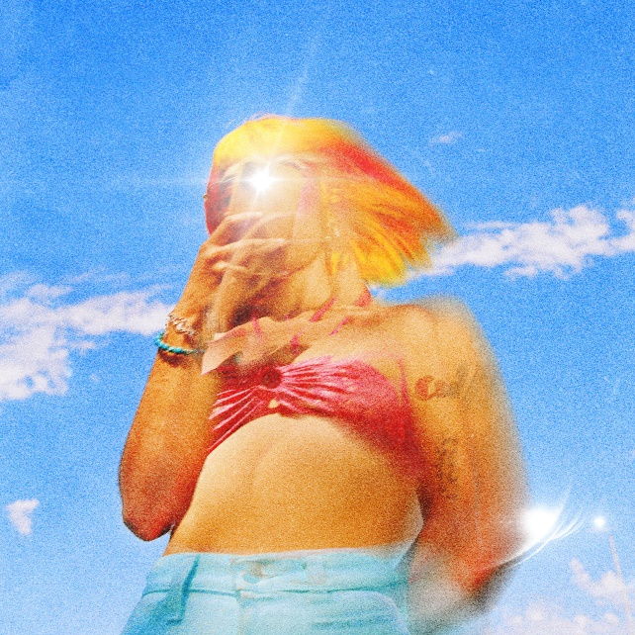

Visionary indie-pop outfit Arlie has today released their groovy new single “poppin” – out now via Atlantic Records (listen here). The song arrives with an official music video shot in Los Angeles and starring lead singer/songwriter/producer Nathaniel Banks and featuring roller skating influencer Nena aka @ziggystardusstt, plus appearances from the entire band – Adam Lochemes, Carson Lystad, and Ryan Savage (watch here).

“poppin” juxtaposes today’s fast paced, social media-influenced lifestyle against the slower moving, funk infused 1970s. The new single and video also showcase Banks’ unconventional songwriting and ingenious fantasies.
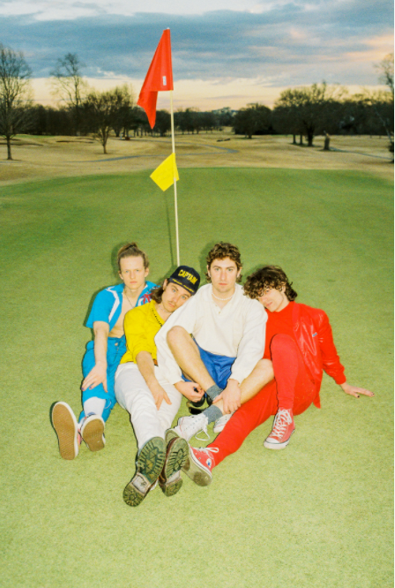
download hi-res press photo; photo credit Gabe Ruckus

Today’s release follows last month’s “karma” which marked the first new music from Arlie since their breakthrough Wait EP, released in 2018.

“karma” was heralded by Melodic Magazine as “one of the most exhilarating listens of 2021”, with pop music blog The Honey Pop exclaiming “The perfect song to come back with! The song gets you pumped to hear what their upcoming body of work will sound like”.

Arlie will celebrate their return with a wide-ranging North American tour supporting Dayglow. The Harmony House Tour gets underway September 9th at Dallas, TX’s House of Blues and includes already sold-out shows in Austin, Boston, Los Angeles (2 nights at The Fonda), and New York’s iconic Webster Hall. For complete details and ticket information, click here.

Hailed for its striking synthesis of classic pop melodies with wildly creative modern production, the band’s 2018 Wait EP included such hit singles as “didya think” and “big fat mouth,” both joined by official music videos.

The project immediately drew acclaim for its invigorating songcraft, meticulous production, and playful, summertime energy. Upon release, FLAUNT praised the EP for “fusing a sound both futuristic and vintage…Arlie flirts with an aroma of nostalgic youth, like a mix between a 1984 Testarossa and The Jetsons’ hovercraft.” Ones to Watch similarly declared it: “A true collage of everything from pop to alternative, pulled together with a squelching kaleidoscopic flare…beaming with lyrical savviness that exudes alternative infatuation.”

Arlie followed the Wait EP with nearly non-stop touring, including tours with Rostam, Mt Joy, COIN, and Cold War Kids, show-stealing sets at such festivals as Bonnaroo and Forecastle, and an East Coast headline run (supported by Briston Maroney) that included sold-out shows in both Nashville and Brooklyn.

With over 54M worldwide streams and counting, Arlie have fast risen from a lo-fi solo project to critically acclaimed indie pop sensations. Founded in 2015 as the bedroom pop brainchild of Nashville-based singer-songwriter-producer Nathaniel Banks, Arlie expanded into a full-fledged band and quickly began growing a fervent fan following in Music City and beyond. Genre-blurring tracks like “big fat mouth” and “Too Long” lit up playlists across the country and have only grown in popularity in the years that followed. Indeed, Arlie’s overall streaming numbers have more than tripled since they were last active, while also maintaining a devoted audience exceeding 550K monthly listeners.

# # #

ARLIE
NORTH AMERICAN TOUR 2021
ALL DATES WITH DAYGLOW

SEPTEMBER
9 – Dallas, TX – House of Blues SOLD OUT
10 – Austin, TX – Stubb’s SOLD OUT
11 – Houston, TX – Warehouse Live
13 – Phoenix, AZ – The Van Buren
15 – Los Angeles, CA – The Fonda Theatre SOLD OUT
16 – Los Angeles, CA – The Fonda Theatre SOLD OUT
17 – San Diego, CA – House of Blues
18 - Santa Ana, CA – The Observatory SOLD OUT
22 - San Francisco, CA - The Regency Ballroom
23 – Portland, OR – Roseland Theater
24 – Vancouver, BC – Commodore Ballroom
26 – Seattle, WA – Showbox
28 - Salt Lake City, UT – The Depot SOLD OUT
29 – Denver, CO – Summit

OCTOBER
5 – Indianapolis, IN – Deluxe
6 – Nashville, TN – Brooklyn Bowl
12 – Atlanta, GA – Center Stage
13 – Charlotte, NC – The Underground
15 – Philadelphia, PA - TLA
16 – Boston, MA – Paradise Rock Club SOLD OUT
17 – New York, NY – Webster Hall SOLD OUT
19 – Washington, D.C. – 9:30 Club
21 – Columbus, OH – Newport Music Hall
23 – Toronto, ON – The Phoenix Concert Center
24 – Grand Rapids, MI – Elevation
27 – Minneapolis, MN – First Avenue
29 – St. Louis, MO – Delmar Hall
30 – Kansas City, MO – The Truman

# # #

CONNECT WITH ARLIE:
OFFICIAL | INSTAGRAM | FACEBOOK | YOUTUBE | TWITTER

FOR ALL PRESS INQUIRIES, PLEASE CONTACT:
Libby Kober | Libby.Kober@AtlanticRecords.com

