AVA MAX
DEBUTS BRAND NEW HOLIDAY SONG
“CHRISTMAS WITHOUT YOU”

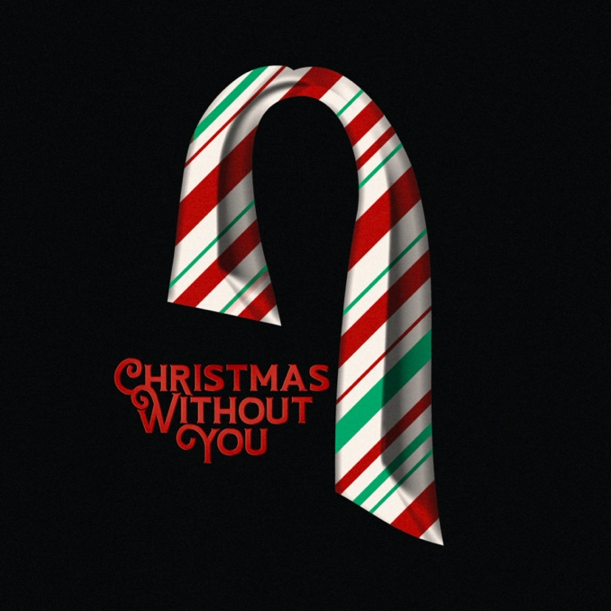

Pop sensation Ava Max has announced the debut of a brand-new holiday song “Christmas Without You,”out TODAY!

Listen to “Christmas Without You” HERE

Cementing her place as one of the most listened to pop artists in the world, the release of “Christmas Without You” follows on the heels of the release of her debut album, Heaven & Hell ([APG/Atlantic Records]. The album features her smash hit single “Kings & Queens,” which has quickly become a global anthem. The track is currently climbing the U.S. Top 40 chart, impacting the Top 10 at #9 this week.

Ava Max is the daughter of Albanian immigrants and has grinded since grade school, exploding in the music world on a global scale with her 2018 triple-platinum smash “Sweet but Psycho.” Streamed over 2.1 billion times by 2020, the song clinched a spot in the Top 10 of the Billboard Hot 100 for three weeks. Ava Max only accelerated this rapid rise to pop superstardom with the gold-selling “So Am I” [702 Million Global Streams], “Salt” [334 Million Global Streams], and “Kings & Queens” [582 Million Global Streams] and “Who’s Laughing Now” [110 Million Global Streams]. In the middle of this whirlwind, she pieced together her 2020 full-length debut album, Heaven & Hell.

“Ava Max Claims Her Throne on ‘Kings and Queens’” – Rolling Stone

‘Kings & Queens’ continues her brazen, loyal-little-monster updating of Gaga’s glitter” –
The New York Times

“Ava Max sheds her princess of pop title and crowns herself among elevated ‘Kings & Queens.’ This one has all the goods for delivering another home run with its great melody and solid, hook-driven pop appeal.” - Billboard

FOLLOW AVA MAX:
Website | Instagram | Facebook | Twitter | TikTok | YouTube | Spotify | Apple Music

PRESS CONTACTS:
DPR
Carleen Donovan
carleen@donovanpublicrelations.com
Amanda Brophy
amanda@donovanpublicrelations.com
Micaela Cohen
micaela@donovanpublicrelations.com

Atlantic Records
Andrew George
andrew.george@atlanticrecords.com

