AVA MAX PREMIERES “SO AM I” (MAJESTIC REMIX)

THE FOLLOW-UP TO GLOBAL HIT “SWEET BUT PSYCHO” SOARS INTERNATIONALLY
NEARING TOP 10 OVERALL AIRPLAY IN EUROPE

RISING POP SENSATION TO PERFORM AT RADIO SHOWS ACROSS NORTH AMERICA

DOWNLOAD/STREAM “SO AM I” (MAJESTIC REMIX) HERE
DOWNLOAD/STREAM “SO AM I” HERE

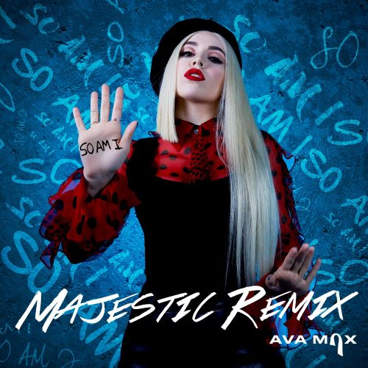
DOWNLOAD HIGH-RES ART

2019’s newest pop sensation Ava Max has collaborated with UK DJ legend Majestic for an official remix of her irresistibly catchy pop anthem “So Am I” – out now via Atlantic Records. The remix is available now at all DSPs and streaming services HERE. Released last month, the single boasts over 56 million global streams while the official video companion, which promotes a message of inclusivity and acceptance, has garnered over nearly 21 million views on YouTube alone (watch here). Overseas, the song is already skyrocketing as it nears Top 10 Overall Airplay in Europe. Max will soon take her energetic live performance on the road as she plays radio shows across North America – check out the full itinerary below.

“So Am I,” follows Max’s worldwide smash single “Sweet but Psycho” which has earned more than ¾ of a billion streams and overall global sales consumption in excess of 2 million. The companion video is now boasting over 265 million views via Ava Max’s official YouTube channel HERE. Produced by GRAMMY® Award-nominated super-producer Cirkut (Maroon 5, Miley Cyrus, The Weeknd) and co-written with Madison Love (Camila Cabello), “Psycho” – which reached #1 on both Spotify’s “United States Viral 50” and Billboard’s “Dance Club Songs” – is currently Top 5 at USA Pop Radio and climbing while ascending to 16 on the Billboard’s “Hot 100.” Ava made her national TV debut with performances of “Sweet but Psycho” on The Late Late Show with James Corden and The TODAY Show and most recently performed the hit single on The Ellen DeGeneres Show. She hit #1 on Billboard’s Emerging Artists Chart for 6 consecutive weeks and has received critical praise from Vanity Fair, Forbes, PAPER, V Magazine, Billboard, FADER, PAPER & more.

Majestic (real name Kevin Christie); house producer, garage MC and resident Kiss FM DJ started out as an MC performing on the North London nightclub circuit at just fifteen years of age. Majestic has since crossed into a multitude of dance music genres from UK Garage to House to Drum & Bass and Dubstep performing with leading artists across the scene such as Sigma, DJ EZ, MJ Cole, Judge Jules, Micky Slim, Jack Beats, Laidback Luke, The Wideboys, Netsky, High Contrast, Loadstar, Shy FX, Skream, Prodigy, Nero, Jacob Plant, Craig David, Tinie Tempah, and Stormzy to name a few. He has had five sold out London shows and 2x UK Top Compilation albums. With over 5 million plays on three singles, Majestic is rising in the industry.

CATCH AVA MAX ON THE ROAD:
5/30 – KLUC Las Vegas – Summer Jam 2019 – The Chelsea at the Cosmopolitan
6/2 – KYLD San Francisco – WAZZMATAZZ – Shoreline Amphitheatre
6/15 – WKTU New York – KTUPhoria – Northwell Health @ Jones Beach Theater
6/16 – WXKS Boston – 2019 Kiss Concert – Xfinity Center
6/20 – WKSE Buffalo – Kiss The Summer Hello 2019 – Canalside
6/21 – WZPL Indianapolis – ZPL Birthday Bash – The Lawn
6/22 – B96 Chicago – B96 Summer Bash – Allstate Arena
6/23 – WXSS Milwaukee – Kiss The Summer Hello – Eagles Ballroom

(Press Photo Credit: Lauren Dunn – download high res)

CONNECT WITH AVA MAX:
OFFICIAL I INSTAGRAM I TWITTER I FACEBOOK | SOUNDCLOUD | PRESS ASSETS

CONNECT WITH MAJESTIC:
OFFICIAL I INSTAGRAM I TWITTER I FACEBOOK | YOUTUBE

CONTACT:
Andrew George / andrew.george@atlanticrecords.com

