AVA MAX
JOINS FORCES WITH LAUV AND SAWEETIE
FOR “KINGS & QUEENS PT. 2”

CLICK HERE TO LISTEN

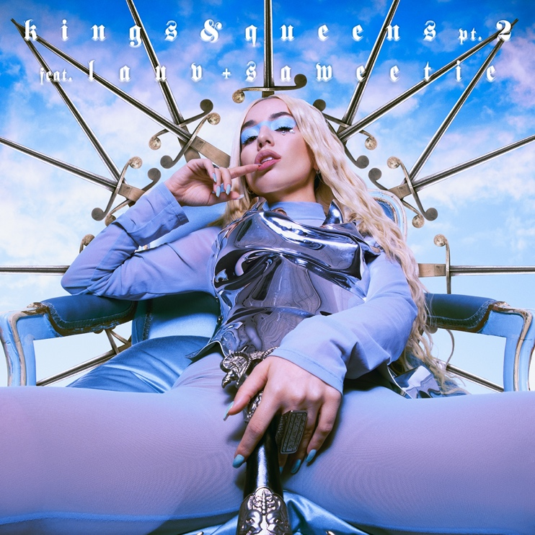

CLICK HERE TO DOWNLOAD ARTWORK

Los Angeles (August 6, 2020) – Global pop sensation Ava Max has joined forces with pop visionary Lauv and rapper Saweetie for “Kings & Queens Pt. 2.” The track is available on all DSPs and streaming services today.

Click HERE to listen.

“Kings & Queens” is #1 on European airplay and is climbing at Top 40 radio. The song receives nearly 25 million streams per week globally, has more than 200,000 Creates on TikTok and sits within the Top 50 on Apple Music in 20 countries.

The newly reimagined version comes on the heels of Ava’s latest single and video, “Who’s Laughing Now,” and the announcement of her highly-anticipated debut album Heaven & Hell being released September 18.

Click HERE to pre-order the album.
Click HERE to purchase merch bundles.

A truly international artist, Ava sealed her pop superstar status with the blockbuster success of the RIAA 3x-platinum certified hit, “Sweet but Psycho.” Currently boasting over 2 billion global streams and counting, “Sweet But Psycho” was named among the New York Times’ “54 Best Songs of 2019,” spent three weeks in the top 10 of Billboard’s “Hot 100,” peaked at #3 at US Pop Radio and earned Ava her first-ever Teen Choice Awards nomination for “Choice Pop Song.” The song was joined by an official video that is approaching 600 million views on YouTube. Produced by GRAMMY® Award-nominated super-producer Cirkut (Maroon 5, Miley Cyrus, The Weeknd) and co-written with Madison Love (Camila Cabello), “Sweet But Psycho” hit #1 on both Spotify’s “United States Viral 50” and Billboard’s “Dance Club Songs” while becoming one of “The Top Most-Shazamed Songs of 2019.” The song’s stateside success followed the track’s remarkable popularity abroad, including four consecutive weeks atop the UK Singles Chart and #1 rankings on charts in nearly 20 countries

FOLLOW AVA MAX:
Website | Instagram | Facebook | Twitter | TikTok | YouTube | Spotify | Apple Music

PRESS CONTACTS:
DPR
Carleen Donovan
carleen@donovanpublicrelations.com
Amanda Brophy
amanda@donovanpublicrelations.com

Atlantic Records
Andrew George
andrew.george@atlanticrecords.com

