AVA MAX
RELEASES “OMG WHAT’S HAPPENING”

LATEST SINGLE OFF FORTHCOMING
DEBUT ALBUM HEAVEN & HELL

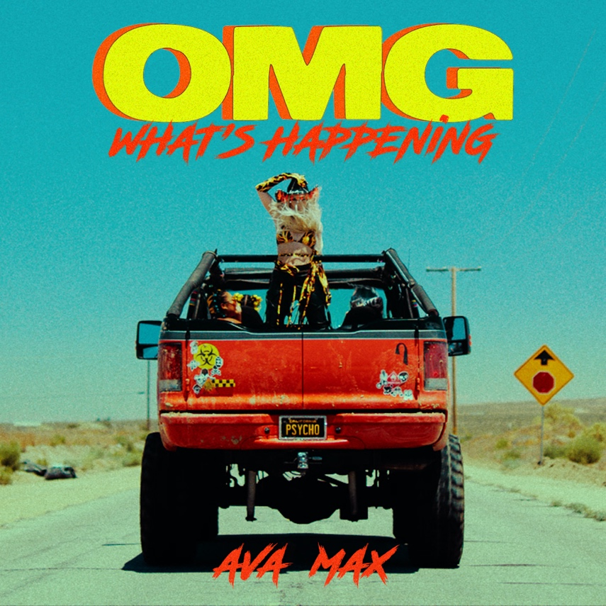

CLICK HERE TO DOWNLOAD ARTWORK

Los Angeles (September 3, 2020) – Global pop sensation Ava Max has today released new single “OMG What’s Happening” and revealed the tracklist for her highly-anticipated debut album Heaven & Hell out September 18.

Click HERE to listen.
Click HERE to watch the lyric video.

Heaven & Hell tracklist:

Side A – Heaven:
1. H.E.A.V.E.N
2. Kings & Queens
3. Naked
4. Tattoo
5. OMG What’s Happening
6. Call Me Tonight
7. Born to the Night
Purgatory:
8. Torn
Side B – Hell:
9. Take You To Hell
10. Who’s Laughing Now
11. Belladonna
12. Rumors
13. So Am I
14. Salt
15. Sweet But Psycho

Click HERE to pre-order the album.
Click HERE to purchase merch bundles.

ABOUT AVA MAX:
Outspoken, yet mysterious. Empowered, and also vulnerable. Sweet, but psycho... Duality drives Ava Max, cementing her as one of the most-listened to pop artists in the world. The daughter of Albanian immigrants grinded since grade school and exploded on a global scale with the 2018 triple-platinum smash “Sweet but Psycho.” Streamed over 2 billion times by 2020, it clinched a spot in the Top 10 of the Billboard Hot 100 for three weeks. As the tune took the world by storm, The New York Times named it among the “54 Best Songs of 2019,” and Rolling Stone christened her “An Artist You Need To Know.” Becoming inescapable, “Sweet but Psycho” received a nomination in the category of “Choice Pop Song” at the Teen Choice Awards as she took home “Best Push Artist” at the 2019 MTV Europe Music Awards. In addition to performing on The Late Late Show with James Corden, Jimmy KIMMEL LIVE!, and The TODAY Show, she appeared in features by Vanity Fair, Billboard, PAPER, FORBES, and more. She only accelerated this rapid rise to pop superstardom with the gold-selling “So Am I” [357 million Spotify streams], “Salt” [177 million Spotify streams], and “Kings & Queens” [201 million Spotify streams]. Right out of the gate, “Who’s Laughing Now” continued this hot streak, amassing over 13 million YouTube views and 1.6 million streams in less than a week. In the middle of this whirlwind, she pieced together her 2020 full-length debut album, Heaven & Hell [APG/Atlantic Records].

FOLLOW AVA MAX:
Website | Instagram | Facebook | Twitter | TikTok | YouTube | Spotify | Apple Music

PRESS CONTACTS:
DPR
Carleen Donovan
carleen@donovanpublicrelations.com
Amanda Brophy
amanda@donovanpublicrelations.com

Atlantic Records
Andrew George
andrew.george@atlanticrecords.com

