AVA MAX
REVEALS SEPTEMBER 18 RELEASE DATE FOR EAGERLY AWAITED DEBUT ALBUM HEAVEN & HELL

NEW SINGLE “WHO’S LAUGHING NOW” OUT TODAY

WATCH THE OFFICIAL VIDEO HERE

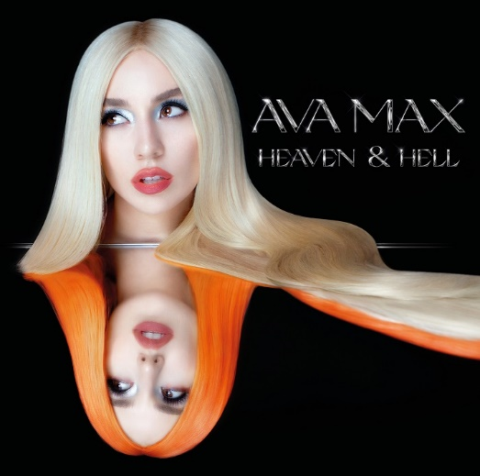

CLICK HERE TO DOWNLOAD ARTWORK & PRESS PHOTOS

Los Angeles (July 30, 2020) – Global pop sensation Ava Max has today revealed the September 18 release date of her highly anticipated debut album Heaven & Hell, as well as unveiled her new track and video for “Who’s Laughing Now.” The song is now available on all DSPs and streaming services, and the official video – directed by Isaac Rentz (Katy Perry, Mabel, Nick Jonas) and written by Ava and Isaac – can now be viewed on YouTube.

Click HERE to pre-order the album.
Click HERE to purchase merch bundles.
“I’ve been holding onto this secret for so long and am so excited I can finally talk about my debut album Heaven & Hell,” says Ava. “I put my heart and soul into making it and cannot wait to share my music with everyone.”

“Who’s Laughing Now” follows the release of Ava’s powerful anthem “Kings & Queens,” which is #1 on European airplay and made its debut at Top 40 radio. The song receives nearly 25 million streams per week globally, has more than 200,000 Creates on TikTok and sits within the Top 50 on Apple Music in 20 countries. The official video has accumulated more than 62 million views and sees Ava set in a heavenly throne room where she rules as a glamorous queen over an army of loyal dancers.

A truly international artist, Ava sealed her pop superstar status with the blockbuster success of the RIAA 3x-platinum certified hit, “Sweet but Psycho.” Currently boasting over 2 billion global streams and counting, “Sweet But Psycho” was named among the New York Times’ “54 Best Songs of 2019,” spent three weeks in the top 10 of Billboard’s “Hot 100,” peaked at #3 at US Pop Radio and earned Ava her first-ever Teen Choice Awards nomination for “Choice Pop Song.” The song was joined by an official video that is approaching 600 million views on YouTube. Produced by GRAMMY® Award-nominated super-producer Cirkut (Maroon 5, Miley Cyrus, The Weeknd) and co-written with Madison Love (Camila Cabello), “Sweet But Psycho” hit #1 on both Spotify’s “United States Viral 50” and Billboard’s “Dance Club Songs” while becoming one of “The Top Most-Shazamed Songs of 2019.” The song’s stateside success followed the track’s remarkable popularity abroad, including four consecutive weeks atop the UK Singles Chart and #1 rankings on charts in nearly 20 countries.

Dubbed an “Artist You Need to Know” by Rolling Stone, Ava has been feted with a wide range of media attention including high profile features in Vanity Fair, Billboard, FORBES, PAPER, and more. The pop star first took over TV with performances of “Sweet but Psycho” on CBS’s The Late Late Show with James Corden, NBC’s TODAY, and the Ellen DeGeneres Show, as well as a summer performance of her RIAA-certified gold single “So Am I,” on ABC’s Jimmy Kimmel Live. Ava became one of 2019’s most honored performers, including “Best New Artist” nominations at both the 2019 MTV Video Music Awards and the 2019 MTV Europe Music Awards. The latter was highlighted by both Ava’s first-ever win for “Best Push Artist” and show-stopping live performances of both “Torn” and “Sweet But Psycho,” streaming now HERE.

FOLLOW AVA MAX:
Website | Instagram | Facebook | Twitter | TikTok | YouTube | Spotify | Apple Music

PRESS CONTACTS:
DPR
Carleen Donovan
carleen@donovanpublicrelations.com
Amanda Brophy
amanda@donovanpublicrelations.com

Atlantic Records
Andrew George
andrew.george@atlanticrecords.com

