**AVONLEA RELEASES MUSIC VIDEO FOR “AGAIN”**

**WATCH** [**HERE**](http://avonlea.lnk.to/againPR/youtube)

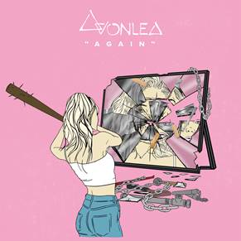

Today, rising singer-songwriter Avonlea releases the music video for her latest track “[Again](https://urldefense.proofpoint.com/v2/url?u=https-3A__COM.us12.list-2Dmanage.com_track_click-3Fu-3Dd603194f10cf782b3db0023cb-26id-3D421063acab-26e-3D4ccb010e84&d=DwMFaQ&c=Ftw_YSVcGmqQBvrGwAZugGylNRkk-uER0-5bY94tjsc&r=IJHKnmAZQa7xGOQ_e8OAY35U13_8uDdm_v5fM9HEtRQ&m=rF7lbQpounlHConmJ_XTjKUTSrdvYyiA47-pBIJeTTI&s=GYpRGxAPSr-UTVehW1g8PcpRsCqhvLQWwweo63ryTpo&e=),” off of her forthcoming self-penned project *10 2 17 (*Art Club/Atlantic). The song and video has critics raving with *Billboard* calling it a "stunning visual...bringing viewers an emotional and heartbreaking depiction of Avonlea's intense message," and *L’Officiel USA* praising, “Avonlea’s lo-fi beats, easy pop hooks, and haunting voice are the definition of mellow millennial pop.”

The upcoming EP showcases a series of deeply honest tracks that detail the different stages of Avonlea’s adolescence from ages 10-17. “Again” represents Avonlea’s experience at the age of 15 and follows debut track “[It Sucks](https://urldefense.proofpoint.com/v2/url?u=https-3A__COM.us12.list-2Dmanage.com_track_click-3Fu-3Dd603194f10cf782b3db0023cb-26id-3De703bdb612-26e-3D4ccb010e84&d=DwMFaQ&c=Ftw_YSVcGmqQBvrGwAZugGylNRkk-uER0-5bY94tjsc&r=IJHKnmAZQa7xGOQ_e8OAY35U13_8uDdm_v5fM9HEtRQ&m=rF7lbQpounlHConmJ_XTjKUTSrdvYyiA47-pBIJeTTI&s=oUAULqvifOJ79IAySCAmbYW3h6PolXaC7sS-YxCgxog&e=)” and second single “[Cars and Boys](https://urldefense.proofpoint.com/v2/url?u=https-3A__COM.us12.list-2Dmanage.com_track_click-3Fu-3Dd603194f10cf782b3db0023cb-26id-3Da596714b55-26e-3D4ccb010e84&d=DwMFaQ&c=Ftw_YSVcGmqQBvrGwAZugGylNRkk-uER0-5bY94tjsc&r=IJHKnmAZQa7xGOQ_e8OAY35U13_8uDdm_v5fM9HEtRQ&m=rF7lbQpounlHConmJ_XTjKUTSrdvYyiA47-pBIJeTTI&s=SyM92P1hP8lxR4EiJCwy7fVjnSriExeLfOB8H8rZ1Qw&e=)” – representing ages 14 and 16 respectively. The official music video for “It Sucks” has garnered well over one million views since its release. “Cars and Boys” received high praise from *NYLON* who applauded the track as “filled with poignant lines that are beautifully morose in their simplicity.”

18-year-old Avonlea is a multi-instrumentalist who began producing and songwriting at a very young age. She recently collaborated with producer Oshi on their track “Whispers” to rave reviews, and opened for Jhené Aiko on the singer’s 2018 European “Trip Tour”. With a firm grasp on what she believes in, Avonlea’s musical talents mirror her abilities to be incredibly self-aware, raw and vulnerable all at the same time. Avonlea’s fierce feminist spirit and independent nature are reflective in her music, and push her to accomplish one goal - for her fans to find solace in her songs.

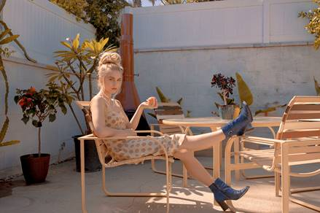

**\***Download Single Art [HERE](https://warnermusicgroup.box.com/s/6snhxrlocg2zhc4596cwss80eaub4sgn)*   
(Press Photo Credit: Sarah Bahbah – [download high res](https://warnermusicgroup.box.com/s/wyei7du5hg0842zcgugjk94zwoy9jrko))

**WATCH MUSIC VIDEO FOR “AGAIN”** [**HERE**](http://avonlea.lnk.to/againPR/youtube)

**BUY/STREAM “AGAIN”** [**HERE**](https://urldefense.proofpoint.com/v2/url?u=https-3A__COM.us12.list-2Dmanage.com_track_click-3Fu-3Dd603194f10cf782b3db0023cb-26id-3De66a985d6e-26e-3D4ccb010e84&d=DwMFaQ&c=Ftw_YSVcGmqQBvrGwAZugGylNRkk-uER0-5bY94tjsc&r=IJHKnmAZQa7xGOQ_e8OAY35U13_8uDdm_v5fM9HEtRQ&m=rF7lbQpounlHConmJ_XTjKUTSrdvYyiA47-pBIJeTTI&s=AAGIxsx92eFgZBXTbpjQjvXr6UxEKuqL3SndJYyriZI&e=)

**CONNECT:**  
[Website](http://www.avonleamusic.com/)| [Instagram](https://www.instagram.com/avonleamusic/) | [Facebook](https://www.facebook.com/Avonlea-528900163801625/) | [Twitter](https://twitter.com/avonlea_music?lang=en) | [YouTube](https://www.youtube.com/user/avonleashow)  
   
**CONTACT:**  
Chelsey Northern | [chelsey.northern@atlanticrecords.com](mailto:chelsey.northern@atlanticrecords.com)  
Erica Gerard | [Erica.Gerard@pmkbnc.com](mailto:Erica.Gerard@pmkbnc.com)  
Lauren Morris | [Lauren.Morris@pmkbnc.com](mailto:Lauren.Morris@pmkbnc.com)  
 Kelli Tomashoff | [Kelli.Tomashoff@pmkbnc.com](mailto:Lauren.Morris@pmkbnc.com)