AVONLEA DROPS “CARS AND BOYS”

MUSIC VIDEO OUT NOW

"AVONLEA'S 'CARS AND BOYS' IS AN ANTHEM FOR ADOLESCENT OUTCASTS. WE'VE GOT GOOSEBUMPS."
NYLON

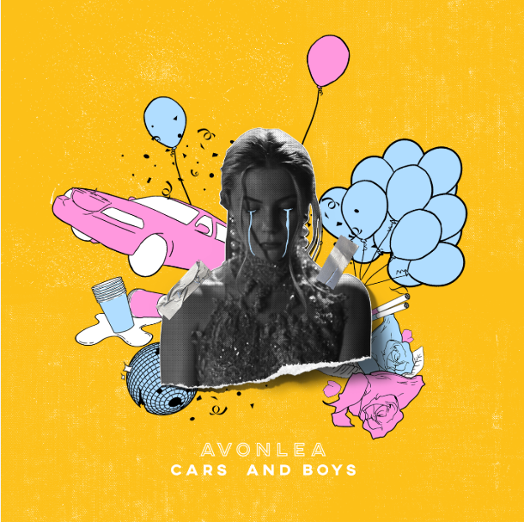

FOLLOWS DEBUT TRACK “IT SUCKS” OFF FORTHCOMING PROJECT
10 2 17

AVAILABLE NOW VIA ALL STREAMING SERVICES
WATCH: HERE | BUY/STREAM: HERE

Los Angeles, CA (August 10, 2018) – Today, up-and-coming singer/songwriter Avonlea has revealed her mesmerizing new single “Cars and Boys” with accompanying music video -- off her forthcoming self-penned project 10 2 17 (Art Club/Atlantic). The song and video exclusively premiered with Nylon who praised the track saying, "'Cars and Boys'" is armed with a sweeping chorus that's almost Lana Del Rey-esque in its dramaticism...filled with poignant lines that are beautifully morose in their simplicity." In true Avonlea fashion, the video is deeply raw and honest, showcasing the singer at her most vulnerable state. “Cars and Boys” is the latest installment of unapologetically candid tracks detailing the different stages of the young starlet’s adolescence and acts as an expression of the emotions brought upon by coming of age. Each of the seven songs on 10 2 17 represent different years of Avonlea’s life between ages 10 to 17, with “Cars and Boys” representing age 16. “Cars and Boys” is out today via ArtClub/Atlantic Records.
“'Cars and Boys' is very personal to me” divulges Avonlea, “It's about not having the classic teen experience that you see in the movies. Dances, partying, romance etc. I didn't go to high school so I wasn't involved with a lot of people my age. I spent a lot of time writing. That's where the song stemmed from. Life isn't like what you see in the films.”

“Cars and Boys” follows the debut track off 10 2 17 titled “It Sucks,” which narrows in on the 14-15 age range with an accompanying music video that tackles themes of underage drinking and teen romance. Impressively, the video is already just shy of 1 million views. Watch “It Sucks” here. Avonlea also recently collaborated with producer Oshi on their track “Whispers.” Noise Porn celebrated the track and praised the young singer, saying “Avonlea’s sultry vocals elevate the track into goosebumps-worthy territory.” Avonlea has opened for Jhene Aiko on the singer’s 2018 European “The Trip Tour.”

At only 18 years old, Avonlea is a young artist with developed songwriting skills and a firm grasp on what she believes in. A multi-instrumentalist, she began producing at the age of 12. Avonlea’s musical talents mirror her independent nature and feminist spirit, determined to accomplish just one goal. She recalls a recent session where she was writing “and crying my eyes out, getting tears all over the organ that I was playing. Thinking. ‘Man. This fuckin’ hurts. But I know that I will feel better once it’s out.’ I really hope that someone will find solace in my words.”
*Download Single Art HERE*
(Press Photo Credit: Sarah Bahbah -- download high res)

CONNECT:
Website| Instagram | Facebook | Twitter | YouTube| Soundcloud

CONTACT:
Chelsey Northern | chelsey.northern@atlanticrecords.com
Erica Gerard | Erica.Gerard@pmkbnc.com
Lauren Morris | Lauren.Morris@pmkbnc.com
Kelli Tomashoff | kelli.tomashoff@pmkbnc.com

