BAZZI UNVEILS NEW VIDEO FOR “CRAZY”!

WATCH HERE!

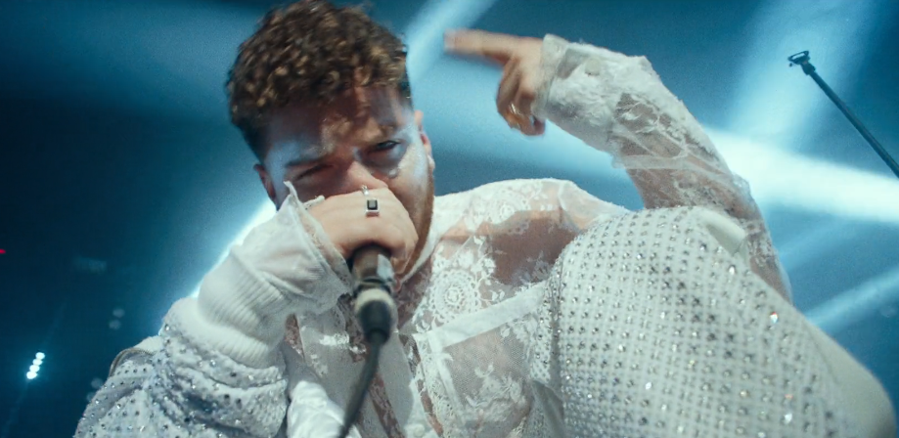

Multi-platinum singer-songwriter Bazzi unveiled the video for his single, “Crazy” – an intoxicating visual, today via iamcosmic/Atlantic Records. Watch HERE! The track, penned by Bazzi and produced by Bazzi and Kevin White from Rice N’ Peas, comes from his forthcoming project. “Crazy” made its broadcast premiere today on MTV Live and MTVU and its digital premiere via YouTube and Facebook. Keep on the lookout for more new music coming from Bazzi soon.

About Bazzi:
Multi-platinum singer-songwriter, Bazzi, released his debut album, COSMIC, in 2018 which has proven to be a worldwide chart success and now certified platinum; fueled in part by his international smash single, “Mine,” which is now 4x RIAA certified platinum. In 2019, Bazzi performed on both the main stage during Coachella and also Lollapalooza. Bazzi spent much of 2018 on THE COSMIC TOUR, including a sold-out headline run and special guest role on Camila Cabello’s sold out “Never Be The Same” North American tour. Additionally, Bazzi served as special guest on the European leg of Justin Timberlake’s blockbuster 2018 “Man Of The Woods Tour.” COSMIC which also features stand-out tracks “Honest,” “Myself,” “3:15” and “Why?” reached the Top 15 on the Billboard 200, with similar rankings in Canada, Denmark, Finland, New Zealand, Norway, among others. His hit single, “Mine,” reached #1 at Top 40 while ascending to top 3 at Rhythmic and #11 on the overall Billboard “Hot 100.” Named among Billboard’s “50 Best Songs of 2018 (So Far),” the single received RIAA platinum certification in the United States, earning additional platinum awards in Australia, Canada, New Zealand, and Sweden. An online phenomenon, amassing over 600M streams to date, “Mine” reached #1 on Apple Music’s “Pop Streaming” chart and Shazam’s “Global Top 100,” and went top 5 on Spotify’s overall “Global Top 50.” The music video for “Mine” is also a massive favorite garnering over 157M views via YouTube alone. Written predominantly by Bazzi and produced by Rice N’ Peas and Bazzi, COSMIC has received ecstatic critical applause. In 2017, Bazzi released “Beautiful” featuring Camila Cabello. The song was certified 3x platinum and the video currently has over 140 million views. Bazzi Released his mixtape, SOUL SEARCHING, in 2019 which included hits “I.F.L.Y.,” “Focus (Feat. 21 Savage),” and RIAA certified platinum “Paradise.” Most recently, Bazzi released his newest tracks, “Crazy”, “Young & Alive”, “Renee’s Song”, “I Got You” and “I Don’t Think I’m Okay”. Keep on the look out for new music coming from Bazzi this year.

Connect with Bazzi:
bazziofficial.com | Instagram| Facebook| Twitter| YouTube| SoundCloud| Press Assets

Press Contacts:
Sheila Richman: Sheila.Richman@AtlanticRecords.com
Trish Mollo: Trish.Mollo@AtlanticRecords.com

