FOR IMMEDIATE RELEASE
AUGUST 13, 2021

BEN PLATT UNVEILS EAGERLY AWAITED NEW ALBUM, REVERIE

GRAMMY®, TONY®, AND EMMY® AWARD-WINNER ANNOUNCES
BIGGEST NORTH AMERICAN HEADLINE TOUR TO DATE

PRESALES BEGIN THURSDAY, AUGUST 19;
PUBLIC ON-SALES START FRIDAY, AUGUST 27 AT 10 AM (LOCAL)

NEW ALBUM CELEBRATED WITH VERY SPECIAL LIVE PERFORMANCE
STREAMING HERE

PERFORMANCE ON THIS MORNING’S
NBC’S TODAY 2021 CITI MUSIC SERIES
STREAMING HERE

UPCOMING TV APPEARANCES INCLUDE NBC’S LATE NIGHT WITH SETH MEYERS,
SET FOR MONDAY, AUGUST 16

REVERIE AVAILABLE NOW VIA ATLANTIC RECORDS HERE

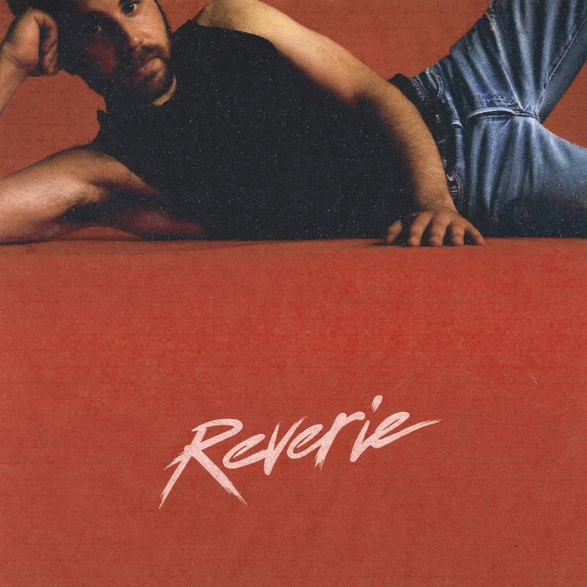
DOWNLOAD HI RES ALBUM COVER ART HERE
DOWNLOAD HI RES PRESS IMAGES HERE

GRAMMY®, TONY®, and Emmy® Award-winning artist Ben Platt is proud to announce today’s release of his eagerly awaited new album. REVERIE is available now via Atlantic Records HERE.

Platt will mark the arrival of REVERIE with his biggest North American headline tour to date, set to kick off February 23, 2022 at Orlando’s Amway Center culminating with the tour finale on April 8, 2022 at Los Angeles’s legendary Hollywood Bowl. Among the tour’s indisputable highlights will be Platt’s first ever headline show at New York City’s world-famous Madison Square Garden, set for March 6, 2022.

Fans can register for presales now HERE. American Express® Card Members can purchase tickets before the general public beginning Thursday, August 19 at 10 am local time through Thursday, August 26 at 10 pm local time, no presale registration needed. Additional presales begin Monday, August 23rd at 10 am (local). Public on-sales start on Friday, August 27 at 10 am (local). For complete details and ticket availability, please visit www.benplattmusic.com. A limited number of exclusive VIP Packages are also available. Packages include an amazing selection of reserved seated tickets, custom merchandise and more.

In addition, last night Platt performed a very special YouTube live stream performance from Los Angeles which can be streamed HERE and this morning saw Platt heralding REVERIE with a show-stopping performance on NBC’s TODAY as part of their 2021 Citi Music Series, streaming now HERE. Next week will see Ben visiting NBC’s Late Night with Seth Meyers as both lead guest and musical performer, set for Monday, August 16th (check local listings). This week’s appearances mark the latest in a recent series of high profile TV performances and interviews, including the live season finale of NBC’s The Voice, the nationally syndicated Kelly Clarkson Show (streaming HERE), and CBS’s The Late Late Show with James Corden (streaming HERE). Additional TV appearances will be announced soon.

Platt’s much anticipated second solo album, REVERIE includes such extraordinary new singles as “Happy To Be Sad” and “Imagine,” both available now on all digital platforms. Produced by Michael Pollack (Justin Bieber, Katy Perry) and Zach Skelton (Jonas Brothers, Paul McCartney) with additional production from GRAMMY® Award nominee Gian Stone (Maroon 5, Dua Lipa), “Happy To Be Sad” was met with applause from Billboard, which raved, “On ‘Happy To Be Sad,’ the singer beautifully illustrates the portrait of a lover having to leave his significant other for a while, and simply reveling in the sadness as a source of pure joy. It's a confusing emotion to describe until you hear Platt's cherubic vocals sing the words – then it feels like it's happening to you right in this moment.” “Happy To Be Sad” is joined by an official companion visualizer, streaming HERE.

“Imagine” arrived earlier this summer and has fast proven one of Platt’s biggest singles to date. Produced by The Monsters & Strangerz and Jon Bellion – the superstar team behind such hits as Maroon 5’s “Memories,” Justin Bieber’s “Holy,” and “Prisoner” by Miley Cyrus Feat. Dua Lipa – and co-written by Platt with Bellion, Michael Pollack, Alexander Izquierdo, Jordan K. Johnson, and Stefan Johnson, the track now boasts over 20M worldwide streams and counting. Hailed by Rolling Stone as “tender and confident… a tribute to everyday saviors,” “Imagine” reached #7 on iTunes’ “Top Pop Songs”, to the “30 Hot AC Hit” list, and the top 50 on Spotify’s “US Viral 50” while also lighting up Hot AC Radio outlets nationwide. An official music video, directed by Matty Peacock (Billie Eilish, Shawn Mendes, Selena Gomez), is streaming now via YouTube HERE.

Platt followed “Imagine” with a series of creative reworks including the stripped-down “Imagine (Acoustic)” (available HERE) and the mesmerizing “Imagine (Tiësto Remix)” an unprecedented collaboration with GRAMMY® Award-winning, platinum-certified, international icon Tiësto available HERE; an official visualizer is streaming HERE.

What’s more, Platt recently unveiled a spectacular cover of Lady Gaga’s classic “Yoü And I,” featured on her newly released BORN THIS WAY 10th anniversary celebration, BORN THIS WAY: REIMAGINED. The track earned raves from such major outlets as Billboard, which wrote, “Ben Platt is the one artist here with the Broadway vocal chops to match Gaga – but instead of aping Gaga’s rock ‘n’ roll swagger, he brings out the tenderness…Love songs are the bread and butter of pop music, but the truth is, it’s hard to be this sincere and vulnerable, to sing with no armor at all. Ben Platt makes it feel utterly natural.” An official music video is streaming now HERE.

“Imagine” represented the first new music from Platt since 2019’s “So Will I, available HERE. Produced by multiple GRAMMY® Award-winner Finneas (Billie Eilish, Halsey, Camila Cabello) and applauded by Rolling Stone as “moving, inspiring…a powerful new ballad,” “So Will I” is featured on the deluxe edition of Platt’s acclaimed debut album, SING TO ME INSTEAD. The expanded collection also includes live material recorded during Platt’s sold-out 2018 headline show at New York City’s legendary Radio City Music Hall, filmed for the concert special, Ben Platt Live From Radio City Music Hall, which streamed exclusively on Netflix.

SING TO ME INSTEAD proved a full-fledged sensation upon its March 2019 release, amassing over 337M global streams and earning applause from fans and critics alike. A truly multi-faceted actor, singer, and all-around performer, the album saw Platt making a remarkable arrival as a solo recording artist and a songwriter, co-writing all of the album’s 12 songs. Highlights include “Bad Habit,” “Ease My Mind,” “Grow As We Go,” and “Temporary Love,” all of which are joined by official music videos streaming HERE.

The winner of the 2017 Tony® Award for “Best Leading Actor in a Musical” for his performance as Evan Hansen in the smash hit, Dear Evan Hansen, Platt also received a GRAMMY® Award for his role on Atlantic’s DEAR EVAN HANSEN (ORIGINAL BROADWAY CAST RECORDING and a 2018 Daytime Emmy Award for his part in the cast’s powerful performance of “You Will Be Found” on NBC’s TODAY. Platt will reprise his role as Evan in the Dear Evan Hansen film, set for release on September 24th; watch the official trailer HERE.

Platt’s evolving body of work also includes memorable roles in the TONY® Award-winning original Broadway production of The Book of Mormon, the blockbuster films, Pitch Perfect and Pitch Perfect 2, and the acclaimed Netflix series, The Politician which earned him a Golden Globe nomination for “Best Actor in a Comedy,” among many others. Platt – who recently made a guest appearance on FOX’s The Simpsons, began filming Merrily We Roll Along with Beanie Feldstein directed by Richard Linklater which will be shot over the course of twenty years. He will soon be seen in BJ Novak’s anthology series, The Premise, a new comedy-drama coming to FX and Hulu; plus begin production on the film, The People We Hate At The Wedding alongside Kristen Bell and Allison Janney.

# # #

BEN PLATT
NORTH AMERICAN TOUR 2022
February 23 – Orlando, FL – Amway Center
February 25 – Hollywood, FL – Seminole Hard Rock Hotel & Casino
February 26 – Tampa, FL – Amalie Arena
February 28 – Atlanta, GA – Fox Theatre
March 2 – Fairfax, VA – EagleBank Arena
March 3 – Boston, MA – Agganis Arena
March 4 – Atlantic City, NJ – Hard Rock Live at Etess Arena
March 6 – New York, NY – Madison Square Garden
March 8 – Pittsburgh, PA – Petersen Events Center
March 9 – Columbus, OH – Schottenstein Center
March 11 – Toronto, ON – Coca-Cola Coliseum
March 13 – Detroit, MI – Masonic Temple Theatre
March 14 – Grand Rapids, MI – Van Andel Arena
March 16 – St. Louis, MO – The Fabulous Fox Theatre
March 18 – Minneapolis, MN – Target Center
March 19 – Chicago, IL – Wintrust Arena
March 22 – Nashville, TN – Bridgestone Arena
March 24 – Sugar Land, TX – Smart Financial Centre
March 25 – Grand Prairie, TX – Texas Trust CU Theatre at Grand Prairie
March 28 – West Valley City, UT – Maverik Center
March 30 – Seattle, WA – WAMU Theater
March 31 – Portland, OR – Theater of the Clouds
April 2 – Las Vegas, NV – The Theater at Virgin Hotels Las Vegas
April 3 – San Diego, CA – The Rady Shell at Jacobs Park
April 5 – Stanford, CA – Frost Amphitheater
April 6 – Santa Barbara, CA – Santa Barbara Bowl
April 8 – Los Angeles, CA – Hollywood Bowl

# # #

BEN PLATT
REVERIE
(Atlantic Records)

TRACK LISTING:

- king of the world pt 1
- childhood bedroom
- happy to be sad
- I wanna love you but I don’t
- leave my mind
- dance with you
- king of the world pt 2
- carefully
- chasing you
- come back
- dark times
- imagine
- king of the world pt 3

# # #

CONNECT WITH BEN PLATT
OFFICIAL | TWITTER | FACEBOOK | INSTAGRAM | YOUTUBE

# # #

CONTACT FOR BEN PLATT:
Sheila Richman | Sheila.Richman@atlanticrecords.com

CONTACT FOR BEN PLATT 2022 TOUR:
ERIK STEIN | ESTEIN@SOLTERS.COM
ANNA LOYNES | ALOYNES@SOLTERS.COM
MAXIE SOLTERS | MSOLTERS@SOLTERS.COM

ABOUT AEG PRESENTS
Combining the power of the live event with a focus on true artist development, AEG Presents is a world leader in the music and entertainment industries. Operating across four continents, the company has an unparalleled commitment to artistry, creativity, and community. Its tentpole festivals and multi-day music events — _which include the iconic Coachella Valley Music & Arts Festival, the legendary New Orleans Jazz & Heritage Festival, British Summer Time at Hyde Park, Stagecoach, Hangout Festival, Electric Forest, and Firefly — _continue to set the bar for the live music experience alongside such renowned clubs and theaters as Webster Hall, Eventim Apollo, Mission Ballroom, The Roxy and Forest Hills Stadium, to name a few. AEG Presents promotes global tours for such artists as Justin Bieber, Kenny Chesney, Celine Dion, Elton John, Paul McCartney, Katy Perry, The Rolling Stones, Ed Sheeran, and Taylor Swift, in addition to creating and developing an unmatched infrastructure for artist development and audience reach through its network of clubs, theatres, arenas, stadiums, renowned wholly owned brands Concerts West and Goldenvoice, and partner brands Messina Touring Group, Frontier Touring, The Bowery Presents, PromoWest Productions, Marshall Arts, and Zero Mile Presents. More information can be found at www.aegpresents.com.

