BIRDY RELEASES HER BRILLIANTLY ASSERTIVE NEW SINGLE ‘KEEPING YOUR HEAD UP’

BIRDY’S THIRD STUDIO ALBUM SET FOR RELEASE LATER THIS YEAR

LISTEN HERE
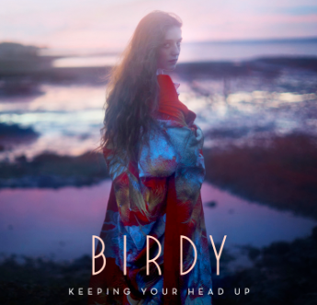

The incredible B irdyis back with a brand new sound on her compelling new single “Keeping Your Head Up,” out now via Atlantic Records.

The single was co-produced by Birdy and Steve Mac and has been chosen by the BBC as the sound-bed for previews of their forthcoming 2016 schedule.

Birdy is currently finishing her third album for release later in Spring 2016 – further details to follow.

Birdy commented on the track, “I hope the song is inspiring, it’s meant to feel powerful and uplifting. It’s about finding a light in the dark, having the strength to hold on to it and overcome the times when we feel completely lost.”

The last few years have seen Birdy work with a number of other artists and projects, including highly prestigious film scores. Most recently her song, “Let It All Go,” was released as a duet with Rhodes whilst her classic “Wings” was covered by Nothing But Thieves. Her music has been used in “The Hunger Games” and “Brave” whilst she was also commissioned to write specially for the film “The Fault In Our Stars.”

For more information:
Sheila Richman/Sheila.Richman@atlanticrecords.com
Ilana Gold / Ilana.Gold@atlanticrecords.com

