**BIRDY RELEASES BRAND NEW VIDEO FOR “WILD HORSES”**

***BEAUTIFUL LIES* OUT EVERYWHERE MARCH 25**

**WATCH “WILD HORSES” HERE:** [**https://www.youtube.com/watch?v=tCP6sXi33JE**](https://www.youtube.com/watch?v=tCP6sXi33JE)

*“I’m so excited to share the video for Wild Horses with you! I wrote this song about a free spirit remembering how strong she is. The video shows the story of a diver who falls in love with a siren and has to make a decision between life and living without her.” –***BIRDY**

[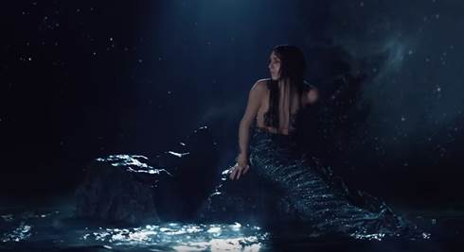](https://www.youtube.com/watch?v=tCP6sXi33JE)

UK singer/songwriter **Birdy** has released a brand new video for “Wild Horses” – a new track off her forthcoming album, “Beautiful Lies,” out everywhere March 25 via Atlantic Records. Birdy transforms into a mermaid in a mesmerizing underwater video, watch here: [**https://www.youtube.com/watch?v=tCP6sXi33JE**](https://www.youtube.com/watch?v=tCP6sXi33JE).

Birdy co-produced 6 of the 14 tracks on the album.  Producing credits go to Jim Abbiss (Arctic Monkeys/Adele) and MyRiot (London Grammar) while mixing duties were taken on by Craig Silvey (Arcade Fire/Florence and the Machine).

Discussing the album Birdy said; “This is my coming of age record. I’ve learned so much in the last few years and have been able to use the many experiences – good and bad - as inspiration when writing this album. This is the album that I’ve been able to steer most confidently and proudly, from the writing to the production to the artwork. A lot of the album is about finding light in the dark and overcoming the times when we feel completely lost.”