**BROODS**

**“FALLING APART”**

**NEW TRACK OUT NOW**

**NEW ALBUM**

***DON’T FEED THE POP MONSTER***

**OUT NEXT FRIDAY, FEB. 1**

**PERFORMING ON**

***THE LATE LATE SHOW WITH JAMES CORDEN* FEB. 7**

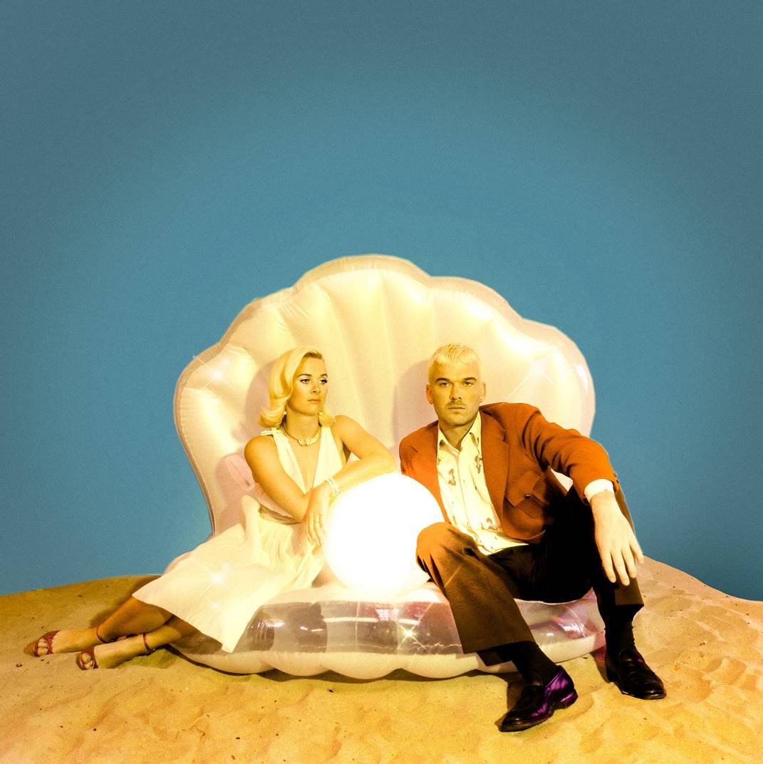

*Credit: Dana Trippe*

Broods have shared “Falling Apart,” a new track from their highly anticipated third studio album, *Don’t’ Feed The Pop Monster*, today. Georgia shares, “We wrote this song after the election a couple of years ago. Being in the thick of it in LA, we saw how divided the country was. People felt so estranged from one another. It felt like the echo chamber shattered and to a lot of people we knew, everything was falling apart.” Listen to “Falling Apart” here: [https://Atlantic.lnk.to/FallingApartPR](https://protect-us.mimecast.com/s/67QpCM851MF721V7uwnry1)

“Falling Apart” is the latest track Broods have released from their forthcoming album, *Don’t Feed The Pop Monster*, out next Friday, February 1 via Neon Gold/Atlantic Records. Earlier this month, Broods released the new track “Hospitalized,” and yesterday, they shared the music video for the track which features the viral dancing sensation Donté Colley. View the video [here](https://protect-us.mimecast.com/s/bYcACNk50NczZ85zT4YdNn).  In addition to “Hospitalized,” previous releases include  “Everything Goes (Wow)” and lead single “Peach,” which has amassed over 14 million streams. Last week, fans were able to get a preview of “Too Proud,” another new track from the forthcoming album that was featured on the winter premiere of *Grey’s Anatomy*.

Following album release, Broods will perform on *The Late Late Show with James Corden* on February 7th. In March, the band will embark on their spring headlining tour. Kicking off on March 26 in Santa Ana, CA, the tour will bring the band through Los Angeles, Seattle, Chicago, Boston, New York City and more (see below for a full list of dates). For tickets and more info, visit [https://www.broodsmusic.com/](https://protect-us.mimecast.com/s/lUFqCOY58OcMNjrMIkUU8Y).

*Don’t Feed The Pop Monster* is the band’s follow up to their sophomore record, *Conscious*, which they released in June 2016 and saw lead single “Free” hit the Top 10 on Spotify’s US Viral Chart. Broods had their breakthrough with the 2014 single “Bridges” from their full-length debut *Evergreen*. Broods have played leading festivals like Coachella, Lollapalooza and Outside Lands and shared stages with artists like Ellie Goulding, Haim, Sam Smith, CHVRCHES, and most recently, Taylor Swift.

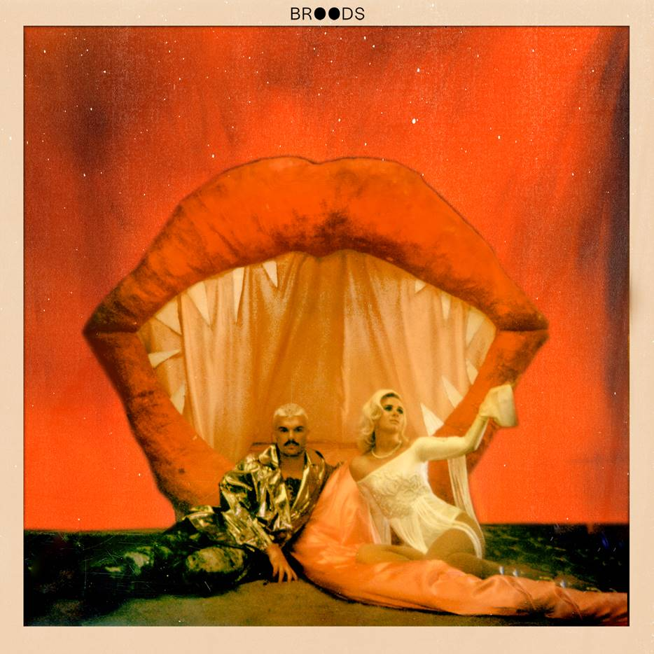

***DON’T FEED THE POP MONSTER* SPRING 2019 TOUR NORTH AMERICAN DATES:**

03.26   Santa Ana, CA            The Observatory

03.27   Los Angeles, CA         The Fonda

03.29   San Diego, CA            The Observatory North Park

03.30   San Francisco, CA      August Hall

04.01   Seattle, WA                 Neptune Theatre

04.02   Vancouver, BC           Vogue Theatre

04.03   Portland, OR               Wonder Ballroom

04.05   Salt Lake City, UT       In The Venue

04.06   Denver, CO                 Summit

04.07   Kansas City, MO         The Truman

04.08   St Paul, MN                 Amsterdam Hall

04.10   Chicago, IL                  Metro

04.12   Toronto, ON                The Phoenix

04.13   Montreal, QC              Fairmount

04.14   Boston, MA                 Paradise

04.16   Philadelphia, PA         Union Transfer

04.18   New York, NY             Irving Plaza

04.19   Asbury Park, NJ          Asbury Lanes

04.20   Washington, DC         The Fillmore Silver Spring

**Follow Broods:** [FACEBOOK](https://protect-us.mimecast.com/s/zkWWCPN5QPsP0RAPujwP22) | [INSTAGRAM](https://protect-us.mimecast.com/s/zMPXCQW57QHYXp4YurzB5P) | [TWITTER](https://protect-us.mimecast.com/s/NKZSCR651RhxG1PxtoX5Mu) | [WEBSITE](https://protect-us.mimecast.com/s/8MoyCVO0QYuY26jYuW_gS3)

**For More Information on Broods, please contact BT PR at 646.405.7010:**

Christopher Iacullo | [Chris@BTPR.biz](mailto:Chris@BTPR.biz)

Benny Tarantini | [Benny@BTPR.biz](mailto:Benny@BTPR.biz)