GRAMMY® AWARD-WINNING AFROFUSION SUPERSTAR BURNA BOY
UNVEILS NEW SINGLE “KILOMETRE” WITH MUSIC VIDEO

LISTEN TO/WATCH “KILOMETRE” HERE

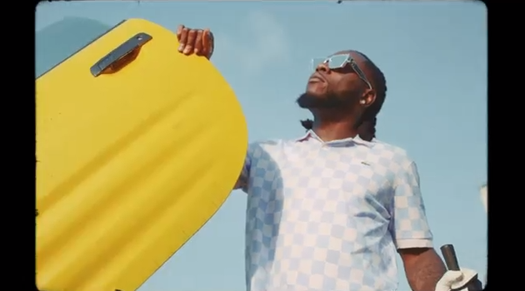

Nigeria's music export and Afrofusion pioneer Burna Boy premieres his first solo single following his GRAMMY® Award-winning 2020 album, TWICE AS TALL, today. “Kilometre” (written and performed by Burna Boy and produced by Chopstix) is available now with an accompanying high energy music video that features Burna Boy. Watch HERE.

The groundbreaking Nigerian artist’s fifth studio album TWICE AS TALL proved an immediate sensation, earning more than 5M worldwide streams within its first hour of release. Fueled by such singles as “Wonderful,” “Monsters You Made (Feat. Chris Martin), “ Real Life (Feat. Stormzy),” and “23,” TWICE AS TALL – which features additional collaborations with Youssou N’Dour, Sauti Sol, and Naughty by Nature – debuted at #1 on Billboard’s “US World Albums” chart while receiving unprecedented worldwide critical acclaim. Among its countless accolades, TWICE AS TALL received the 2021 GRAMMY® Award for “Best Global Music Album,” having already made history as the first time a Nigerian artist received back-to-back nominations in the category (following 2019’s GRAMMY® Award-nominated AFRICAN GIANT). What’s more, TWICE AS TALL was named among 2020’s very best by a wide span of global publications, including The New York Times, The FADER, Consequence of Sound, British GQ, NME, Pitchfork, Vice, and Uproxx, to name but a few.

2021 has already seen Burna Boy join forces with diverse fellow artists for such collaborations as Becky G x Burna Boy’s “Rotate,” featured in Pepsi’s global football campaign, “Music Keeps Us Fizzing.” Burna Boy also allied with 9x GRAMMY® Award-nominee Sia for “Hey Boy (Feat. Burna Boy),” available now via Monkey Puzzle/Atlantic HERE. The song arrived alongside an eye-popping animated video, directed by Rafatoon (Katy Perry, Deftones, Savage X Fenty) and now boasting over 15M individual views at YouTube HERE.
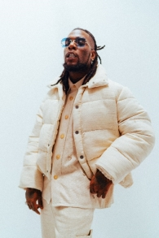
DOWNLOAD OFFICIAL PRESS PHOTO HERE
CONNECT WITH BURNA BOY
TWITTER | FACEBOOK | INSTAGRAM | YOUTUBE
PRESS CONTACTS
Corey Brewer | Corey.Brewer@atlanticrecords.com
Selam Belay | Selam.Belay@atlanticrecords.com

