FOR IMMEDIATE RELEASE

OCTOBER 9TH, 2020

**MULTI-PLATINUM RAPPER O.T. GENASIS TEAMS UP WITH CHRIS BROWN AND CHARLIE WILSON**

**TO INTRODUCE LEGENDARY COLLABORATION “BACK TO YOU”**

**LISTEN HOW** [**HERE**](https://nam04.safelinks.protection.outlook.com/?url=https%3A%2F%2Fotgenasis.lnk.to%2FBackToYou&data=02%7C01%7CAlyssa.Reddish%40atlanticrecords.com%7C359d2834b3a6424a3ab008d86bdfe52f%7C8367939002ec4ba1ad3d69da3fdd637e%7C0%7C0%7C637377956650448857&sdata=B5VA25CI8I%2FUxsX3ErElLkojvnxDMfvLHNvxwKsJJq8%3D&reserved=0)

**DEBUT ALBUM *LEAVE ME ALONE I’M DRUNK* COMING SOON**

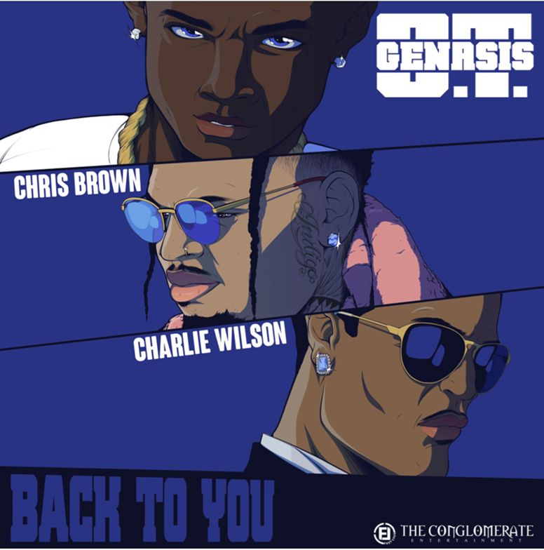

Today, O.T. GENASIS has officially released his superstar collaboration with Chris Brown and Charlie Wilson, “Back To You.” The upbeat melody, in which O.T. Genasis’ bars are accentuated by Chris Brown’s angelic hymns and the legendary vocals of Charlie Wilson, is now available via all digital streaming platforms [HERE](https://nam04.safelinks.protection.outlook.com/?url=https%3A%2F%2Fotgenasis.lnk.to%2FBackToYou&data=02%7C01%7CAlyssa.Reddish%40atlanticrecords.com%7C359d2834b3a6424a3ab008d86bdfe52f%7C8367939002ec4ba1ad3d69da3fdd637e%7C0%7C0%7C637377956650448857&sdata=B5VA25CI8I%2FUxsX3ErElLkojvnxDMfvLHNvxwKsJJq8%3D&reserved=0). On the new record, O.T. takes a more relaxed approach, rapping about the lavish lifestyle he’s afforded his girl, equally complimenting both Chris Brown and Charlie Wilson’s rich, soulful melodies.

“Back To You” arrives via Conglomerate Entertainment/Fast Lyfe/Atlantic Records, the latest since O.T. Genasis’ May release of “I Look Good.” Accompanied by a witty, creative companion visual that highlights the different ways O.T. has spent his time in quarantine—from dancing around the house creating Tik Toks to cooking and flexing his fit—the record couldn’t have been released at a better time. Check it out [HERE](https://nam04.safelinks.protection.outlook.com/?url=https%3A%2F%2Fwww.youtube.com%2Fwatch%3Fv%3D4mHuvmhvD8Y&data=02%7C01%7CAlyssa.Reddish%40atlanticrecords.com%7C187caf3162354e9213eb08d86badc394%7C8367939002ec4ba1ad3d69da3fdd637e%7C0%7C0%7C637377741357168912&sdata=1ujc029DIuY2G%2BKRhgGaVq3oqmsHie4xIc7reJx9OgA%3D&reserved=0).

Earlier this year, O.T. Genasis collaborated with both Mustard on “[Big Shot](https://nam04.safelinks.protection.outlook.com/?url=https%3A%2F%2Fotgenasis.lnk.to%2FBigShotPR&data=02%7C01%7CAlyssa.Reddish%40atlanticrecords.com%7C187caf3162354e9213eb08d86badc394%7C8367939002ec4ba1ad3d69da3fdd637e%7C0%7C0%7C637377741357168912&sdata=BP9p6isZxeX8FMPI9RLrJM%2Fw1M9j%2FH0xmMwpq7X7Xnc%3D&reserved=0)” and Young Thug on “[When I Get It](https://nam04.safelinks.protection.outlook.com/?url=https%3A%2F%2Fwww.youtube.com%2Fwatch%3Fv%3DYDryK2wddI8&data=02%7C01%7CAlyssa.Reddish%40atlanticrecords.com%7C187caf3162354e9213eb08d86badc394%7C8367939002ec4ba1ad3d69da3fdd637e%7C0%7C0%7C637377741362625736&sdata=tA9OxhjBtRjdMOTEVf3GH%2BD40Z146taOYcmponTMA4g%3D&reserved=0),” both strong singles that remind fans of the rapper’s hit-making ability, showcased in earlier hits such as the notorious single “Bae”; the 2018 banger which has accumulated over 8 million views on YouTube [HERE](https://nam04.safelinks.protection.outlook.com/?url=https%3A%2F%2Fwww.youtube.com%2Fwatch%3Fv%3DOSaSuo4YrCY&data=02%7C01%7CAlyssa.Reddish%40atlanticrecords.com%7C187caf3162354e9213eb08d86badc394%7C8367939002ec4ba1ad3d69da3fdd637e%7C0%7C0%7C637377741362625736&sdata=Ejz7nifWl4D0QE5Ir7uW%2BtufLin7OWQv5KJaLFdvQIo%3D&reserved=0). His 2017 hit single, “[Everybody Mad](https://nam04.safelinks.protection.outlook.com/?url=https%3A%2F%2Fwww.youtube.com%2Fwatch%3Fv%3D79iSRIt_Czg&data=02%7C01%7CAlyssa.Reddish%40atlanticrecords.com%7C187caf3162354e9213eb08d86badc394%7C8367939002ec4ba1ad3d69da3fdd637e%7C0%7C0%7C637377741362635730&sdata=esslVop0sSLqflbxQ8UzvxbVSUiEifnrPGbQFqXMRPU%3D&reserved=0),” became a viral sensation soon after its release and is regarded as one of the artist’s biggest hits, in addition to being featured during Beyoncé’s historic Coachella performances in 2018 and her most recent “On the Run II” Tour with Jay-Z.

Born in Los Angeles but raised in Long Beach, CA, O.T. Genasis made his breakthrough with 2014’s RIAA platinum certified hit single, “CoCo,” reaching #5 on Billboard’s “Top R&B/Hip-Hop Songs” chart and also reaching #20 on the overall “Hot 100.” O.T. Genasis’ 2016 mixtape “COKE N BUTTER,” saw guest spots from T.I., 2 Chainz, Remy Ma, YG, and Quavo, among others. The project featured standouts such as “[Push It (Feat. Quavo & Remy Ma)](https://nam04.safelinks.protection.outlook.com/?url=https%3A%2F%2Fwww.youtube.com%2Fwatch%3Fv%3DcchnXS5cnOQ&data=02%7C01%7CAlyssa.Reddish%40atlanticrecords.com%7C187caf3162354e9213eb08d86badc394%7C8367939002ec4ba1ad3d69da3fdd637e%7C0%7C0%7C637377741362635730&sdata=hJ2%2BjgZYTecZZDdLALnVE%2BWp0xW0qNyHCbT78X3WyuE%3D&reserved=0),” an RIAA-certified gold track and “[Thick (Feat. 2 Chainz](https://nam04.safelinks.protection.outlook.com/?url=https%3A%2F%2Fwww.youtube.com%2Fwatch%3Fv%3D6lF_uGLaOtU&data=02%7C01%7CAlyssa.Reddish%40atlanticrecords.com%7C187caf3162354e9213eb08d86badc394%7C8367939002ec4ba1ad3d69da3fdd637e%7C0%7C0%7C637377741362645726&sdata=%2F6tVbH1mVP9N0WUsAA3%2FV8LSSnjhQmciCRcKjEfnKsA%3D&reserved=0)).” The success of “COKE N BUTTER” mirrored the rapper’s earlier mixtape, “RHYTHM & BRICKS,” which included the double-platinum record “[Cut It (Feat. Young Dolph).”](https://nam04.safelinks.protection.outlook.com/?url=https%3A%2F%2Fwww.youtube.com%2Fwatch%3Fv%3DjKduDKsfl6U&data=02%7C01%7CAlyssa.Reddish%40atlanticrecords.com%7C187caf3162354e9213eb08d86badc394%7C8367939002ec4ba1ad3d69da3fdd637e%7C0%7C0%7C637377741362645726&sdata=bPOXx7UpyUASRoKf6f46Ke499JFB2SrFh5v1mFAvJcM%3D&reserved=0)

**CONNECT WITH O.T. GENASIS**

[OTGENASIS.COM](https://nam04.safelinks.protection.outlook.com/?url=http%3A%2F%2Fwww.otgenasis.com%2F&data=02%7C01%7CAlyssa.Reddish%40atlanticrecords.com%7C187caf3162354e9213eb08d86badc394%7C8367939002ec4ba1ad3d69da3fdd637e%7C0%7C0%7C637377741362655712&sdata=ES5A9Q6hrOPuJaupqaUkaAjAzAcUPyHLQRNoMuk6zsA%3D&reserved=0) | [FACEBOOK](https://nam04.safelinks.protection.outlook.com/?url=https%3A%2F%2Fwww.facebook.com%2Fotgenasis&data=02%7C01%7CAlyssa.Reddish%40atlanticrecords.com%7C187caf3162354e9213eb08d86badc394%7C8367939002ec4ba1ad3d69da3fdd637e%7C0%7C0%7C637377741362655712&sdata=ESVfvoUbHNGjkvDADl7FTsHPEiRqSgtKd8F9Ii1YCwY%3D&reserved=0) | [TWITTER](https://nam04.safelinks.protection.outlook.com/?url=https%3A%2F%2Ftwitter.com%2Fotgenasis&data=02%7C01%7CAlyssa.Reddish%40atlanticrecords.com%7C187caf3162354e9213eb08d86badc394%7C8367939002ec4ba1ad3d69da3fdd637e%7C0%7C0%7C637377741362665707&sdata=A5vwC9UAWC1mHIziViiFXgG%2Fnjs86G%2FDIDf13DLeP6U%3D&reserved=0) | [YOUTUBE](https://nam04.safelinks.protection.outlook.com/?url=http%3A%2F%2Fyoutube.com%2Fotgenasis&data=02%7C01%7CAlyssa.Reddish%40atlanticrecords.com%7C187caf3162354e9213eb08d86badc394%7C8367939002ec4ba1ad3d69da3fdd637e%7C0%7C0%7C637377741362665707&sdata=5uhZBFodN3SlMkISw9sRGK%2BZmlYX18IXFMkHbpVb8aQ%3D&reserved=0) | [INSTAGRAM](https://nam04.safelinks.protection.outlook.com/?url=http%3A%2F%2Finstagram.com%2Fotgenasis&data=02%7C01%7CAlyssa.Reddish%40atlanticrecords.com%7C187caf3162354e9213eb08d86badc394%7C8367939002ec4ba1ad3d69da3fdd637e%7C0%7C0%7C637377741362675707&sdata=h26jFGycbILas4R4oZIf%2Bwz3Vz6%2FujFnUpafoS3LbQw%3D&reserved=0)

**FOR ALL PRESS INQUIRIES, PLEASE CONTACT**

SYDNEY MARGETSON

[SYDNEY.MARGETSON@ATLANTICRECORDS.COM](mailto:SYDNEY.MARGETSON@ATLANTICRECORDS.COM)

KERRY SMALLS

[KERRY@THECHAMBERGROUP.COM](mailto:KERRY@THECHAMBERGROUP.COM)





