FOR IMMEDIATE RELEASE
JULY 9, 2018

BAZZI drops surprise track “FTC”

Breakthrough smash “Mine” hits #1 on pop radio

Platinum selling singer-songwriter-producer TO JOIN
Justin Timberlake as special guest on European tour

NEW DATES ADDED TO THIS SUMMER’S SOLD-OUT
HEADLINE COSMIC TOUR DUE TO OVERWHELMING DEMAND

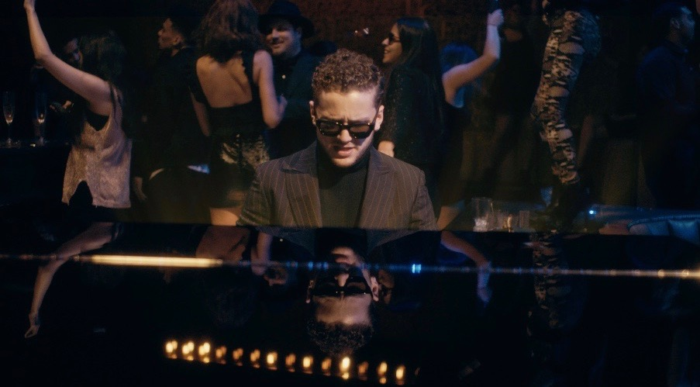

WATCH “FTC” – https://Bazzi.lnk.to/FTC
BUY/STREAM COSMIC – https://Bazzi.lnk.to/COSMIC

Acclaimed singer-songwriter-producer Bazzi surprised fans and industry alike last week by dropping an unplanned video for “FTC” – a newly released candid piano ballad. The release follows Bazzi’s cinematic video for “Beautiful,” which Billboard called “as epic as the song's thematic elements themselves.” The follow-up single to this year’s breakthrough RIAA-certified Platinum smash “Mine,” “Beautiful” boasts over 72 million streams and was recently featured as a global Snapchat Lens.

Along with the continued outpour of critical acclaim, Bazzi was most recently named an “artist you need to know” by Rolling Stone and placed #6 on their “31 Best Things We Saw” at Bonnaroo following his debut festival performance. He embarked on his completely sold out headline COSMIC Tour last week, with new shows added in Portland, Chicago and more due to overwhelming demand. The COSMIC Tour arrives on the heels of his performances as special guest on Camila Cabello’s sold out Never Be The Same North American tour and the release of his debut album COSMIC, which saw a Top 15 debut on the Billboard 200 and boasts over 853 million streams worldwide to date. Bazzi has also been announced as special guest on the European leg of Justin Timberlake’s Man of the Woods Tour, kicking off August 13th in Berlin.

Bazzi’s breakthrough single “Mine” continues to be a force, charting #1 this week on Pop radio where it has proven an unprecedented favorite. The track was named among Billboard’s “50 Best Songs of 2018 (So Far),” in addition to boasting chart positions that include #1 on Apple Music’s Pop Streaming chart, #1 on Shazam’s Global Top 100, top 5 on Spotify’s Overall Global Chart and top 15 on the Billboard Hot 100. The sultry song – which has amassed a total worldwide streaming number exceeding 519 million to date – was also recently performed on The Ellen DeGeneres Show (watch) and Jimmy Kimmel Live! (watch), with more high-profile appearances to be announced soon.

COSMIC, written predominantly by Bazzi and co-produced by Bazzi and Rice N Peas, also features stand-out tracks “Honest,” “Myself,” “Gone” and “Why?” – all of which expertly build sonically upon what Billboard described as “slinky, R&B-infused pop.” Playboy called the collection “genre-bending,” praising Bazzi’s “warts-and-all approach to songwriting.” “Bazzi’s ‘COSMIC’ seems primed to linger near the top of the albums chart for quite a while” said Stereogum, while USA Today echoed “Bazzi's career is just getting started.”

BAZZI: THE COSMIC TOUR
July 10 – San Francisco, CA @ Regency – SOLD OUT
July 11 – Los Angeles, CA @ El Rey – SOLD OUT
July 13 – Los Angeles, CA @ El Rey – SOLD OUT
July 14 – Santa Ana, CA @ The Observatory – SOLD OUT
July 16 – Phoenix, AZ @ Club Red – SOLD OUT
July 17 – Salt Lake City, UT @ The Grand at The Complex – SOLD OUT
July 18 – Denver, CO @ Gothic Theater – SOLD OUT
July 20 – Dallas, TX @ House of Blues – SOLD OUT
July 22 – Houston, TX @ Warehouse Live! – SOLD OUT
July 24 – Atlanta, GA @ Center Stage – SOLD OUT
July 26 – Washington, DC @ The Fillmore – SOLD OUT
July 27 – Montclair, NJ @ Wellmont Theater – NEWLY ADDED
July 29 – Atlantic City, NJ – BeachFest Music Festival*
July 30 – New York, NY @ Irving Plaza – SOLD OUT
July 31 – New York, NY @ Irving Plaza – SOLD OUT
August 3 – Montreal, QC @ Osheaga Music Festival*
August 4 – Toronto, ON @ Danforth Music Hall – SOLD OUT
August 5 – Chicago, IL @ Lollapalooza*
August 7 – Detroit, MI @ St. Andrews Hall – SOLD OUT
August 8 – Detroit, MI @ St. Andrews Hall – SOLD OUT
August 9 – Chicago, IL @ House of Blues – SOLD OUT
September 22 – Las Vegas, NV @ iHeartRadio Music Festival*
October 5-7 – Austin, TX @ Austin City Limits*
October 12-14 – Austin, TX @ Austin City Limits*
*FESTIVAL PERFORMANCE

Justin Timberlake – Man of the Woods Tour
w/ special guest Bazzi
August 13 – Berlin, Germany @ Mercedes-Benz Arena
August 16 – Zürich, Switzerland @ Hallenstadion
August 18 – Vienna, Austria @ Stadthalle
August 20 – Frankfurt, Germany @ Festhalle
August 21 – Frankfurt @ Festhalle
August 24 – Arnhem, Netherlands @ Gelredome
August 25 – Amsterdam, Netherlands @ Ziggo Dome
August 27 – Birmingham, England @ Birmingham Arena
August 29 – Manchester, England @ Manchester Arena

CONNECT:
Instagram | Facebook | Twitter | YouTube | SoundCloud | Press Assets

CONTACT:
Ted Sullivan | ted.sullivan@atlanticrecords.com

