FOR IMMEDIATE RELEASE
JULY 19, 2019

BEN ABRAHAM SIGNS TO ATLANTIC RECORDS,
RELEASES “SATELLITE”

ACCLAIMED SINGER-SONGWRITER’S LATEST RELEASE FOLLOWS RECENT SONGWRITING COLLABORATIONS WITH KESHA, MACKLEMORE, BEN PLATT & MORE

“SATELLITE” AVAILABLE NOW FOR STREAMING AND DOWNLOAD HERE

“‘Satellite’ is a stunningly cinematic cut, keeping the barebones instrumentation to just piano and strings, letting Abraham's warm vocal shine.” – BILLBOARD

https://www.youtube.com/watch?v=7o7gwkVAE9Y
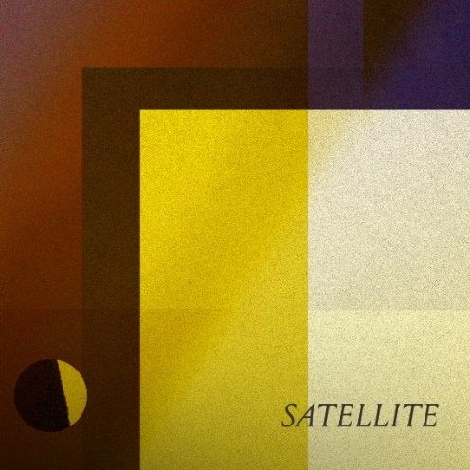
download hi-res images here

Atlantic Records has announced the signing of acclaimed singer-songwriter Ben Abraham to its legendary roster. The Australian artist is celebrating the news – unveiled earlier today exclusively via Billboard – with the release of a new single, “Satellite,” available now for streaming and download HERE. Billboard praised the track, declaring: “‘Satellite’ is a stunningly cinematic cut, keeping the barebones instrumentation to just piano and strings, letting Abraham's warm vocal shine.”

“I wrote Satellite late one night in Melbourne and recorded it with the help of my friend, composer Tilman Robinson,” explains Abraham to Billboard. He continues, “Sometimes as a writer you fill a song with words you need to hear yourself, and if you need to hear them too, I hope this song finds you.”

Of his new label, Abraham exclaims: “I’m really excited to be working with Atlantic Records to release new music. Obviously their legacy is the stuff of legend, but they also have a reputation for taking great care of their artists and I’m excited to see what we can make together.”

Atlantic Records Chairman & CEO Craig Kallman echoes Abraham’s sentiments about the partnership: “Ben is not only a phenomenal songwriter and musician, but a brilliant singer with an authentic voice of emotional power and intimacy. We’re thrilled to be joining him on what we know will be a deeply moving and compelling musical journey.”

“Satellite” follows Abraham’s acclaimed 2016 debut album, Sirens, hailed by the New York Times as “a debut of remarkable depth,” further praising its “straightforward yet cinematic songwriting.” The album – which features guest appearances from such like-minded artists as Sara Bareilles and Gotye – was followed by a series of remarkable collaborations, including co-writing Kesha’s 2x RIAA platinum certified, GRAMMY® Award-nominated 2017 smash, “Praying,” as well as work alongside Demi Lovato, Macklemore, and gnash, among others.

More recently, Abraham teamed with GRAMMY®, Tony® & Emmy Award-winner (and new labelmate) Ben Platt, composing and co-writing a number of songs on Platt’s debut solo album, Sing to Me Instead. A charismatic and charming live performer, Abraham recently supported Platt on his acclaimed North American headline tour, highlighted by a sold-out performance at New York City’s historic Beacon Theatre. Currently, Abraham is hard at work recording the eagerly awaited follow-up to Sirens, due via Atlantic next year.

The 2018 winner of Australia’s APRA Music Award for “Overseas Recognition” – and “Breakthrough Songwriter of the Year” nominee – Ben Abraham was born to make music, the son of a successful Indonesian folk-pop duo popular across Asia. Still, the Melbourne-based artist had other plans, at first embarking on a career in screenwriting. Slowly but surely, music returned to his life as he began writing songs, initially as a vehicle for navigating a complex relationship but eventually as a focused new artist with a preternatural gift for telling powerfully human stories with his words and music. As Zane Lowe praised, “This is a remarkable new singer-songwriter who definitely understands the craft.”

Highlighted by the breakthrough tracks, “Home,” “Speak,” and “This Is On Me (Feat. Sara Bareilles),” Sirens was self-released and then re-released internationally two years later to critical acclaim, with Atwood Magazine praising it for possessing a “sound that seeps into the darkest corners of the human soul… executed with luxurious soundscapes that continue to grasp [Abraham’s] film-making talents.” Describing his rise, Tone Deaf exclaimed “Ben’s honest songwriting has seen him grow… from a well-kept hometown secret into an independent artist with a passionate international following.”

CONNECT WITH BEN ABRAHAM
OFFICIAL
FACEBOOK
YOUTUBE
TWITTER
INSTAGRAM

PRESS CONTACT
Libby Kober | Atlantic Records
Libby.Kober@AtlanticRecords.com

