FOR IMMEDIATE RELEASE
FEBRUARY 13, 2019

BEN PLATT DEBUTS STUNNING OFFICIAL MUSIC VIDEO FOR
“EASE MY MIND”

VISUAL STARS PLATT ALONGSIDE CHARLIE CARVER + COMES ON THE HEELS
OF NORTH AMERICAN HEADLINE TOUR ANNOUNCEMENT

“BAD HABIT” + “EASE MY MIND” OUT NOW – OFF EAGERLY AWAITED
DEBUT SOLO ALBUM ‘SING TO ME INSTEAD’

TELEVISION DEBUT OF “BAD HABIT” SET FOR 2/21 ON
“THE LATE SHOW WITH STEPHEN COLBERT”

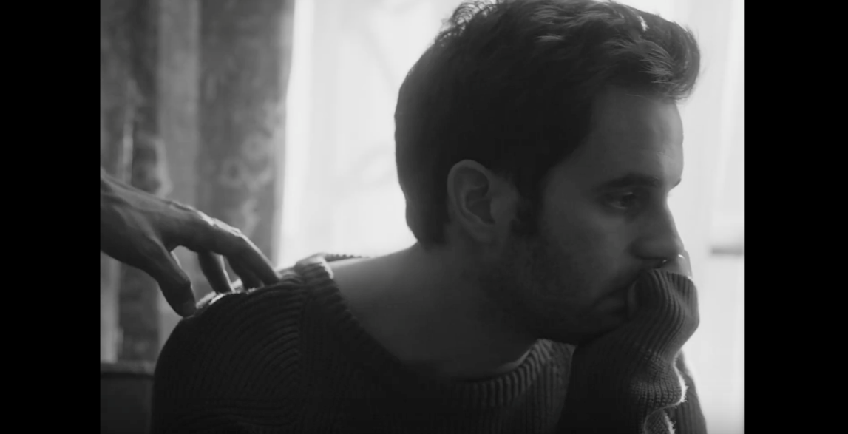

WATCH HERE: LINK

Fresh off the announcement of his North American headline tour, Grammy®, TONY®, and Emmy® Award-winning artist Ben Platt today releases the incredible official music video for “Ease My Mind,” directed by Nick Lieberman – watch HERE. Premiered this morning via People Magazine, the stunning visual stars Platt alongside acclaimed actor Charlie Carver.

The video is a continuation of the storyline first introduced in Platt’s debut music video “Bad Habit,” also directed by Lieberman and released earlier this month. “Bad Habit” and “Ease My Mind” both arrive ahead of Platt’s debut solo LP Sing to Me Instead, set to arrive everywhere Friday, March 29th via Atlantic Records. The two tracks were met with acclaim from fans and critics alike, with the Los Angeles Times declaring “‘Bad Habit’ and ‘Ease My Mind’ showcase [Platt’s] signature vibrato and guttural vulnerability.”

Earlier this week, Platt outlined details for a headline tour in support of the album, set to kick off May 3rd at Chicago Theatre in Chicago, IL. With stops throughout the US and Canada, the run will feature support from Wrabel and Ben Abraham and include a stop at New York’s Beacon Theatre on May 14th, culminating with a show at LA’s iconic Dolby Theatre on May 24th (full itinerary enclosed).

Fans pre-ordering the album (pre-order available here) will receive a pre-sale ticket code and exclusive first access to tickets beginning this Friday, February 15th @ 10 AM (local). General on-sale for the dates will begin on Friday, February 22nd @ 10 AM (local). American Express® Card Members can purchase tickets in select markets before the general public beginning Wednesday, February 20th at 10 AM (local) through Thursday, February 21st at 10 PM (local). A limited number of VIP packages will be available, including post show receptions with Ben, meet & greets, photos, Q&A’s and more.

The album announcement and track release were heralded by exclusive performances from Platt at New York’s Bowery Hotel and LA’s The Nice Guy, as well as a three-night immersive gallery installation for fans in Manhattan’s Lower East Side, marked by surprise performances each night from Platt himself. Later this month, Platt will stop by “The Late Show with Stephen Colbert” for the television debut performance of “Bad Habit” on Thursday, February 21st.

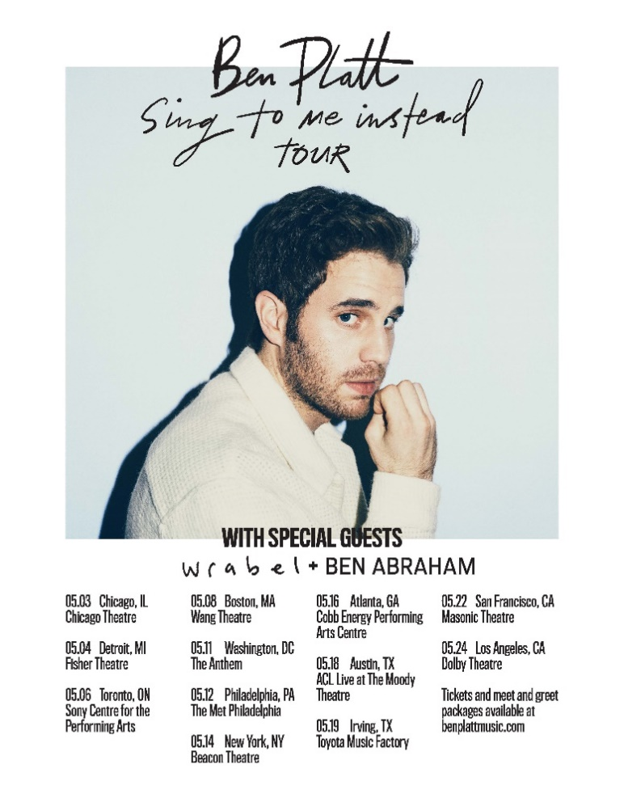

SING TO ME INSTEAD TOUR – 2019
Friday, May 3 | Chicago, IL | Chicago Theatre
Saturday, May 4 | Detroit, MI | Fisher Theater
Monday, May 6 | Toronto, ON | Sony Centre for the PA
Wednesday, May 8 | Boston, MA | Wang Theatre
Saturday, May 11 | Washington DC | The Anthem
Sunday, May 12 | Philadelphia, PA | The Met Philadelphia
Tuesday, May 14 | New York, NY | Beacon Theatre
Thursday, May 16 | Atlanta, GA | Cobb Energy PAC
Saturday, May 18 | Austin, TX | ACL Live at The Moody Theatre
Sunday, May 19 | Irving, TX | Toyota Music Factory
Wednesday, May 22 | San Francisco, CA | Warfield Theatre
Friday, May 24 | Los Angeles, CA | Dolby Theatre

+++

CONNECT WITH BEN PLATT
TWITTER
FACEBOOK
INSTAGRAM

