FOR IMMEDIATE RELEASE
MARCH 1, 2019

BEN PLATT RELEASES THIRD SOLO TRACK “GROW AS WE GO” ACCOMPANIED BY OFFICIAL MUSIC VIDEO

TRACK ARRIVES OFF EAGERLY AWAITED DEBUT SOLO ALBUM
‘SING TO ME INSTEAD’ – OUT EVERYWHERE MARCH 29TH

NORTH AMERICAN HEADLINE TOUR KICKS OFF MAY 3RD IN CHICAGO –
NYC SHOW SELLS OUT DURING PRE-SALE PERIOD ALONE

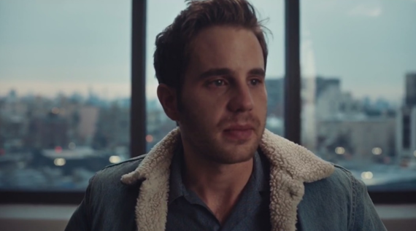

WATCH HERE: LINK

Grammy®, TONY®, and Emmy® Award-winning artist Ben Platt today releases “Grow As We Go” – the third track off his highly anticipated debut solo album Sing to Me Instead, set to arrive everywhere Friday, March 29th via Atlantic Records. The track also comes accompanied by an official music video directed by Nick Lieberman and starring dancers Rudy Abreu and Effie Tutko – watch HERE.

Today’s release is the final chapter in a trilogy first introduced last month via Platt’s debut music video “Bad Habit,” also directed by Lieberman. That video was followed by the stunning visual for “Ease My Mind,” starring Platt alongside acclaimed actor Charlie Carver and premiered via People Magazine. The two tracks were met with acclaim from fans and critics alike, with the Los Angeles Times declaring “‘Bad Habit’ and ‘Ease My Mind’ showcase [Platt’s] signature vibrato and guttural vulnerability.”

Last month, Platt outlined details for a North American headline tour in support of the album, set to kick off May 3rd. The tour will include a stop at New York’s Beacon Theatre on May 14th, a date which sold out during the pre-sale period before general on-sale for the tour had even begun. With stops throughout the US and Canada, the run will feature support from Wrabel and Ben Abraham and culminate with a show at LA’s iconic Dolby Theatre on May 24th (full itinerary enclosed). A limited number of VIP packages will be available, including post show receptions with Ben, meet & greets, photos, Q&A’s and more.

Platt recently stopped by “The Late Show with Stephen Colbert” for the stunning television debut performance of “Bad Habit” – watch HERE. This followed exclusive performances from Platt at New York’s Bowery Hotel and LA’s The Nice Guy, as well as a three-night immersive gallery installation for fans in Manhattan’s Lower East Side, marked by surprise performances each night from Platt himself.

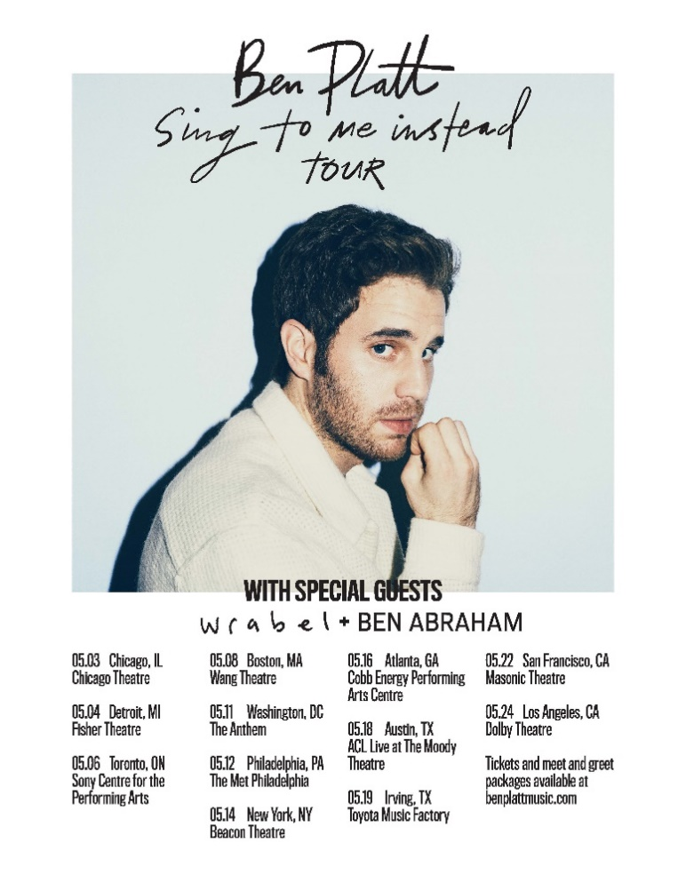

SING TO ME INSTEAD TOUR – 2019
Friday, May 3 | Chicago, IL | Chicago Theatre
Saturday, May 4 | Detroit, MI | Fisher Theater
Monday, May 6 | Toronto, ON | Sony Centre for the PA
Wednesday, May 8 | Boston, MA | Wang Theatre
Saturday, May 11 | Washington DC | The Anthem
Sunday, May 12 | Philadelphia, PA | The Met Philadelphia
Tuesday, May 14 | New York, NY | Beacon Theatre **SOLD OUT**
Thursday, May 16 | Atlanta, GA | Cobb Energy PAC
Saturday, May 18 | Austin, TX | ACL Live at The Moody Theatre
Sunday, May 19 | Irving, TX | Toyota Music Factory
Wednesday, May 22 | San Francisco, CA | Warfield Theatre
Friday, May 24 | Los Angeles, CA | Dolby Theatre
+++

CONNECT WITH BEN PLATT
TWITTER
FACEBOOK
INSTAGRAM

