BEN PLATT DRAWS HUNDREDS OF FANS FOR SURPRISE POP-UP PERFORMANCES IN LA

SECOND PERFORMANCE ADDED BY DEMAND

WATCH HERE

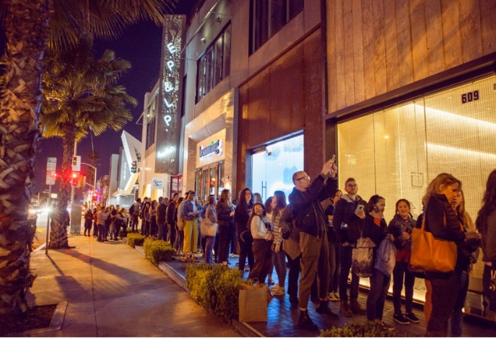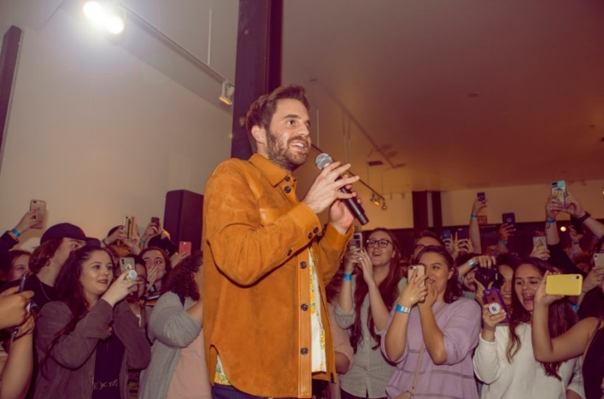

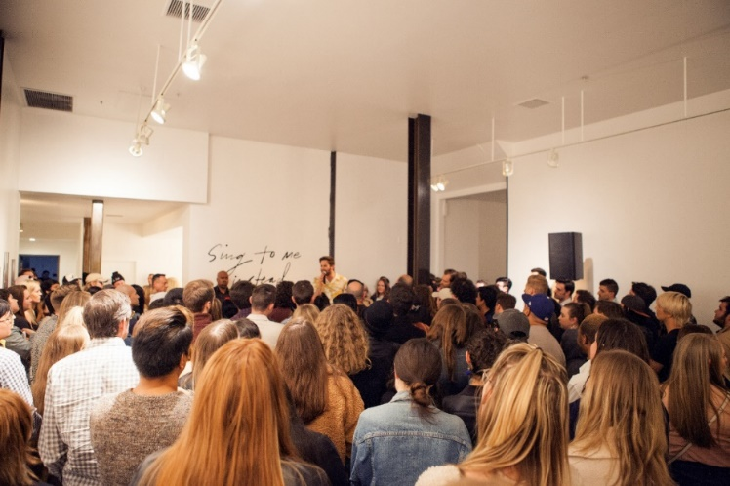
download hi-res images here; photo credit: Jill Augusto

Last night, Grammy®, TONY®, and Emmy® Award-winning artist Ben Platt surprised fans with a performance of tracks off his highly anticipated debut album, Sing to Me Instead – out everywhere 3/29.

The performance took place in the midst of a pop-up immersive gallery installation made to resemble the sets of his recently released music videos for “Bad Habit” and “Ease My Mind.”

An unplanned second performance was added due to the sheer number of fans – spanning down the street and around two blocks.

This followed exclusive performances from Platt at New York’s Bowery Hotel and LA’s The Nice Guy, as well as a similar three-night pop-up event for fans in Manhattan’s Lower East Side, also marked by surprise performances each night.

Last month, Platt outlined details for a North American headline tour in support of the album, set to kick off May 3rd. The tour will include a stop at New York’s Beacon Theatre on May 14th, a date which sold out during the pre-sale period before general on-sale for the tour had even begun. With stops throughout the US and Canada, the run will feature support from Wrabel and Ben Abraham and culminate with a show at LA’s iconic Dolby Theatre on May 24th (full itinerary enclosed).

