FOR IMMEDIATE RELEASE
AUGUST 23, 2019

BEN PLATT RETURNS WITH “RAIN”

GRAMMY®, TONY®, AND EMMY® AWARD-WINNING STAR UNVEILS NEW SINGLE

UPCOMING LIVE SCHEDULE INCLUDES US OPEN OPENING NIGHT CEREMONY
AND GLOBAL CITIZEN FESTIVAL 2019

SOLD OUT HEADLINE SHOW AT NYC’S FAMED RADIO CITY MUSIC HALL
SET FOR SUNDAY, SEPTEMBER 29TH

EAGERLY AWAITED NEW SERIES, THE POLITICIAN, DEBUTS SEPTEMBER 27TH VIA NETFLIX

ACCLAIMED DEBUT ALBUM, SING TO ME INSTEAD, AVAILABLE EVERYWHERE NOW
“RAIN” ARRIVES TODAY AT ALL DSPS AND STREAMING SERVICES

hi-res image here – credit Zoey Grossman for Netflix

LISTEN HERE: https://benplatt.lnk.to/RAINPR

GRAMMY®, TONY®, and Emmy® Award-winning artist Ben Platt has announced today’s release of a remarkable new single. “RAIN” is available now at all DSPs and streaming services – listen here.

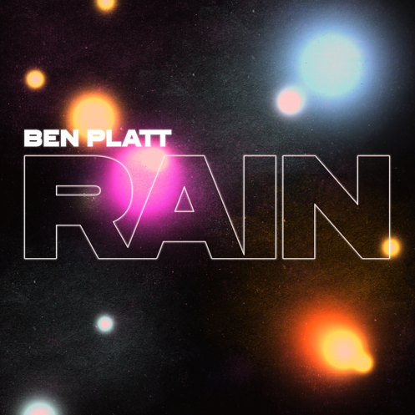
download hi-res artwork here

Produced by Alex Hope (Troye Sivan, Tove Lo, Jack Antonoff), “RAIN” marks Platt’s first new music since the arrival of his acclaimed debut, Sing to Me Instead, released earlier this year on Atlantic Records.

Platt will kick off a very busy fall season with a headline performance of “RAIN” and Sing to Me Instead’s “Temporary Love” at next week’s US Open Opening Night Ceremony, to be broadcast live from Queens, NY’s Arthur Ashe Stadium on Monday, August 26th at 7:20 pm ET via ABC and ESPN.

Next month will see Platt join an array of superstars – including Queen + Adam Lambert, Pharrell Williams, Alicia Keys, OneRepublic, H.E.R., and Carole King – for the annual Global Citizen Festival 2019, set for Saturday, September 28th at the Great Lawn in New York City’s Central Park. Complete details and free ticket information can be found HERE.

Last but certainly not least, Platt will mark a career milestone with a sold-out headline show at New York City’s legendary Radio City Music Hall, set for Sunday, September 29th. Platt first announced the show earlier this spring during a sold-out show at NYC’s equally renowned Beacon Theatre.

Platt will also be seen next month leading an all-star cast in the much-anticipated new series, The Politician, produced by Ryan Murphy, Brad Falchuk, and Ian Brennan (Glee) and co-starring Jessica Lange, Gwyneth Paltrow, and Zoey Deutch. Co-executive produced by Platt – who recently appeared alongside his co-stars in an exclusive cover feature in The Hollywood Reporter – The Politician premieres Friday, September 27th on Netflix.

Sing to Me Instead has proven a full-fledged sensation, amassing over 60 million global streams and earning acclaim from fans and critics alike since its release this March. Highlights include “Bad Habit,” “Ease My Mind,” “Grow As We Go,” and “Temporary Love,” all of which came accompanied by official music videos streaming HERE. A truly multi-faceted actor, singer, and all-around performer, the album saw Platt making a remarkable arrival as a solo recording artist and a songwriter, co-writing all of the album’s 12 songs. Tracks such as the aforementioned “Bad Habit” and “Ease My Mind” reveal a striking, deeply emotive brand of classic popcraft, enlivened with theatrical sweep and Platt’s own undeniable charm and versatility.

Sing to Me Instead was greeted with a wave of acclaim, with Entertainment Weekly declaring it “a departure from Platt’s TONY®-award winning musical theatre stylings…(taking) the ‘narrative and emotionally-focused’ techniques of singer-songwriters like Carole King, James Taylor, and Joni Mitchell as inspiration alongside the soul and rhythms of artists like Stevie Wonder and Ray Charles,” adding “(Platt) still relies on many of the principles of storytelling, emotion, and performance he learned from his roots in musical theatre.” The songs of Sing to Me Instead “are diarylike remembrances of the three major relationships that have shaped him,” noted USA Today, “with earnest vocals and achingly specific lyrics that are reminiscent of Platt's musical heroes Carole King and James Taylor.” Platt “has a soulful voice and proves to be a consummate storyteller throughout,” wrote The Huffington Post, “laying his emotions bare with refreshing candor.”

Platt celebrated his debut solo album with a sold out headline tour that drew packed houses and ecstatic reviews across North America, with The Newark Star-Ledger heralding “Platt’s on his way to becoming a format-busting household name.” Upon the announce of the Radio City Music Hall date, Billboard exclaimed “His tour may be over, but fans near New York can rejoice: he’s scheduled one further date at New York’s Radio City Music Hall on Sept. 29.”

Platt also commemorated the arrival of Sing to Me Instead with a wide range of high profile TV performances, including NBC’s TODAY, CBS’s The Late Show with Stephen Colbert (streaming HERE) and The Late Late Show with James Corden, as well as the nationally syndicated Ellen DeGeneres Show (streaming HERE).

The winner of the 2017 Tony® Award for Best Leading Actor in a Musical for his performance as Evan Hansen in the smash hit, Dear Evan Hansen, Platt also received a GRAMMY® Award for his role on the Dear Evan Hansen (Original Broadway Cast Recording) and a 2018 Daytime Emmy Award for his part in the cast’s powerful performance of “You Will Be Found” on NBC’s TODAY. His rapidly growing body of work also includes memorable roles in the TONY® Award-winning original Broadway production of The Book of Mormon and the blockbuster films, Pitch Perfect and Pitch Perfect 2, amongst many others. Platt will also star in the film Run This Town, which earned wide-ranging praise upon its premiere at Austin, TX’s SXSW Film Festival.

# # #

CONNECT WITH BEN PLATT
OFFICIAL
TWITTER
FACEBOOK
INSTAGRAM
YOUTUBE

