FOR IMMEDIATE RELEASE
SEPTEMBER 10, 2019

BEN PLATT UNVEILS OFFICIAL MUSIC VIDEO FOR “RAIN”

GRAMMY®, TONY®, AND EMMY® AWARD-WINNING STAR RELEASES HIGH-ENERGY
VIDEO DIRECTED BY JAMES LARESE FOR LATEST SINGLE

SOLD OUT HEADLINE SHOW AT NYC’S FAMED RADIO CITY MUSIC HALL (9/29) TO BE FILMED FOR FEATURE-LENGTH NETFLIX CONCERT SPECIAL

PLATT TO PERFORM AT GLOBAL CITIZEN FESTIVAL ON SEPTEMBER 28TH

EAGERLY AWAITED NEW SERIES, THE POLITICIAN, DEBUTS SEPTEMBER 27TH VIA NETFLIX

ACCLAIMED DEBUT ALBUM, SING TO ME INSTEAD, AVAILABLE EVERYWHERE NOW
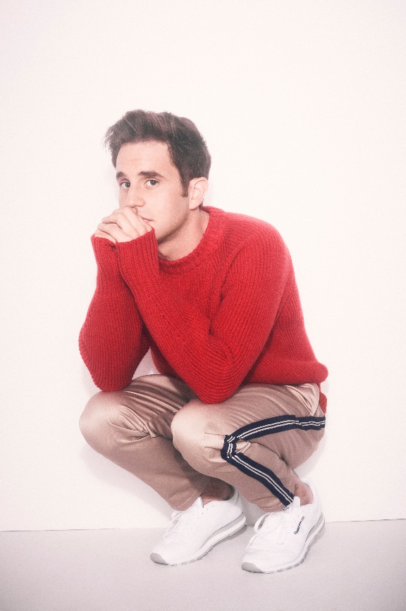
hi-res image here – credit Zoey Grossman for Netflix

WATCH HERE: https://benplatt.lnk.to/RAINVideoPR

GRAMMY®, TONY®, and Emmy® Award-winning artist Ben Platt today unveiled the official music video for his latest single “Rain” – watch here. Directed by James Larese, the visual opens with a melancholy Platt outside of an empty gas station. As the video progresses, his spirits lift - ultimately leading to a high-energy dance scene from Platt, while bathed in technicolor lights and the rain. Platt debuted the new video via a YouTube livestream premiere at 12pm (ET), answering questions from fans before and during the premiere.

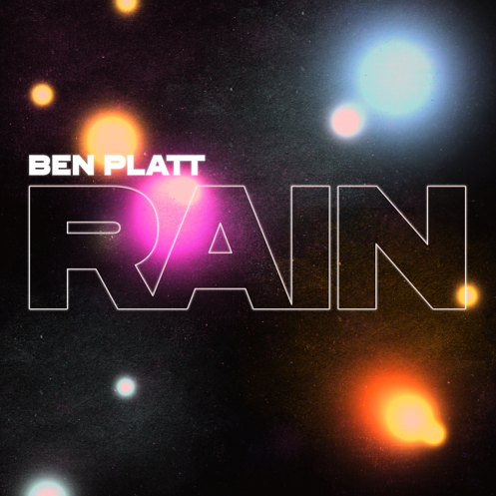
download hi-res artwork here

Produced by Alex Hope (Troye Sivan, Tove Lo, Jack Antonoff), “RAIN” marks Platt’s first new music since the arrival of his acclaimed debut, Sing to Me Instead, released earlier this year on Atlantic Records.

Platt recently performed the track live, alongside Sing to Me Instead’s “Temporary Love,” at the US Open Opening Night Ceremony, broadcast live from Queens, NY’s Arthur Ashe Stadium.

Later this month, Platt will join an array of superstars – including Queen + Adam Lambert, Pharrell Williams, Alicia Keys, OneRepublic, H.E.R., and Carole King – for the annual Global Citizen Festival 2019, set for Saturday, September 28th at the Great Lawn in New York City’s Central Park. Complete details and free ticket information can be found HERE.

Last but certainly not least, Platt will mark a career milestone with a sold-out headline show at New York City’s legendary Radio City Music Hall, set for Sunday, September 29th. Adding to the anticipation of the evening, it was announced yesterday via Hollywood Reporter that the show – the final stop on Platt’s debut tour – will be filmed live and broadcast on Netflix as a feature-length concert special; airdate forthcoming. Alongside “Rain,” Platt will also perform fan favorites from Sing to Me Instead for the special.

Platt will also be seen this month leading an all-star cast in the much-anticipated new series, The Politician, produced by Ryan Murphy, Brad Falchuk, and Ian Brennan (Glee) and co-starring Jessica Lange, Gwyneth Paltrow, and Zoey Deutch. Co-executive produced by Platt – who recently appeared alongside his co-stars in an exclusive cover feature in The Hollywood Reporter – The Politician premieres Friday, September 27th on Netflix.

# # #

CONNECT WITH BEN PLATT
OFFICIAL
TWITTER
FACEBOOK
INSTAGRAM
YOUTUBE

